Cross Case Analysis of an Elementary Engineering Task
Submitted to Meet the Requirements of the Comprehensive Examination
September 23, 2014
John Heffernan
University of Massachusetts, Amherst

Abstract 3
Introduction 4
Frameworks and Models 6
Theoretical Frameworks 7
Engineering Design Process Models 13
Previous Research and Methods 17
Methodology 23
Results 26
Data Results 27
Qualitative Results 34
Discussion 38
Engineering Design 38
Design Concepts and Aesthetics 38
Cycles, Subsystems, and Hierarchical Thinking 39
Tinkering 42
Concrete Evaluation 43
Planning and Research 44
Persistence in Non-Optimal Design Choices 45
Projection/Cause and Effect 47
Instruction 48
Research Protocol 51
Programming 52
Affect 52
Strategies 53
Strengths 54
Limitations of Study 54
Future Research 55
Conclusion 55
References 57
Appendix A - Code Book 63
Appendix B - Research Prompt 65
Appendix C - Permission Letter 66
Appendix D - Second Grade Transcript 67
Appendix E - Sixth Grade Transcript 100

Abstract

Designerly play has been identified as a fundamental component of childhood learning (Baynes, 1994). However, as students enter grade one and beyond, the increasing academic focus has resulted in the loss of opportunities for designerly play (Zhao, 2012). At the same time, there are increasing calls to increase the number, skill, and diversity of STEM workers (Brophy, Portsmore, Klein, & Rogers, 2008). The robotics based Elementary Engineering Curriculum (Heffernan, 2013) - used by students in this study - and other similar projects have the potential to increase the STEM pipeline but elementary engineering is not well-understood. This qualitative, cross case study has done an initial characterization the elementary engineering process at two separate ages, grades 2 and 6, in terms of engineering design process models, and other emergent processes, skills, and strategies. The study also analyzed cognitive barriers that impact students’ ability to realize their design ideas. The study found that the second grade student used engineering skills but they were limited by age dependent cognitive development such as the lack of formal operations and causal reasoning. However, when questioned by the researcher, the second grader could concretely trace problems and find creative solutions. The second grade student also persisted in non-optimal design choices resisting consideration of redesign, which can be traced to irreversibility and ego-centrism. The sixth grade student’s formal operations allowed the anticipation of potential problems. The sixth grade student also showed understanding and use of adult design concepts such as symmetry, scale, and stability. Further research is needed to characterize the engineering processes and barriers for a broader range of grades, knowledge and skill level, and gender. The long-term goal of this line of research is to optimize the teaching of elementary engineering taking student development into account.

Introduction

Designerly play has been identified as a fundamental component of childhood learning (Baynes, 1994). Designerly play is supported in typical preschool and kindergarten classes with sand tables, water tables, blocks, LEGO blocks, art, and dramatic play areas. However, as students enter grade one and beyond, the increasing academic focus has resulted in the loss of opportunities for designerly play (Zhao, 2012). At the same time, there are increasing calls to increase the number, skill, and diversity of STEM workers (Brophy et al., 2008). The lack of opportunities for designerly play in elementary school results may be causing a reduction in the number and diversity of students interested in the STEM fields (especially engineering) later in middle and high school. Elementary engineering curriculum such as the robotics based Elementary Engineering Curriculum (Heffernan, 2013) and more general Engineering Is Elementary (Ernst & Bottomley, 2011) have the potential to ameliorate this problem. Robotics offers specific affordances that make it an especially attractive educational technology (Brophy et al., 2008; Gura, 2011).
This pilot study and separate, detailed literature review lay the groundwork to answer the question: how do grade K to 6 elementary students’ robotics engineering skills and processes change over time in terms of construction and programming techniques? Specifically, what changes in their techniques and processes can be seen over time that impact their ability to realize their design ideas? The aim is to gain an understanding of students’ processes as they undertake open-ended engineering challenges at different ages. The long-term goal is to improve instruction of engineering for elementary aged children.
The pilot study establishes the methodologies for a larger dissertation study by executing a small subset of the larger dissertation case study (see figure Table 1 - Relationship Between Studies). Note that the pilot study data will be used as part of the dissertation study if possible.

Student Rating In Engineering | Grade K | Grade 2 | Grade 4 | Grade 6
Expert | Dissertation | Dissertation | Dissertation | Pilot
Normal | Dissertation | Pilot | Dissertation | Dissertation

Table 1. Relationship between studies.
This pilot study occasionally references a separate, longitudinal, informal case study underway that is examining the same eight children over a period of seven years as they do the same amusement park ride challenge in the pilot study.
The pilot study determined the following:
- The task,
- The videotaping and interview process,
- The transcription process,
- The coding scheme for the video,
- The data analysis process and outputs,
- The process to identify the developmental strengths and barriers of each age formally,
- The engineering design process model that best fits this study and age range.
The pilot study analyzed video of two elementary students of two different ages (grade 2 and grade 6) as they completed an open-ended robotics-based engineering challenge. Through a combination of think-aloud (Ericsson & Simon, 1993), direct observation, and semi-structured clinical interview (Brenner, 2006; Ginsburg, 1997), a coding scheme was developed to characterize student’s engineering processes over time with particular focus on identifying on the challenging aspects at different ages. These difficulties were tied back to the matching development milestones provided by the theoretical frameworks of Piaget and others with the long-term goal of informing elementary engineering curriculum and instruction in a developmentally appropriate way. The literature does not provide guidance on how to identify strengths at different ages. A more systemic approach for identifying strengths than anecdotal observation emerged from the pilot study.
Levy & Mioduser (2010) showed that complex and advanced cognition could occur in young children’s interpretation of robot rules and behaviors. Similar understandings need to be uncovered for the construction and programming of educational robots. In light of the Next Generation Science Standards (“Next Generation Science Standards,” 2012) incorporation of engineering design as a way to teach science K-12, research that helps teachers and curriculum developers understand elementary engineering design processes has timely relevance.

Frameworks and Models

In this section, the most relevant theoretical frameworks and engineering design process models are identified for a case study of elementary, robotics-based engineering education. In a case study with a strong focus on cognition, existing cognitive benchmarks are obvious frameworks in which to measure development in the specific domain of focus. Engineering design process models can be used to show how children’s engineering processes change over time by measuring the duration and occurrences of different engineering phases as different aged student tackle an open-ended engineering design challenge.

Theoretical Frameworks

The learning theories of constructivism (Piaget & Inhelder, 1969), constructionism (Bers, 2008; Martinez & Stager, 2013; Papert, 1993), and social constructivism (Vygotsky, 1978) all provide a framework to support the teaching of design because: 1) children actively construct their knowledge in design projects (constructivism), they typically do so while building a physical model (constructionism), and they work effectively in groups to do so (social constructivism).
Piaget’s constructivist theory defines four stages of cognitive development: sensorimotor (0 to 2), pre-operational (2 to 7), concrete operational (7 to 11), and formal operational (11 and up) (Piaget & Inhelder, 1969). In a longitudinal study of K-6 children, students transition from the pre-operational, intuitive thought substage (between grades K and 2) to concrete operational (grades 2 to grade 5) and finally to formal operational (grade 6). Piaget notes that ages are “average and approximate” (Piaget & Inhelder, 1969, p. 3).
The development characteristics relevant to an elementary robotics longitudinal study are listed below.
- Pre-operational, intuitive thought (K to grade 2)
  - Egocentric – can only see their own point of view,
  - Primitive reasoning – wanting to and starting to understand the “why” of things,
  - Children know they have much knowledge but don’t know how they acquired it,
  - Key cognitive characteristics:
    - Centration – only focusing on one aspect or cause of a situation,
    - Irreversibility – children can not mentally reverse a sequence of events,
- Concrete operational (Grade 2 to grade 5)
  - Start solving problems logically but only with concrete objects,
  - Inductive reasoning from cases to a general principle,
  - Trial and error problem solving,
  - Key cognitive characteristics (for concrete objects):
    - Seriation – the ability to sort objects by different characteristics,
    - Conservation – even if an object’s appearance changes, the quantity remains constant,
    - Transitivity for concrete objects – just as in mathematics, if A < B and B < C, the A <C, for example,
    - Reversibility – the ability to mentally reverse a sequence of events or operations, specifically, objects that are modified can be returned to their original state,
    - Conservation – an object can change appearance but still has the same quantity,
    - Classification – the ability to name sets (and subsets) based on objects’ characteristics,
    - Decentering – the ability to take in multiple aspects of a problem,
- Formal operational (Grade 6)
  - Deductive reasoning from a general principle to specific cases,
  - Logical and systemic problem solving,
  - Key cognitive characteristics:
    - Abstract thought – all the operations developed in previous stages can be done mentally without reference to concrete objects,
    - Metacognition – the ability to reflect on cognition itself.
Neo-Piagetian researchers have modified Piagetian theory to address the issues that had developed with Piagetian theory. Namely, data showed that there was wide individual variation in the stages and that the universal structures Piaget claimed were not turning out to be as universal as originally claimed (Bidell & Fischer, 1992; Case, 1991; Young, 2011). This resulted in a variety of modifications to Piaget. Bidell & Fischer (1992) in their skills theory see cognitive development as more of a web than a linear stage model so that different children take different paths through the web. They also pointed out that active instruction and learning in domain specific areas and learning was needed for cognitive development; one cannot just wait for brain development to occur. The modification of universal structures to domain specific structures was also delineated by Case (1991) with his notion of Central Cognitive Structures (CCS) and Demetriou, Gustafsson, Efklides, & Platsidou (1992) with their Specialized Structural Systems. Finally, Neo-Piagetians (Bidell & Fischer, 1992) point out the need for development sequences in different domains. This latter point reveals the possibility for the identification of a learning progression for engineering for children (Krajcik, 2011). One key cognitive characterize that is especially relevant to engineering education is causal reasoning, the understanding of cause and effect.
Piaget defined a progression of causality from magical-phenomenalist (also called realism) to an eventual scientific viewpoint (Fuson, 1976; Piaget & Inhelder, 1969). Infants do not have a delimitation of self and the outside world, attribute cause to the temporal proximity of events, and attribute all events to them without consideration of physical proximity. From three to eleven, a progression of causality occurs from realism to objectivity, reciprocity, and relativity (Fuson, 1976). Between these states, children may give animistic, finalistic, participatory, and artificial explanations of phenomenon. An example of animism from robotics is when children attribute causation in robots or machines to an anthropomorphic conception of machine itself (Mioduser, Levy, & Talis, 2007). Finalistic explanations are the result of the belief that everything has an explanation and any explanation suffices regardless of its plausibility. Participatory explanations result from children’s belief that they participate causally in natural phenomenon and are sometimes seen with associated magical thinking. Finally, artificial explanations attribute causality to its benefit to humans.
Jonassen & Ionas (2008) provide a complex model of causal reasoning and then suggest different ways to support the learning of causal reasoning. In this model, problem solving and conceptual change support predictions, inferences, explanations, and implications, which, in turn, enable causal reasoning. They see causal reasoning being engaged by direct instruction, simulations, question prompts, and learner modeling. Causal reasoning can be described using mechanism based or covariance based information. Engineering education provides problem-solving affordances for learning causal reasoning. All four enablers of causal reasoning in this model are part of engineering - predictions, inferences, explanations, and implications - but predicting the performance of a system, subsystem, or program is most relevant to the pilot study. However, prediction is defined in terms of either scientific method, namely hypothesis, or forecasting events such as weather or economic performance (Jonassen & Ionas, 2008).
Research on causality is split into two camps (Kuhn & Dean, 2004). The multivariate inference (MVI) researchers looked at how college students attributed causes from multiple variables based on data presuming quantitative but very general cognitive models. Scientific Reasoning (SR) researchers looked at how children in general use knowledge of underlying mechanisms to attribute cause in the scientific realm (Kuhn & Dean, 2004). Kuhn & Dean (2004) argue that both approaches have merit, can be combined, and that causal reasoning should combine both data and underlying mechanism.
How does causal reasoning operate in the domain of engineering? Engineering in particular and design in general centers around the prediction (Jonassen & Ionas, 2008) of how a design, process, or software program will actually function in the physical world. While extant casual reasoning research does address prediction, an important component of engineering, , I was unable to locate any research on causality or prediction in the specific context of engineering.
Casual reasoning research typically centers on a posteriori evaluation of data to determine causes. However, in engineers make a priori predictions of the performance of their designed systems. The predictions may be augmented with simulations, models, and prototypes. In the context of LEGO robotics, students are expected to design and then build with a prediction of performance in mind and then subsequently evaluate the actual performance of their system. Since prediction is usually associated with science, I use the term mental projection to describe this cognitive skill in the domain of engineering. As will be shown, the ability to mentally project the impact of design decisions turned out to be an important difference between the second and sixth grade students.
The Elementary Engineering Curriculum (EEC) (Heffernan, 2013) uses a mediated learning approach (Suomala & Alajaaski, 2002), which combines teacher instruction, structured activities, and open-ended engineering challenges. Students work in dyads to help develop collaboration and communication skills (The Partnership for 21st Century Skills, 2002). Constructionism (Papert, 1993) is the theoretical framework that best reflects this approach. Bers defines constructionism as “a constructivist approach to developing and evaluating educational programs that make use of technologies with the purpose of learning” (Bers, 2008, p. 13). The key connectors between constructionism and the EEC are shown next.
- The construction of artifacts as way to explore big ideas; “children … construct powerful ideas through firsthand experience” (Martinez & Stager, 2013, p. 18).
- Social aspects are important (students work in dyads) but not central to this research, which is more concerned with how cognitive development manifests in elementary engineering.
- The use of programming and computers has a rich history intertwined with constructionism both in terms of the value of debugging as a process (Bers, Flannery, Kazakoff, & Sullivan, 2014; Sullivan, 2008) and the actual use of computer programming to instantiate big ideas (Papert, 2000).
- The use of the engineering design process gives children a balance of scaffolding and open-endedness that provides a “constructionist learning environment” (Bers, 2008, p. 17).

- Robotics, a constructionist learning environment (Bers, 2008) is a natural way to encourage epistemological pluralism (multiple ways of knowing) (Turkle & Papert, 1991).

- There is a focus on students documenting their own designs and processes and sharing out with a larger community, which provide a vehicle for reflecting on learning, an important tenet of constructionism (Bers, 2008; Papert, 1993; Resnick, 2007).

In summary, the extant research on design, engineering design, and robotics comes out of constructivist, social constructivist, and constructionist frameworks. A constructionist/constructivist framework with a strong focus on causal reasoning best informs my own research questions on the EEC curriculum. The goal is to use the constructionist/constructivist theoretical framework to gain an understanding of students’ processes as they undertake open-ended engineering challenges at different ages. The long-term goal of this line of research is to optimize the teaching of elementary engineering taking student development into account.

Engineering Design Process Models

One way to determine changes over time in children’s engineering skills is to measure the usage of various stages defined by engineering design process models. Even though the research focus is on strengths and challenges at different ages, characterization of these strengths and challenges in the context of where they occur in a design process model provides additional insights. One typical engineering design process model is shown below (Portsmore, 2011).
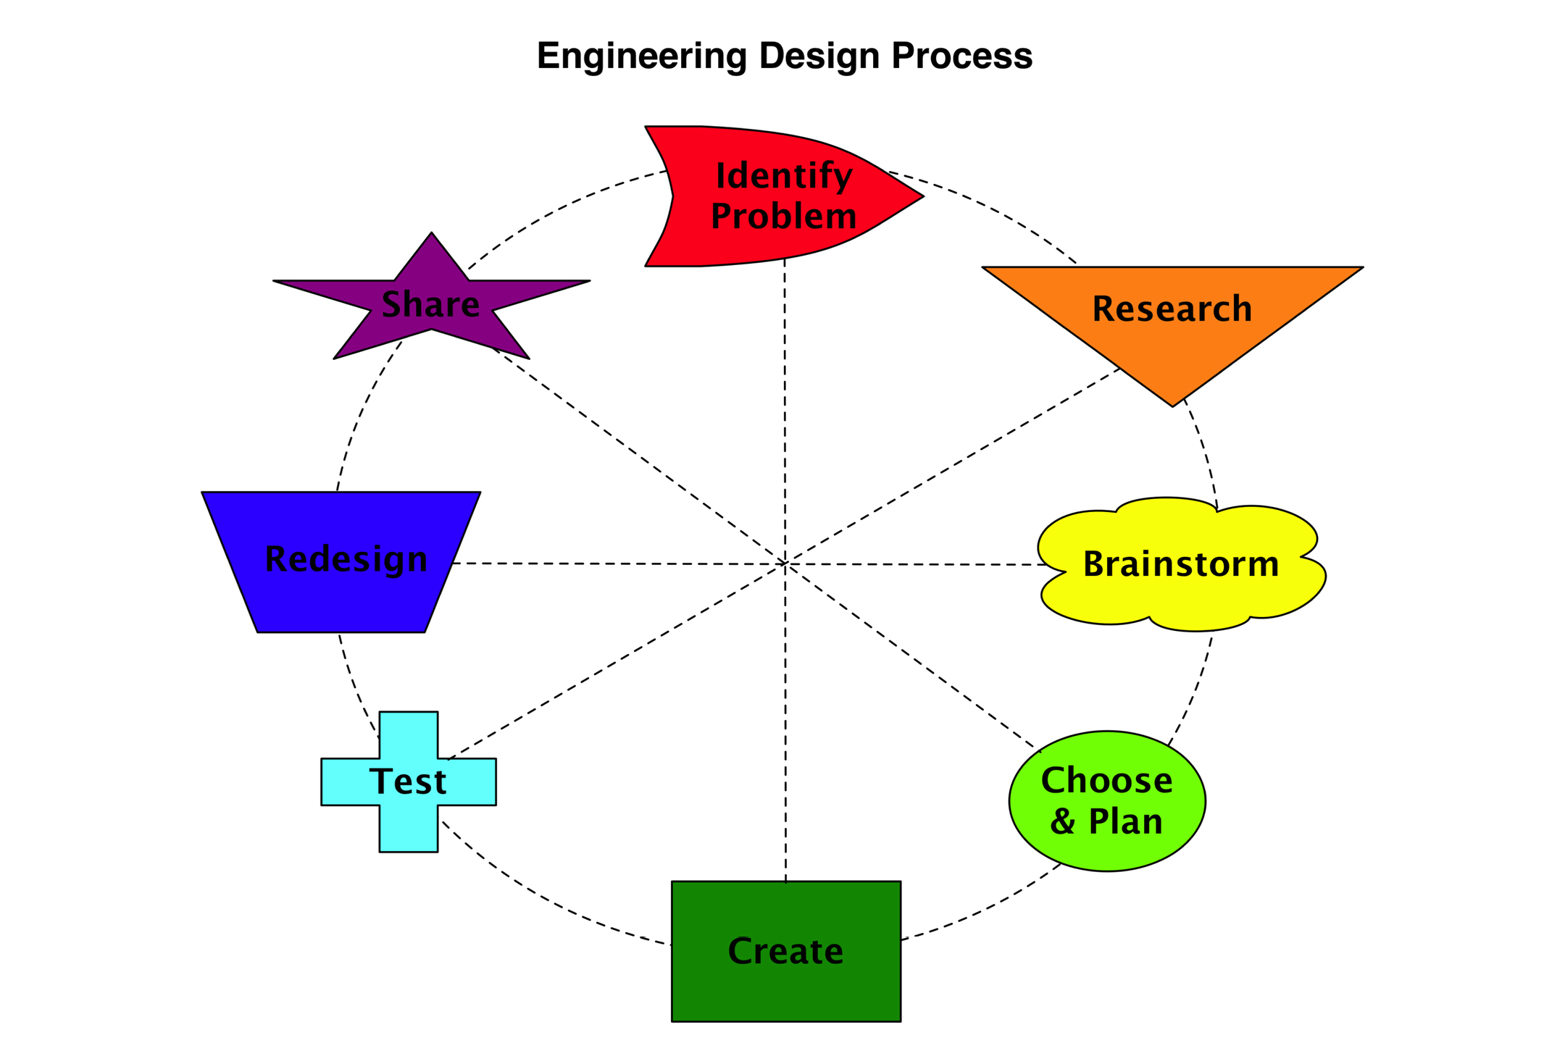
Figure 1. Engineering Design Process Model - Dr. Merredith Portsmore, Tufts CEEO. Used with permission.

Note the connecting lines across the circle, which indicate that the flow in the process may not be linear around the circle. This is an improvement on more linear models such as Mehalik, Doplet, & Schunn (2008). Welch (1999) points out that studies show that linear, rational, deterministic design process models may not actually be followed by designers and even less so by novice designers.
Different models also vary with the number of steps and complexity. Martinez & Stager (2013) have a simple three-step model they call TMI: Think, Make, Improve. The steps delineated in other models are subsumed into one of the three steps of the TMI model. Bers, Flannery, Kazakoff, & Sullivan (2014) use another child friendly variation in robotics studies of kindergarten students.

Crismond & Adams (2012) reviewed the existing design process models and attempted to synthesis extant models into a parsimonious and widely applicable model. Note that they do not explicitly label these strategies a design process model because they want them to fit into extant design process models with different numbers of steps (D. Crismond, personal communication, March 16, 2014). They define these nine parsimonious design strategies as part of their larger Informed Design Teaching and Learning Matrix.

- Understand the Challenge
- Build Knowledge
- Generate Ideas
- Represent Ideas
- Weigh Options & Make Decisions
- Conduct Experiments
- Troubleshoot
- Revise/Iterate
- Reflect on Process
For each strategy row, the authors have a rubric consisting of columns for novice and informed designers. They also have a column of learning goals and teaching strategies. For example, for the design strategies Understand the Challenge”, novice designers “Treat design task as a well-defined, straightforward problem that they prematurely attempt to solve” while informed designers “Delay making design decisions in order to explore, comprehend and frame the problem better” (Crismond & Adams, 2012, p. 748). The matrix could be a lens in which to classify and measure student design strategies as they progress through school.
Tinkering is an alternate way of approaching the design process.
Resnick & Rosenbaum (2013) define tinkering as follows.
We see tinkering as a valid and valuable style of working, characterized by a playful, exploratory, iterative style of engaging with a problem or project. When people are tinkering, they are constantly trying out ideas, making adjustments and refinements, then experimenting with new possibilities, over and over and over. (page 164)
Tinkering is a bottom-up approach as opposed to the top-down approaches of the design process models examined previously. Tinkerers, also known as bricoleurs, may not have a plan at all or may only have a general idea and may begin the design process by “messing around with the materials” (Resnick & Rosenbaum, 2013, p. 165). This is significant in any case study of design that attempts to classify activities into a formal design process model because some students may be tinkerers and may not fit into a defined design process model.
Based on an examination of extant models and my own experience teaching elementary engineering for a number of years, I was able define a baseline engineering design process model for this study (see Figure 3). A design process taxonomy based on observable behaviors (visually and with a think-aloud protocol) is the most useful for measuring how engineering processes change over time: planning, researching, building, rebuilding, programing, reprogramming, and evaluating. The distinction between building and rebuilding and between programming and reprogramming is germane to this study because the study seeks to identify the difficult parts of each session. Evaluation, in the context of engineering, refers to the determination of current state of a design in relation to the overall or intermediate goals of the prototype or final engineering solution. Different researchers use different terminology for this phase of the engineering design process. Examples are: testing, evaluation, and troubleshooting. Note that defining the problem and sharing out are part of my model but not coded since they are not part of the particular task being researched.
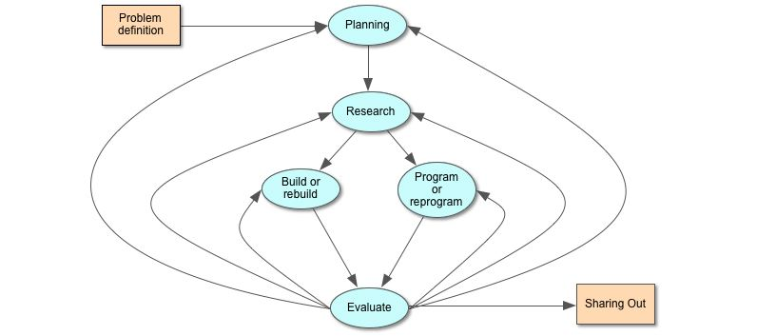
Figure 3. Engineering design process model for study. The problem definition and sharing out are parts of the model but were not part of the task so they were not coded.
Note that other models focus on the surrounding culture and environment where design takes place and take a situated cognition (Roth, 1996) or social constructionist perspective (Leonard & Derry, 2011). While social and environmental factors are important and interesting, our focus in on individual cognition changes over time. Now that a theoretical framework and design process model have been define for applicability for a case study of elementary robotics, we turn an examination of relevant previous research.

Previous Research and Methods

A brief review of the existing research and methodology on robotics and elementary design follows. Because so few studies have been done with elementary age students, some studies across a wider age range are included. Also, design process models and methodologies of older learners may still be applicable (with modification) to studies of elementary students.
Previous studies have investigated different aspects of design and engineering as a means of teaching science concepts and process skills (Puntambekar & Kolodner, 2005), engineering (Hynes, 2007), problem solving (Fortus, Krajcik, Dershimer, Marx, & Mamlok-Naaman, 2005), and systems thinking (Sullivan, 2008). These studies have been of limited duration, have focused on older children, and have looked at the overall educational efficacy of the intervention.
Other studies have examined the novice design processes of learners in different contexts, ages, and have used different learning and process models. McRobbie, Stein, & Ginns (2001) analyzed the novice design practices of preservice teachers. They found that novice teachers did not follow the idealized practices found in engineering design process models. This case study resulted in a methodology of mapping the evolution of design using connectors and symbols to map out the design and problem solving processes dyads used by analyzing their discourse.

The researchers found a three level hierarchy of problems that learners solved: macro (high level), meso (intermediate), and micro (small, specific). Also, “without intervention by the teacher at appropriate times, deeper and more extensive learning about the natural world, about design processes or about knowledge itself at a world knowledge level will not necessarily occur (McRobbie et al., 2001, p. 111). The methodology of mapping out problem solving processes used in this could be a basis for my own research. However, it would be need to be modified to work with individual students by examining their building and programming moves and self-talk.
Roden (1999) looked at changes in the design process from infant school to primary school in Great Britain over a period of two years. He classified the collaborative problem solving strategies as: personalization, identification of wants and needs, negotiation and reposing the task, focusing on the task, tools, and materials, practice and planning, identifying difficulties, talking self through problems, tackling obstacles, sharing and cooperating, panic or persistence, showing and evaluating. Each strategy was judged as: declining, emerging, developing, and changing over time. The study showed that these strategies do change over time and he suggests that teachers need to understand them and help children make them explicit. Roden included cognitive, social, and emotional strategies in his analysis.
This study is importance to my own research questions in that it did show changes over relatively short longitudinal time frames. The strategies Roden identified are a mix of cognitive, social, and affective strategies. To reduce the amount of confounding variables, my own plan is to focus primarily on cognitive and physical milestones as they relate to design tasks.
Crismond (2001) compares novice and expert high school and adult designers as they tried to redesign some common household tools. Each teams’ activities was coded and analyzed in terms of a cognitive model Crismond calls the Cognitive Design Framework (CDF). In the CDF, there are three pillars with these horizontal bases: design space, process skills, and content knowledge. Each pillar goes from the concrete level to the abstract level vertically. His thesis was that expert designers make connections both between the three pillars and also vertically from concrete to abstract. The CDF suggested a design process model with these design activities: handling materials, big picture thinking, generating ideas, making vertical CDF connections, making horizontal CDF connections, analyzing, suggesting solutions, questioning, deciding, sketching, and reflecting. The study then analyzed and compared how much time each expert and novice teams spend in each design activity.

Figure 5. Design process analysis of a redesign task. From “Learning and Using Science Ideas When Doing Investigate-and-Redesign tasks: A Study of Naive, Novice, and Expert designers doing constrained and scaffolded design work” by D. Crismond, 2001, Journal of Research in Science Teaching, 38(7), p. 813. Copyright 2001 John Wiley & Sons, Inc.
Crismond found that only the expert designers used general principles and used connections to science concepts to help their design process. Crismond (2001) concludes that teachers must scaffold design tasks for this reason. Crismond’s methodology and design process timelines for a redesign task could be a useful basis for study of elementary student design processes and should apply to design (rather than redesign) tasks with modifications and simplifications. However, the focus would not be on making connections between science concepts and the design tasks as much as the strengths and challenges students face at different ages in realizing their design ideas.
Welch (1999) studied grade 7 students untrained in design working in single sex dyads on a design task. He coded their dialogue, analyzed it, and compared it to an idealized design process.

Figure 6. Predicted theoretical design process. From “Analyzing the Tacit Strategies of Novice Designers” by M. Welch, M., 1999, Research in Science & Technological Education, 17(1), p. 28. Copyright 1999 Taylor and Francis Ltd.

He found that students did not follow an idealized design process. They evaluated their design much more frequently that the model would predict, tried one idea at a time instead of evaluating alternatives, and preferred 3-dimensional materials to 2-dimensional sketches. Welch used a variation of grounded theory to produce codes for the study by first using codes for known design activities and then adding those induced by grounded coding theory. The major categories for the codes were: 1) understand the problem, 2) generate possible solutions, 3) model, 4) build, and 5) evaluate. These general categories and/or the method used to generate the codes could be utilized in my own research with younger students.
Fleer (1999) looked at design at for 5 and 11 years olds in terms of how their intended designs relate to what they actually built. In the study, students designed and built cubbies (hiding spaces). She found that drawings were not always used. However, post-make drawings, especially by the older students provided good documentation of design choices. Older students still engaged in fantasy play associated with the design task but in a more subdued and socially acceptable way. They showed a preference for using 3-D models (i.e., the actual materials) to solve design problems. A macro, meso, and micro taxonomy of problems in this case study was used as a way to analyze student processes (McRobbie et al., 2001; Roth, 1996)
The methodology used in this study was not fully defined but it appears that drawings, interviews, and videos were examined for commonalities. Fleer also noted the importance of “tacit doing knowledge”, that is, children expressed knowledge by acting on materials rather than discourse or drawings. It will be useful for own purposes to ensure that opportunities for preplanning and post make drawings be provided in elementary design research.
Portsmore (2011) looked at preplanning (in the form of drawings) for grade 1 students and found that even first grade students could sometimes used effective preplanning in a design task with familiar materials. This challenges the Piagetian notion that formal operations such as planning are only available to older students suggesting that more research is needed to understand cognitive development in the context of design tasks.
To meet the goal of understanding elementary engineering skills and process development to improve instruction, a study should have the following characteristics:
- Study students over time with either a longitudinal or cross-sectional study,
- Unpack student learning in detail with a case-study or microgenetic study
- Focus on elementary students,
- Focus on student cognition and relate that to developmental frameworks,
- Analyze the engineering design processes of students at different ages,
- Desirable secondary aspects of the study could include: analyze any hierarchies of processes or problem-solving and analyze differences between expert and novice designers.
Very few longitudinal or cross sectional studies exist for design or engineering. Roden's (1997, 1999) early study tried to broadly induce cognitive, affective, and social problem solving strategies at two points in early childhood. Fleer (1999) did some early, cross sectional work on characterizing the relationship between design and the artifacts actually produced in a design problem at ages five and eleven. English, Hudson, & Dawes (2013) (not reviewed here) are doing a longitudinal study of middle school students simple machine based designs. However, they are not looking at how students change over time but are more interested in the complete educational systems of teachers, students, and materials. There are some relevant cross-sectional studies. However, Crismond (2001) looked only at adults and high school students and the two cross-sectional studies (Fleer, 1999; Penner, Giles, Lehrer, & Schauble, 1997) did not cover the complete elementary spectrum and did not have a primary focus on engineering and robotics.
There have been a number of case studies and microgenetic studies focused on engineering or design. However, most do not cover the elementary age spectrum ((Crismond, 2001; Fleer, 1999; Leonard & Derry, 2011; Levy & Mioduser, 2010; McRobbie et al., 2001; Outterside, 1993; Roden, 1997, 1999; Roth, 1996; Sullivan, 2011; Wendell & Lee, 2010) or are focused on design based science rather than engineering (Leonard & Derry, 2011; Levy & Mioduser, 2010; Penner et al., 1997; Wendell & Lee, 2010). Other case studies are not centered around cognitive development but more on curriculum or analyzing the classroom context (Leonard & Derry, 2011; Roth, 1996).
Sullivan (2008) does relate difficulties student had with multiple sensors, for example, to developmental issues in causal reasoning. However, my research goal is to relate elementary engineering more broadly to more general Piagetian and neo-Piagetian developmental frameworks (as well as causal reasoning models). Finally, while studies do look at experts and novices (Crismond, 2001; McRobbie et al., 2001) or process/cognitive hierarchies (Fleer, 1999; Kolodner et al., 2003), they do not span elementary school.
While the reviewed literature provides a rich base of methodologies, single age studies, design processes analyses, and case studies of design processes, there is a need for a systemic characterization and analysis of elementary engineering tied to developmental frameworks that will help inform curriculum, instruction, and assessment.
K-12 robotics engineering, which typically uses design challenges, has been identified as a promising and effective way to incorporate engineering into K-12 (Brophy et al., 2008). Multiple studies have pointed out the need for teacher scaffolding in the design process (Alimisis, 2013; Crismond, 2001; McRobbie et al., 2001; Puntambekar & Kolodner, 2005; Wagner, 1999). However, elementary children’s design processes are not well understood. This proposed research fills a need for systematic description and analysis of the design processes undertaken by young children longitudinally or with a cross-section of ages in the context of an established and systemic robotics based elementary engineering curriculum. A case study of elementary design processes will fill in important gap in the research base to ultimately help elementary teachers provide the appropriate scaffolding at each rapidly developing stage of school age children’s development.

Methodology

The pilot study consists of a cross-sectional, cross-case, microgenetic, qualitative case study that examined two students (one at grades 2 and one at grade 6) as they implemented the same open-ended engineering challenge with age appropriate robotics and craft materials. The materials were the ones that they have used in the classroom robotics curriculum and changed according to the grade level. The goal is to understand how grade K to 6 elementary students’ robotics engineering skills and processes change over time in terms of construction and programming techniques. Specifically, what changes in their techniques and processes can be seen over time that impact their ability to realize their design ideas? Students were invited to describe and capture their initial ideas and plans through talking, writing, and/or drawing. Another goal of the pilot study was to determine most relevant methodologies that can be used or modified for a larger case study of elementary robotics students that seeks to delineate both the strengths and challenges of students at different ages in elementary school as they tackle open-ended engineering challenges.
Students were videotaped to capture their discourse and building/programming moves. Through a think-aloud protocol (Ericsson & Simon, 1993) and semi-structured clinical interview (Brenner, 2006; Ginsburg, 1997) their verbal discourse was captured. A straight forward think-aloud protocol was used by asking the subjects to describe their thoughts and actions as they performed the open-ended engineering task. Subjects were gently reminded to think-aloud if they lapsed into silence. The think-aloud protocol was used in the context of a clinical interview process to further probe their engineering processes.
Ginsburg (1997) defines the clinical interview process as: the clinical examiner begins with some common questions but in reaction to what the child says, modified the original queries, asks follow-up questions, challenges the student’s response, and asks how the student solved various problems and what was meant by a particular statement or response. (p. 2)
A similar process was used in the pilot study. However, the goal was to neutrally ascertain students’ thinking and processes so student responses were not challenged. The discourse, in combination with the videotape of the building and programming moves, comprised the data for this study. The use of “careful observation of the child’s work with ‘concrete’ intellectual objects” (Ginsburg, 1997, p. ix) was critical to later analysis of the building of the engineering prototypes.
Other data that helped characterize the designs and triangulate the video data was also captured: field notes, elapsed time of design activity, design artifacts, photos of the completed design, and the program used. Much of the analysis focused on the time spent in the different phases of the engineering design processes on different activities such as planning, researching, building, rebuilding, programming, reprogramming, and evaluating. The data was compared between ages to see if and how these change as students age. Also, common age related challenges to realizing their design ideas were identified. Important learning moments were coded for later microgenetic analysis (Chinn, 2006; Siegler & Crowley, 1991).

Two students were chosen for the pilot study, one second grade boy and one sixth grade boy. Both were thought to be to subjects who would do well with the think-aloud protocol, that is, they would be able to verbalize their actions to the researcher. The second grade boy was considered to be a normally developing student in robotics and the sixth grade boy was considered to be an advanced robotics student by the classroom teacher and technology teacher (the researcher). The complete study will include both boys and girls. Students were given a prompt (see Appendix B - Research Prompt) that described the task and the protocol. Students were presented LEGO robotics materials both appropriate to their age and what they had used in class as well as craft materials, writing materials, paper, and post-it notes.
The subjects were videotaped from the 45 degrees to their front and side. The researcher took field notes during the sessions. Before transcription took place, the researcher watched the video and took notes on each session (Erickson, 2006). The video sessions were transcribed in multiple passes. The transcription was not literal so that “ums”, extra “likes”, and other non-essentials words were not recorded. When the researcher and subject spoke at the same time, a reasonable facsimile was produced. The physical building and programming activity of each subject was also transcribed. Time stamps were recorded for all parts of the transcript that were later coded.
A deductive approach (Barron & Engle, 2007) that defined an initial set of codes and sub-codes was used that describe the engineering design process. For example, one main EDP code is BUILD. BUILD has two possible sub-codes: BUILD-NORMAL and BUILD-REBUILD. This schema was created so that the primary EDP could be examined as well as a more refined look that included subclasses of many EDP phases. Transitions between EDP phases were determined mainly by the student’s building moves. For example, if the student stopped building with the LEGO parts and moved their design to see it worked, it was clear that a transition from building to evaluation had occurred.
The codes were refined iteratively (Glaser & Strauss, 2009). Also, non-engineering design process (non-EDP) codes were defined inductively (Barron & Engle, 2007) to capture other important aspects of the sessions. See Appendix A - Code Book for the final codes developed and their definitions. Multiple coding passes were made to ensure consistent and complete applicable of the emergent set of codes. As the transcription and coding processes progressed, two documents were created, a process journal to track important process ideas and an emergent themes document, which captured important ideas from the video. When the codes stabilized, the transcripts were checked and finalized.
The next step was to develop a “little program” in the Python programming language to extract the timestamps and codes from the transcripts. The program created three output files for each transcript:
Main Codes - timestamps and main EDP codes,
Sub-codes - timestamps and EDP codes and EDP sub-codes,
Non-EDP Codes - timestamps and non-EDP codes.
These files were then imported in Microsoft EXCEL by type. For example, both the second and sixth grade main EDP codes were imported into the same EXCEL file so they could be compared. Elapsed times for each phase for the main and sub EDP codes were calculated in EXCEL. For each strategy coded, a document was created that listed each by grade. Events coded as important were also extracted into a separate document. Once these files were created, the data was analyzed.

Results

Both subjects were tested in May of 2014 in single sessions. The second grade student decided to make a vehicle based ride and the sixth grade student made a Ferris wheel. Each build is described in detail below before the engineering design process and emergent data is analyzed so an overall context is provided.

Description of Each Build

The second grade student decided to build a vehicle for his amusement park ride. I could not discern an initial planning or research phase in his engineering process. He first built a test course out of wooden blocks. He then made the wheels and axles and he spent time choosing the correct axle length to work with the width of his test course. He then built a chassis to hold the axles in place. Note that the width of the test course constrained the axle length and hence chassis to create an unstable, “tippy”, top heavy design. He next used a large base plate and attached it to the chassis building a seat and steering wheel on top of the chassis. He then attached a motor to the car. However, he did not connect the motor to the hub or connect the motor to the wheel (either directly, with gears, or with a pulley). He positioned the USB hub outside of his car in an unstable way (attached underneath rather than on top of his car). This caused his car to be unbalanced so he added a counterweight to the other side of the car. Through testing and questioning by the author, he was able to figure out, by a concrete tracing of wires, that the motor needed to be attached to the hub. A similar process allowed him to determine that some kind of drive train was needed to transfer the mechanical energy from the motor to the wheels. He spent a lot of time attaching a second axle to outside part of the wheel by connecting both inside and outside axles to the wheel. This was also unstable; a more stable solution would be to use a longer axle instead of two separate axles. He experienced difficulty getting his gear train to work because he connected one of the axles to a beam using a round hole instead of a cross. After exceeding his time, I judged that the design would take a long time to work so I assisted him in developing a functioning car with a belt and pulley drive train. This time was not coded.
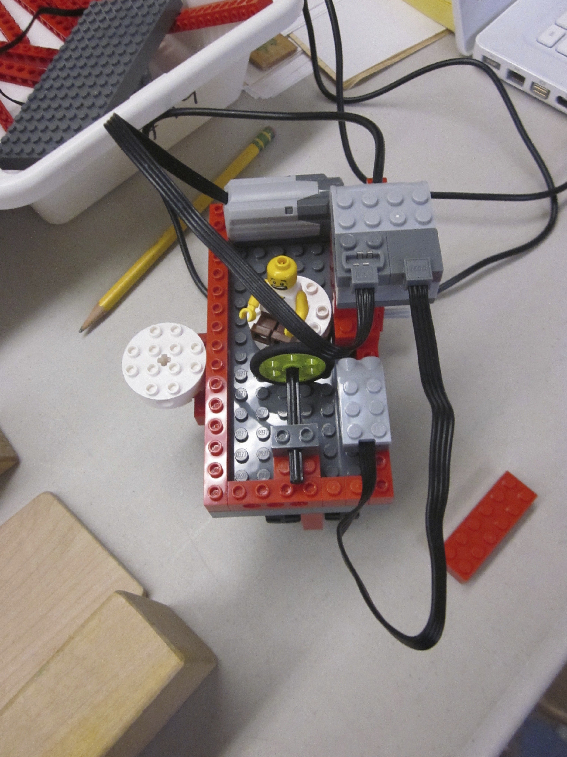
Figure 7. Second grade student finished car ride.
The sixth grade student had a lengthy initial period of considering different design ideas and researching the available parts to make each possible design. He finally settled on a Ferris wheel and proceeded to design a series of subsystems in turn. He first built a tower and base. The tower exhibited stability issues when he attached a motor on top of the tower so he rebuilt the tower base to be larger, which, in turn, made the tower more stable. He next built the rotating structure of the Ferris wheel and finally built the seats. He had difficulty building seats that stayed upright when the Ferris wheel was rotating. After trying a few solutions, time was exceeded and that final issue was left unsolved after it was analyzed and possible solutions discussed. He articulated concerns about stability, scale, and symmetry throughout the process. He frequently paused in his building and looked away from his design and researcher questioning determined that he was actively thinking about design choices and next steps.
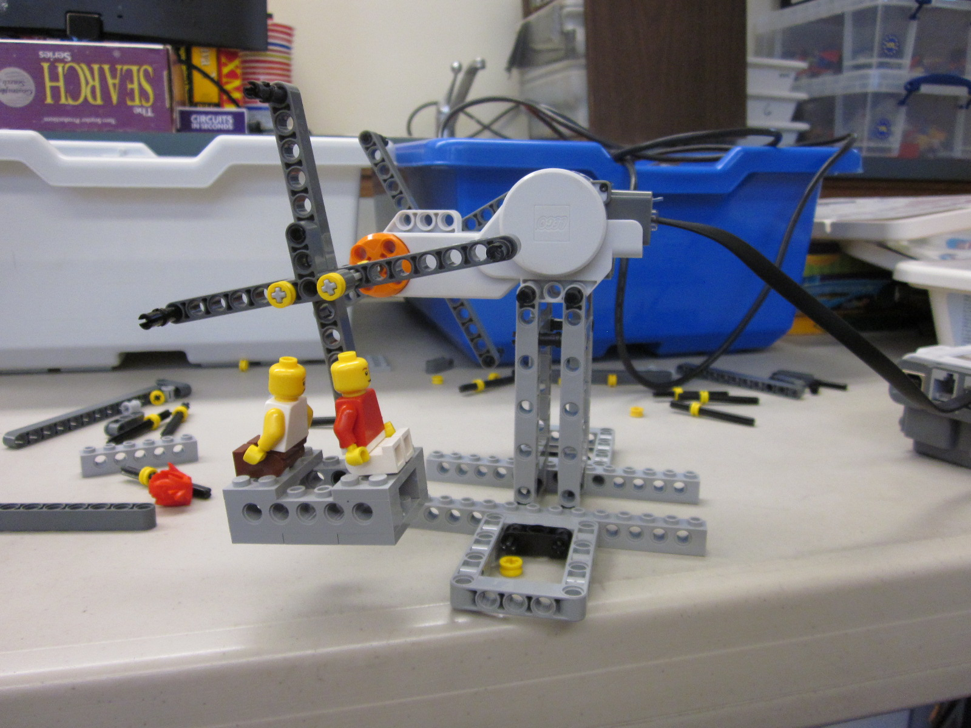
Figure 8. Six grader’s completed design.

Data Results

Graphs that show the main engineering design process codes are shown below.

Figure 9. Time in EDP Phase by Grade.

The grade 6 student spent much more time planning his design. He also researched his design by looking for appropriate parts. The second grade student did not do significant planning and did not do any discernable research. The second grade student spent more time building and evaluating his design.

Figure 10. Count of Engineering Design Process phases by grade.

The frequency of each EDP phase by grade level is shown above. The results are similar to the duration graph but the number of build and evaluation phases are more similar which indicates that the sixth grader has shorter build and evaluate phases.
The average duration of each main EDP phase is shown next. Durations were very similar with the exception of the build and evaluate phases, which tended to be longer for the second grader.

Figure 11. Average duration of engineering design process phases by grade.

Timelines of the main EDP phases are shown next. Note that due to the space limitations, the durations of each phase are not shown.

Figure 12. Engineering design process phase timeline for grade 6 student.

Figure 13. Engineering design process phase timeline for grade 2 student.

The timelines show the grade 6 student had more consistent planning throughout the project. He also had upfront planning time absent in the grade 2 student. The grade 2 student had very little discernable upfront planning. The sub-codes, shown next, reveal more detail about the EDP cycles each student exhibited.

Figure 14. Time in engineering design subcode phase by grade level.

Figure 15. Count of engineering design subcode phase by grade.

The primary result of the sub-code analysis is that the grade 2 student did considerably rebuilding and evaluating his design both physically and as a system. While the sub-codes provided more data on the engineering design process each student undertook, a set of emergent codes provided additional information on underlying processes and ideas.

Figure 16. Count of non-engineering design process codes by grade level.

The chart above reveals the following information.
- The sixth grader utilized mathematics and science much more in his design.
- The sixth grader was able to project out correctly design decisions and how they would manifest. Conversely, the second grade student had frequent issues with design decisions that had unanticipated consequences.
- The sixth grade student was concerned with and used symmetry and scale much more than the second grade student.
- The second grader used more self-talk, showed more affect, and talked to the robot directly more than the sixth grade student.
- Each student showed the ability to more a LEGO piece partly into place as a way to see if the part would work. I termed this action a semi-concrete operation. The second grader used this strategy more.
- Stability was much more of an issue for the second grade student.

Observational Qualitative Results

The data shown in the results section above characterizes the design processes of a second grader and sixth grader engaged in the same open-ended engineering challenge. This section starts with some general observations of each student and also makes comparisons of both students as they relate to different aspects of elementary robotics engineering. While an analysis and comparison of the engineering design process of both students with the aim of improving instruction was planned, other themes emerged as is typical with the use of an inductive, grounded theory coding method (Barron & Engle, 2007; Glaser & Strauss, 2009). These emergent themes are covered in this section: engineering design, affect, strategies, persistence in non-optimal design choices, methodology observations, causal reasoning in the context of engineering, and the scope of computer programming in elementary open-ended tasks.

Engineering Design

Design Concepts and Aesthetics

The sixth grader showed knowledge of stability, scale, and symmetry and he was also able to verbalize these concepts. For example, when building the “arms” of the Ferris Wheel, they were built symmetrically. He articulated this as follows.

[00:48:26] [PLAN] BOY 11: So now … [Tests in the air.] I just have to do it on the other side. [SYMMETRY]

He also explicitly states his concern that the ride be built to scale.

[00:31:27] BOY 11: Because I don’t want the actual [waves hands in a circular motion] ride part to be a lot smaller than like the support and everything. [SCALE]

BOY 11: It shouldn’t be a different scale.

The second grade student did not show concern with these key design concepts and usually built asymmetrically. For example, he put the USB hub on the side of his car rather than centered in the middle. Even though he later put a counter-balance on the other side of the car, it would not have been needed had the hub been initially balanced and stable.
In a related, less formal, long term, longitudinal case study I am undertaking, younger students in general have less concern and knowledge of adult design concepts and sensibilities. For example, multiple first grade students used tape to stabilize their designs, a notion that would be anathema to older LEGO builders.
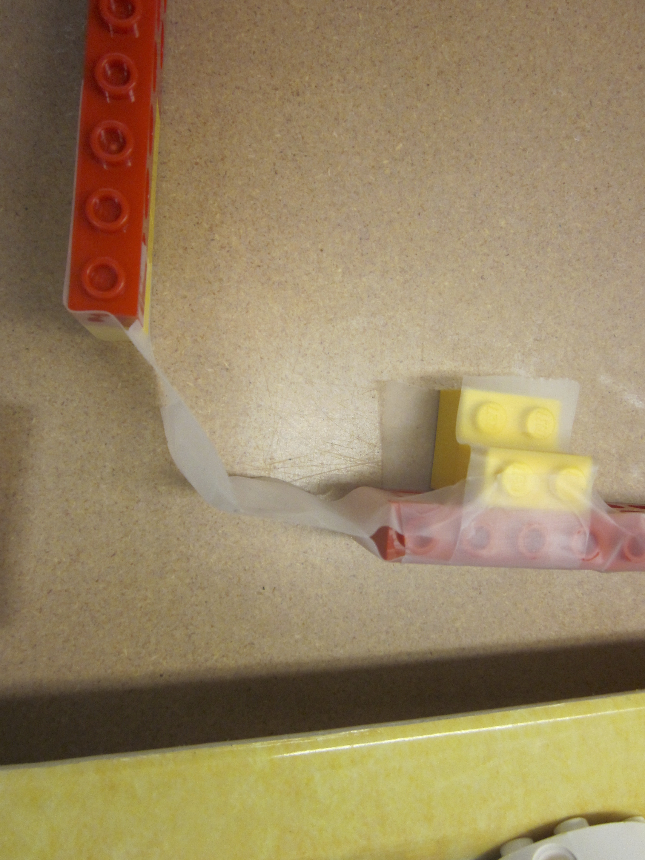
Figure 17. Use of Tape to Stabilize Design

Cycles, Subsystems, and Hierarchical Thinking

The grade six student had an overall idea of his design, built subsystems and successfully integrated them, and manifested smaller design cycles within each subsystem. As shown in Figure 3 - Grade 6 Recursive Design Cycles, the Ferris wheel consisted of three major subsystems: tower, wheel, and seats. The tower subsystem consisted of three minor subsystems: tower, motor, and base. And within each minor subsystem, the sixth grader manifested mini-EDP cycles to actually construct each minor subsystem. EDP cycles also manifested at the minor and major subsystem level and with the complete system. This appears to support neo-Piagetian notions of hierarchical thinking and the ability to integrate multiple dimensions of a task. For example, Young (2011) theorizes that as children move up in stages and levels within stages, they move from coordination of cognitive structures to hierarchization of structures to a systematization of of structures.

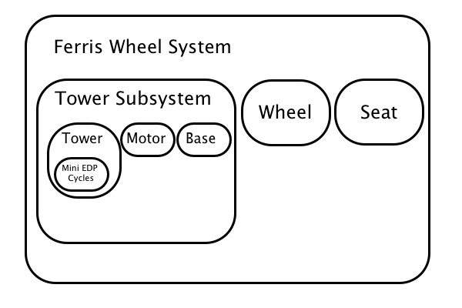
Figure 18 - Grade 6 Recursive Design Cycle Example
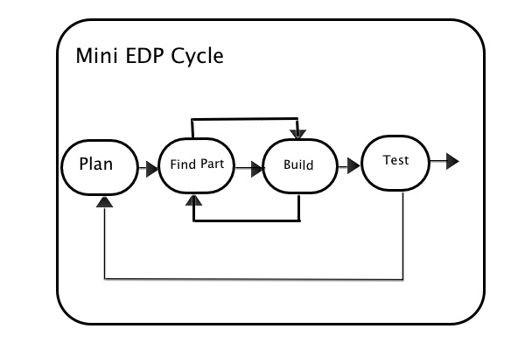
Figure 19 - MiniEDP Cycle
However, the second grade student built subsystems serially (Welch, 1999) without a discernable overall plan and had great difficulty integrating these subsystems (see Figure 5 - Second Grader Serial Design Approach). This indicates difficulty with mentally projecting out design decisions (causal inference) and with holding multiple dimensions of the design task in mind simultaneously. Decisions in one subsystem radically affected subsequent subsystems. For example, the use of short axles to make the car fit the test ramp caused a top-heavy design and many subsequent stability issues. What developmental processes can explain the differences between the second and sixth grade student?
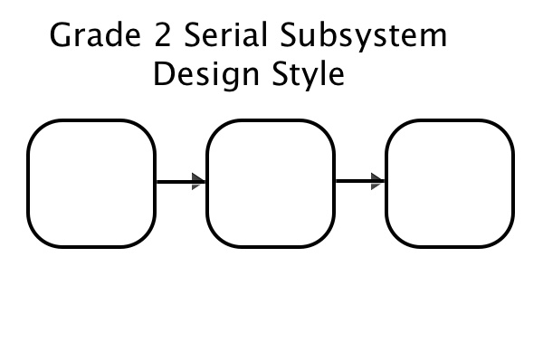
Figure 20 - Second Grader Serial Design Approach
Case (1991) is worth quoting in depth: At the first substage, children assemble new class of operations by coordinating two well-established executive structures that are already in their repertoire. As their working memory grows and as they practice these new operations, they enter a second substage in which they become capable of executing two such operations in sequence. Finally, with further growth and working memory, and with further practice, they enter a third substage in which they become capable of executing two or more operations of the new sort in parallel, and integrating the products of these operations into a coherent system. (p. 345)
Piaget’s defined centration as the tendency for preoperational (K-2) children to be able to only focus on one aspect of a problem at a time. In addition, Piaget defined a trial and error approach to problem solving as a characteristic of concrete operational (grade 2-5) children (Piaget & Inhelder, 1969). The combination of centration, trial-and-error, and Case’s substage model explain the serial approach seen in the second grade student. In contrast, the sixth student data showed an ability to use formal operations (grade 6 and up), a more systemic approach to problem solving, and decentering. Decentering is the ability to take oneself out of the center of consideration and look at situations more objectively (Piaget & Inhelder, 1969).
Keeping in mind the neo-Piagetian position that both development and instruction are needed for cognitive development (Young, 2011), the implication for elementary instruction is that teaching top-down engineering process models such as functional analysis (Cross, 2008), which break down a black box model of inputs and outputs into functional subsystems, may benefit students. It should be noted that a variety of engineering design process models are in use and that teachers should not unthinkingly insist that all students follow the same engineering design process model. The ability to envision, built, and integrate subsystems can also be seen as systems thinking (Sullivan, 2008).

Tinkering

The second grader had a sequence of activity at 00:11:22 that consisted of a combination of plan, build, and evaluate phases in rapid order. This micro-cycle can be thought of as tinkering (Resnick & Rosenbaum, 2013). The whole process with LEGO building at a more macro level could also be considered tinkering. There are some unique affordances to LEGO robotics in that very quick cycles of plan, build, and evaluate are easily done and may encourage a tinkering style. This micro tinkering cycle was an example where distinct phases of the EDP are hard to discern. This will be discussed in depth later in the paper.

Concrete Evaluation

The second grade student was capable of figuring out problems after he tested, found a functional problem, and then concretely traced flows in his design.
[00:40:57] STUDENT: OH! There needs to be something in here [points to space between motor and wheels. [He traces the energy route physically.]

The same phenomenon was seen when he discovered that the motor was not running because it was not plugged in.
[00:34:08] RESEARCHER: I mean up here, in your program. Which block up here makes your car go?

[00:33:24] STUDENT: Well, this one is supposed to make the motor turn and then it’s supposed to go down here.

[00:34:27] STUDENT: I think I am forgetting something right here.

RESEARCHER: Ah! What do you think you forgot?

[Student traces wires and realizes problem.]

Note that the researcher’s question caused the student to trace the wires, which led him to understand the problem. This is an important moment that shows how a simple question of asking the student what is going on causes a concrete operation to check the working of the complete system. This teacher scaffolding supported the development of the students’ causal reasoning, specifically the type of inference used in troubleshooting, which can lead to increased prediction of the design performance so less troubleshooting is needed.
The same phenomenon was also seen when the second grade student got the motor running but his car would not move because there was no drive train or direct coupling between the motor and the wheel. By visual inspection, he eventually figured out the problem and could articulate it.

[01:01:59] STUDENT: Because umm if … if this falls off … if the motor is up here and the wheel is down here, it… motor is down here, with no gear, the motor is just running. And if the motor is just running, that means … it doesn’t do anything to the wheel. So that's why … so if I put a wheel on … if I put an axle … some gears in, … and then it will just start going until it will hits this [the end block].

The sixth grader, in contrast, clearly show periods of evaluative thinking without any physical, concrete activity. This is consistent both in terms of the children’s age and behavior with the concrete operation and formal operation stages defined by Piaget (Piaget & Inhelder, 1969).
The second grader had many instances (n=7) and the sixth grade had a few instances (n=2) of what I call a semi-concrete method of testing where they move a part towards its possible location without actually fully positioning it. This could be a precursor to more formal operation of projecting mentally.

Planning and Research

The sixth grader did much more time planning (n=39) than the second grader (n=10). The grade 6 subject had a long period of considering different ideas and researching parts before deciding on a buildable idea and starting in earnest. The grade 2 subject started building his initial idea much earlier, which subsequently had numerous design obstacles that were inherent in the initial idea. He actually built the test track first which later constrained his design. While there were few discernable planning phases for the second grader, when asked, he could articulate a plan. The grade 6 subject said he would do more planning (such as drawings) if he had to do the project again. This finding is consistent with formal operation and concrete operational stages of Piaget (Piaget & Inhelder, 1969) though Portsmore (2011) did find the students can do some planning with familiar materials and well-defined tasks as early as first grade. It is likely that in the context of more general, open-ended challenges that the additional cognitive load of transferring knowledge to the new situation results in cognitive skills more in line with predicted ages.

Other Emergent Themes

Persistence in Non-Optimal Design Choices

One very significant difference between the second (n=21) and sixth grade (n=0) students was seen in the second graders persistence and determination to try and fix non-optimal design choices without reconsidering the design choice and taking a different approach. The same phenomenon was observed in the larger (n=8) longitudinal case study, which focused on second graders this year. Examples of this are:
- Trying to connect two axles by putting them both inside the wheel instead of using a longer axle (pilot study),
- Keeping the hub on the side, rather than the top, of the car, attaching it underneath, and using a counterweight to balance the hub (pilot study),
- Persisting with a top heavy, unstable car design (pilot study),
- Persisting with a gear-based rather than a pulley based design with non-optimal placement of the motor (pilot study),
- Building a large roof with plates only attached on one side (longitudinal study),
- Not attaching, connecting, or positioning motors (pilot study, longitudinal study).
Second grade students did not show signs of being bothered by the constant need to fix these problems and would happily persist in fixing them, in some cases successfully (if not optimally). See Figure 5 - Non-optimal Design Choice - Roof Example. Centration, irreversibility, and the related ego-centrism could also explain the persistence of second graders in following non-optimal design choices and their inability to start over. Without formal operations, without the ability to keep multiple dimensions of the problem in mind at the same time, i.e., centration, (Piaget & Inhelder, 1969; Young, 2011), and with the increased ego-centrism of younger children, students persist in their non-optimal design choices and are not even aware of other options such as redesign. Irreversibility suggests that students may not realize that their design can be taken apart and reassembled. There was no evidence to suggest that these non-optimal persistence states were productive for the student. Teacher scaffolding was needed to help students overcome these “stuck” states. However, the persistence is a important strength needed in the engineering process at any age.
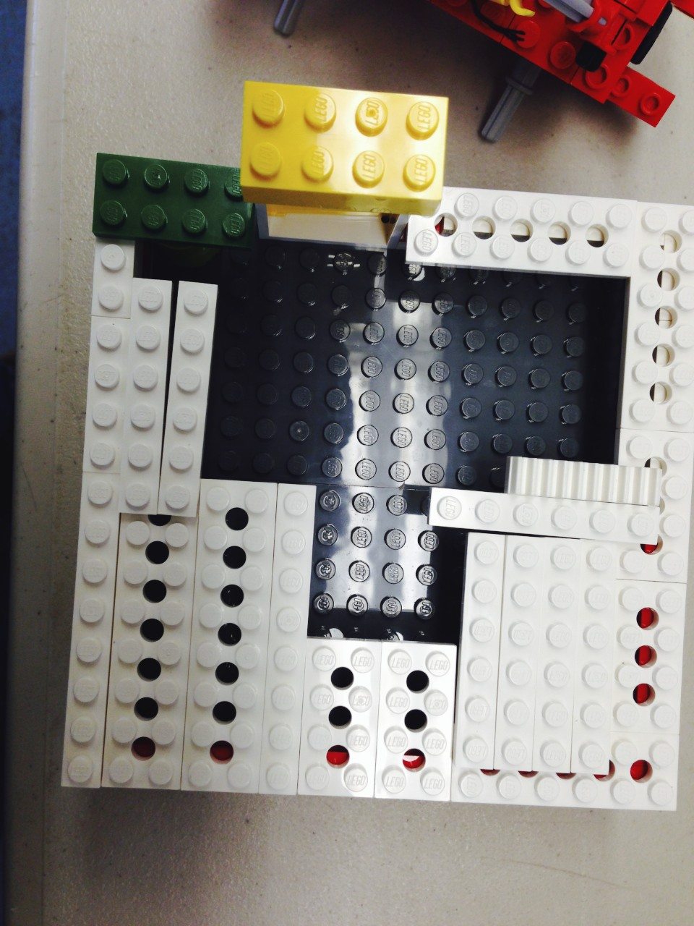
Figure 21 - Non-optimal Design Choice - Roof Example

Projection/Cause and Effect

Second graders have difficulty mentally projecting the effects of their design choices and will perseverate in those choices in spite of evidence that the choice was not optimal. The sixth grader could project correctly the consequences of design choices, which is likely to be the result of emergent formal operations, specifically causal reasoning. See the table below for data to support these claims.

Code | Grade 2 | Grade 6
Persist in non-optimal design choices | 21 | 0
Correct Projection | 15 | 44
Experienced major unanticipated consequences of design choices | 8 | 0
Table 2. Projection Data by Grade
The grade 6 subject showed cause and effect projection as he did his initial planning and research cycles. There were a series of these cycles that occurred in rapid succession. He abandoned his first idea after he determined that he did not have the parts to build it. When he settled on the Ferris wheel idea, he had an overall plan in mind (this was verified in post project interview). Here is one example of the sixth grade student articulating his ability to project out design decisions when he figured out (without testing) that his seat would not work as intended because it was rigidly attached.
[01:08:19] But there is a problem though … because they can’t spin so they will be going upside down.

Likewise, when his original tower base was unstable, he can state the problem and potential solution.

[00:22:31] I think I might need to develop a more support for this.

The second grader rebuilt when new parts were noticed. The sixth grader did less of this. The second grader had examples of projection too but they were more basic than the sixth grader. For example, while the sixth grader predicted problems with his complete seat design, the second grader’s predictions were typically about things such as if the car would hit the side of the ramp with the part he just selected.
Inconsistency and failure spurs thinking about causality and creating causal explanations (Legare, Gelman, & Wellman, 2010). Teacher questions also initiated a concrete tracing of cause and effect, which can contribute to causal reasoning, an important skill for science and engineering. These factors suggest that engineering education has the potential to be a rich affordance for the development of causal reasoning.

Instruction

This pilot study and the longitudinal case study reveal some important implications for the elementary engineering curriculum and instruction. Second grade students improve in building complexity over time and, with one exception, no longer used Scotch tape to help stabilize their designs. However, they still have some common issues that would benefit from explicit instructions especially around stability, which is a key issue for first and second graders. Examples include: supporting plates on both sides, constructing solid bases, and the common LEGO technique of interleaving beams when constructing house walls.
Asking neutral questions caused the second grade student to plan and evaluate, which shows the value of asking questions about what students are doing. This self-monitoring was already internalized by the grade six student, who did not need such prompting.
Other recommendations for teaching resulting from this study are listed below.
- Show examples of and have students do system/subsystem block diagrams to encourage planning of subsystems and subsystem integration, especially at the grade 4 to 6.
- Second graders need help and encouragement in exploring alternative design ideas and starting over when designs are not working well. Their tendency to persist in fixing non-optimal design choices can preclude important and needed learning. Teachers can provide scaffolding and direct instruction to help second graders move past these “sticking points”.
- Second graders need scaffolding in the form of teacher questioning in anticipating the results of design decisions.
- Stability, symmetry, balance, scale, and center of gravity are other key design and science concepts that manifest in different ways and that need explanation and modeling.
- There seems to be key building strategies that need to be taught with LEGO blocks in particular.
  - Teach the function key connector pieces such as the green round brick with the cross in the middle (brick, 2x2, round) for LEGO WeDo.
  - Teach the concept of connecting crosses to crosses to make an axle move a piece.
  - Make sure motors are connected to an energy source.
  - Make sure motors connect through a drive train (gears, pulleys, or directly coupled).
In summary, the detailed qualitative, developmental analysis of student’s building at two different ages provided useful insights that inform curriculum and instruction of elementary engineering. Next, I share insights concerning the research itself.

Research Protocol

There were several cases (see Appendix D - Second Grade Transcript at 5:00 for an example) where the think-aloud protocol caused simultaneous EDP phases to occur. For example, the researcher question asking about the second grader’s plan stimulated a planning discussion while building was going on simultaneously. Also, judgment was required at certain times to specify the codes. For example, I ended up defining as RESEARCH instances of students looking at parts to see if their idea could be built. But the normal looking for parts to build an existing idea did not count as RESEARCH. Another example is that of the grade 6 subject who seemed to be constantly evaluating his design. Furthermore, the verbal activity and physical activity can be seen as two parallel “tracks” that are typically in synch but can also be out of synch. For example, the student could be talking about a plan and building at the same time.
There was no discernable planning phase for the second grader in many cases though it could be inferred that one took place. An example is shown below.
[00:10:40] [EVALUATE-PHYSICAL] [After building 2 wheels and axle sets, tests them at the same time using both hands.]

[00:10:45] [BUILD-NORMAL] [Gets out base plate. Adds long beam to side of base plate.] [There was no discernable planning phase here though he did seem to have a plan.]

In summary, the combination of the think-aloud protocol and observation of the building did provide enough information to do a consistent coding. However, it is not perfect and slightly different interpretations of the verbal and physical activity are certainly possible.
Also worth noting was the fact that second grade students made different designs when they did not have teacher specified requirements. For example, many first and second grade students do not use the computer to animate their designs. In general, students make different choices in clinical setting than classroom setting. This is likely due to a lack of internalization and comfort with the technology at that particular point in time.

Programming

Programming does not seem to play a key role in elementary open-ended design challenges. The grade 6 student spent less than 8% of his time programming and the grade 2 student spent less than 3% of their time programming. Also, four out of ten second graders, when given the choice, still do not animate their rides with the computer. This percentage has increased in the longitudinal study as children age and hence get more comfortable with programming.
In terms of causality, programming is all mental projection (an aspect of causal reasoning) since the programmer does not know what the program will actually do until it is tested. This could be why programming is generally seen as more difficult for young students.

Affect
The second grade student showed somewhat more affect (n=35) than the sixth grade student (n=22). Some of the affect for both students was sighs and frowns. However, both students showed positive affect and also verbally reported positive feelings about the activity in the post-interview. The activity was satisfying for both students, perhaps because they overcame difficult problems with their own creative solutions. The second grader student reflects on his experience.
[01:16:11] STUDENT: The frustrating part was getting the frame to be on here because it kept on falling down. But the easy part was just building … building … the wheels and the frame. I actually just used my imagination, my imagination …

The sixth grade student had a similar comment.
BOY 11: Yeah. That was helpful and that made it a lot easier. And it was hard because I had to keep switching things around and stuff was falling off and there weren’t always easy solutions like how it was balancing. Because it was my invention and not something already set up - basically.

In the quotes, both stressed the importance to them of the open-ended nature of the experience.

Strategies

Both students changed their viewing angle to help them troubleshoot their designs (G6, n=7, G2 n=4). Both students fully or partly moved parts into place as a strategy. The partial movement implies a move towards less concrete and more abstract thinking as the student can mentally project if the part will work or not (G6 n=5, G2 n=7). Both students showed knowledge of troubleshooting techniques such as lifting a car (G2), checking software connection information (G2), checking connections (G2), reversing motor direction (G2), and checking for power (G6). The grade 6 student got out parts he projected to be needed ahead of time, showing the ability to mentally project out needs. In general, the second grader used more of a trial and error (as opposed to a systemic) approach to problem solving as predicted by Piaget for concrete operational students (grades 2-5) (Piaget & Inhelder, 1969). This suggest that elementary engineering is a rich and motivating domain to teach a more systemic approach to trouble shooting such as control of variables, that is, changing only one parameter at a time when testing (Kuhn, 2007).

Strengths

Two codes helped identify student strengths at different ages. The problem solving code was used to identify the solution of major problems. The strategies code was used to mark troubleshooting and other strategies students used. The coding data, in combination of direct observation, identified the strengths of each student as follows.
The grade 2 student showed a real strength in problem-solving difficult issues in creative ways, even if the solutions were not as optimal as older students or adults would have produced. For example, the use of a counter-balance to offset the side mounting of the USB hub was very clever and did work. Second grade students were also happily persistent in solving problems. The sixth grade student showed an internalization of the robotics curriculum he had learned in previous grades. For example, he used a descriptive filename for his program and internalized a sophisticated, hierarchical, and very successful design process. He also was successful at projecting out the consequences of his design decisions. He used adult design notions and sensibilities such as symmetry and scale as well as mathematics and science to realize his design idea.

Discussion

General Conclusions

This pilot study has described a theoretical framework, an engineering design process model, and a methodology for a larger developmental, cognitive, cross-sectional, microgenetic, case study of elementary engineering with the long term goal of informing the elementary engineering curriculum and instruction. The engineering design processes of a second grader and a sixth grader were characterized in detail. The sixth grade student used up-front planning and research before starting the open-ended engineering task. Furthermore, the sixth grader used a hierarchical design process that included an overall plan and nested plans for subsystems and subsystem components. In contrast, the second grade student did not have an overall plan but built subsystems serially and hence had difficulties connecting the subsystems later. Second graders tended to persist in non-optimal design choices rather than “going back to the drawing board.” However, the second grader could troubleshoot and fix (non-optimally) problems after using concrete techniques to identify design problems while the sixth grader had much greater capacity to mentally project out problems in advance. These results are consistent with Piagetian and neo-Piagetian theories that specify that second graders are concrete, can not evaluate systemically, focus on one aspect of a problem at a time, and lack formal operations that would allow more casual reasoning, specifically prediction.
Through the lens of the Informed Design Teaching and Learning Matrix (Crismond & Adams, 2012), the second grade student would be rated as novice designer while the sixth grade student showed many characteristics of an informed designer. For example, in terms of research, novice designers “Skip doing research and instead pose or build solutions immediately” while expert designers “Do investigations and research to learn about the problem, how the system works, relevant cases, and prior solutions” (Crismond & Adams, 2012, p. 748). While the Matrix provides general advice on teaching strategies (for research, an example is “Reverse engineer existing products”), elementary teachers need age specific advice and an understanding of underlying cognitive mechanisms. Table 3 below shows how base cognitive skills manifested in each student in terms of specific composite cognitive skills (such as causal reasoning) or in a general sense. Each base skill is marked as - (the skill or lack thereof hindered the student), +/- (the skill showed both positive and negative aspects), or + (the skill was a benefit to the student’s engineering process and outcome. The table shows that the expert grade 6 student formal operations base skills were a real asset in his building. The second grade student’s preoperational skills hindered him although his emerging concrete operational skills were an asset, in general.
Grade Level | Composite  Cognitive  Skills | Egocentric | Primitive Reasoning | Unaware of how they got knowledge | Centration | Irreversibility | Solve problem logically with concrete objects | Inductive reasoning | Trial and error problem solving | Seriation | Concrete Operations (general) | Conservation | Transitivity | Reversibility | Classification | Decentering | Logical/systemic problem solving | Deductive reasoning | Abstract thought | Metacognition | Apply Math and Science | Design Concepts | Engineering Design Concepts
2 | Casual Reasoning | - |  |  | - | - | + | + | - |  | +
 | Planning (lack of) | - |  |  | - |  |  |  |  | -
 | Troubleshooting persistence (non-optimal) | - |  |  | - | - |  |  | - |  | +
 | General |  |  |  | - | - | + | + | + |  | + |  |  |  |  |  |  |  |  |  | +/- | +/- | +
6 | Causal Reasoning |  |  |  |  |  |  | + | - |  | + |  |  |  |  | + | + | + | + |  | +
 | Planning |  |  |  |  |  |  |  |  | + |  |  |  |  |  |  |  | + | + |  |  |  | +
 | Troubleshooting Persistence (optimal) |  |  |  |  |  |  |  |  |  | + |  |  | + |  | + | + |  | + | + |  |  | +
 | General |  |  |  |  |  |  | + |  |  | + |  |  |  |  |  | + | + | + | + | + | + | +/-

Table 3. Summary of cognitive skills manifested by grade 2 and grade 6 students.

Piagetian and neo-Piagetian theory informs us that novice designers of a certain age may not yet be fully capable of being informed designers due to the lack of required cognitive skills, in this case, causal reasoning and formal operations, without appropriate instruction and learning experiences. This suggest that second graders may benefit from curriculum and instruction focused on causal reasoning, openness to redesign, systemic troubleshooting techniques, and general design principles such as stability and symmetry used by the grade six student. The sixth grade student identified a retrospective desire to engage in more formal planning. Formal engineering analysis techniques such as functional analysis (Cross, 2008) could be indicated for sixth graders.

Limitations of Study

The small sample size of one typically developing, second grade boy and one advanced, sixth grade boy is an obvious limitation of the pilot study. The proposed larger study includes two students at grade K, 2, 4, and 6 and would be balanced for gender and level. The possibility also exists that the differences in materials may influence some of the strategies and processes used by students. These effects do not appear significant. However, a larger study is needed to sort out the differences between levels, ages, and materials. Also, both genders need to be represented.

Future Research
This study raises some additional questions for future research.
- How much scaffolding (if any) is helpful to younger students graders get them to anticipate the results of their design decisions? Is trial and error better than scaffolding?
- Some studies such (Legare et al., 2010; Portsmore, 2011) indicate that more advanced operations can be done earlier than predicted by Piagetian theory. These studies used very constrained and well-defined situations. The pilot study, which used open-ended challenges, showed results more in line with Piagetian theory. How does the structure of experiment itself affect our conclusions about development?
- If causal reasoning is key to the process of engineering especially with young students, can a developmental progression be defined as well as instructional strategies to help develop causal reasoning in the domain of elementary engineering?
- Can an overall, developmental, learning progression for engineering education be defined? Can table 3 above be expanded to different age groups (K and 4) and verified with more data? What differences can be seen between expert and normally developing students at each age?
- Should the larger, follow-on study look at more specific questions or continue to generalize characterize and analyze emergent themes across a broader range of subjects?
- How was this clinical experience, in and of itself, an important learning experience for students even without any direct teaching?
- How do grade six students transition from novice designers to informed designers in four years (assuming a broader pattern) in the context of elementary engineering curriculum? How much of this gain is developmental, how much is instruction and experience, and how much is innate capability?

Conclusion

This qualitative, cross-sectional, case study has characterized the elementary engineering process at two separate ages, grades 2 and 6, in terms of engineering design process models, and other emergent processes, skills, and strategies. Further research is needed to characterize the engineering process for a broader range of grades, knowledge and skill level, and gender. This work has the potential to define a learning progression for elementary engineering that would inform curriculum and instruction. With the advent of NGSS (“Next Generation Science Standards,” 2012) and its use of engineering to teach science and the general need to increase the STEM pipeline (Brophy et al., 2008), the research is both needed and timely.

References

Alimisis, D. (2013). Educational robotics: Open questions and new challenges. Themes in Science and Technology Education, 6(1), pp–63.
Barron, B., & Engle, R. (2007). Analyzing data derived from video records. Guidelines for Video Research in Education: Recommendations from an Expert Panel, 24–43.
Baynes, K. (1994). Designerly play. Loughborough: Loughborough University of Technology, Department of Design and Technology.
Bers, M. (2008). Blocks to robots: learning with technology in the early childhood classroom. Teachers College Press.
Bers, M., Flannery, L., Kazakoff, E., & Sullivan, A. (2014). Computational thinking and tinkering: Exploration of an early childhood robotics curriculum. Computers & Education, 72, 145–157. doi:10.1016/j.compedu.2013.10.020
Bidell, T. R., & Fischer, K. W. (1992). Cognitive development in educational contexts. In A. Demetriou, A. Efklides, & M. Shayer (Eds.), Neo-Piagetian theories of cognitive development: Implications and applications for education (pp. 11–30). New York, New York: Routledge.
Brenner, M. E. (2006). Interviewing in educational research. In Handbook of complementary methods in education research (pp. 357–370).
Brophy, S., Portsmore, M., Klein, S., & Rogers, C. (2008). Advancing Engineering Education in P-12 Classrooms. Journal of Engineering Education, 97(3).
Case, R. (1991). The mind’s staircase: Exploring the conceptual underpinnings of children’s thought and knowledge. Psychology Press.
Chinn, C. A. (2006). The microgenetic method: Current work and extensions to classroom research. In Handbook of complementary methods in education research (pp. 439–456).
Crismond, D. (2001). Learning and using science ideas when doing investigate-and-redesign tasks: A study of naive, novice, and expert designers doing constrained and scaffolded design work. Journal of Research in Science Teaching, 38(7), 791–820.
Crismond, D., & Adams, R. S. (2012). The informed design teaching and learning matrix. Journal of Engineering Education, 101(4), 738–797.
Cross, N. (2008). Engineering design methods: strategies for product design (4th ed.). West Sussex, England: John Wiley and Sons.
Demetriou, A., Gustafsson, J.-E., Efklides, A., & Platsidou, M. (1992). Structural systems in developing cognition, science, and education. In A. Demetriou, A. Efklides, & M. Shayer (Eds.), Neo-Piagetian theories of cognitive development: Implications and applications for education (pp. 79–103). New York, New York: Routledge.
English, L. D., Hudson, P., & Dawes, L. (2013). Engineering-Based Problem Solving in the Middle School: Design and Construction with Simple Machines. Journal of Pre-College Engineering Education, 3(2). Retrieved from http://search.ebscohost.com/login.aspx?direct=true&profile=ehost&scope=site&authtype=crawler&jrnl=21579288&AN=92609426&h=ht05k9am%2Ftl2QOU10jBAcagHyYxbrbL5QLpZyclHMmSLkzUB%2FYLBo6kmakVxYabX12tvjZ1iZfSRTKmxqBdJxg%3D%3D&crl=c
Erickson, F. (2006). Definition and analysis of data from videotape: Some research procedures and their rationales. In Handbook of complementary methods in education research (pp. 177–192).
Ericsson, K. A., & Simon, H. A. (1993). Protocol Analysis: Verbal Reports as Data. Cambridge, MA: MIT Press.
Ernst, J. V., & Bottomley, L. (2011). AC 2011-227: ELEMENTARY ENGINEERING IMPLEMENTATION AND STUDENT LEARNING OUTCOMES. Retrieved from http://www.asee.org/file_server/papers/attachment/file/0001/0688/NIH_Paper_3_10_11.pdf
Fleer, M. (1999). The science of technology: Young children working technologically. International Journal of Technology and Design Education, 9(3), 269–291.
Fortus, D., Krajcik, J., Dershimer, R. C., Marx, R. W., & Mamlok-Naaman, R. (2005). Design‐based science and real‐world problem‐solving. International Journal of Science Education, 27(7), 855–879. doi:10.1080/09500690500038165
Fuson, K. (1976). Piagetian Stages in Causality: Children’s Answers to“ Why?.” The Elementary School Journal, 150–158.
Ginsburg, H. (1997). Entering the child’s mind: The clinical interview in psychological research and practice. Cambridge University Press.
Glaser, B. G., & Strauss, A. L. (2009). The discovery of grounded theory: Strategies for qualitative research. Transaction Publishers.
Gura, M. (2011). Getting Started with LEGO Robotics: A Guide for K-12 Educators [Paperback]. Eugene, OR: ISTE.
Heffernan, J. (2013). Elementary Engineering: Sustaining the Natural Engineering Instincts of Children. Charlestown, SC: Printed by CreateSpace.
Hynes, M. (2007). AC 2007-1684: IMPACT OF TEACHING ENGINEERING CONCEPTS THROUGH CREATING LEGO-BASED ASSISTIVE DEVICES. Presented at the American Society for Engineering Education Annual Conference & Exposition, Honolulu,HI: American Society for Engineering Education. Retrieved from http://icee.usm.edu/ICEE/conferences/asee2007/papers/1684_IMPACT_OF_TEACHING_ENGINEERING_CONCEPTS_.pdf
Jonassen, D. H., & Ionas, I. G. (2008). Designing effective supports for causal reasoning. Educational Technology Research and Development, 56(3), 287–308.
Kolodner, J. L., Camp, P. J., Crismond, D., Fasse, B., Gray, J., & Holbrook, J. (2003). Problem-based learning meets case-based reasoning in the middle-school science classroom: Putting Learning by Design (TM) into practice. Journal of the Learning Sciences, 12(4), 495–547.
Krajcik, J. (2011). Learning Progressions Provide Road Maps for the Development and Validity of Assessments and Curriculum Materials. Measurement: Interdisciplinary Research & Perspective, 9(2-3), 155–158. doi:10.1080/15366367.2011.603617
Kuhn, D. (2007). Reasoning about multiple variables: Control of variables is not the only challenge. Science Education, 91(5), 710–726. doi:10.1002/sce.20214
Kuhn, D., & Dean, D., Jr. (2004). Connecting Scientific Reasoning and Causal Reasoning. Journal of Cognition and Development, 5(2), 261–288.
Legare, C. H., Gelman, S. A., & Wellman, H. M. (2010). Inconsistency with prior knowledge triggers children’s causal explanatory reasoning. Child Development, 81(3), 929–944.
Leonard, M. J., & Derry, S. J. (2011). “What’s the Science Behind It?” The Interaction of Engineering and Science Goals, Knowledge, and Practices in a Design-Based Science Activity. Retrieved from http://widaredesign.wceruw.org/publications/workingPapers/Working_Paper_No_2011_05.pdf
Levy, S. T., & Mioduser, D. (2010). Approaching Complexity Through Planful Play: Kindergarten Children’s Strategies in Constructing an Autonomous Robot’s Behavior. International Journal of Computers for Mathematical Learning, 15(1), 21–43. doi:10.1007/s10758-010-9159-5
Martinez, S. L., & Stager, G. (2013). Invent To Learn: Making, Tinkering, and Engineering in the Classroom. Constructing Modern Knowledge Press.
McRobbie, C. J., Stein, S. J., & Ginns, I. (2001). Exploring designerly thinking of students as novice designers. Research in Science Education, 31(1), 91–116.
Mehalik, M. M., Doplet, Y., & Schunn, C. D. (2008). Middle-school science through design-based learning versus scripted inquiry: Better overall science concept learning and equity gap reduction. Journal of Engineering Education, 97(1), 75=81.
Mioduser, D., Levy, S. T., & Talis, V. (2007). Episodes to scripts to rules: concrete-abstractions in kindergarten children’s explanations of a robot’s behavior. International Journal of Technology and Design Education, 19(1), 15–36. doi:10.1007/s10798-007-9040-6
Next Generation Science Standards. (2012). Retrieved November 2, 2012, from http://www.nextgenscience.org/
Outterside, Y. (1993). The emergence of design ability: The early years. Retrieved from https://dspace.lboro.ac.uk/dspace/handle/2134/1574
Papert, S. (1993). Mindstorms: Children, Computers, And Powerful Ideas (2nd ed.). Basic Books.
Papert, S. (2000). What’s the big idea? Toward a pedagogy of idea power. IBM Systems Journal, 39(3.4), 720–729.
Penner, D. E., Giles, N. D., Lehrer, R., & Schauble, L. (1997). Building functional models: Designing an elbow. Journal of Research in Science Teaching, 34(2), 125–143.
Piaget, J., & Inhelder, B. (1969). The psychology of the child. Basic Books.
Portsmore, M. (2011). Scaffolding the Engineering Design Process for Elementary Students.
Portsmore, M. D. (2011). AC 2011-1780: FIRST GRADE STUDENTS PLANNING AND ARTIFACT CONSTRUCTION WHILE WORKING ON AN ENGINEERING DESIGN PROBLEM. Presented at the ASEE Annual Conference, Vancouver, BC, Canada. Retrieved from http://jee.asee.org/file_server/papers/attachment/file/0001/1710/Draft_Portsmore_ASEE2011v2.pdf
Puntambekar, S., & Kolodner, J. L. (2005). Distributed Scaffolding: Helping Students Learn Science from Design. Journal of Research in Science Teaching`, 42(2), 185–217.
Resnick, M. (2007). All I really need to know (about creative thinking) I learned (by studying how children learn) in kindergarten. In Proceedings of the 6th ACM SIGCHI conference on Creativity & cognition (pp. 1–6). ACM. Retrieved from http://dl.acm.org/citation.cfm?id=1254961
Resnick, M., & Rosenbaum, E. (2013). Designing for Tinkerability. In M. Honey & D. Kantor (Eds.), Design, Make, Play: Growing the Next Generation of STEM Innovators (pp. 163–181). Routledge. Retrieved from http://llk.media.mit.edu/courses/readings/DesignMakePlay-Ch10.pdf
Roden, C. (1997). Young children’s problem-solving in design and technology: towards a taxonomy of strategies. Journal of Design & Technology Education, 2(1). Retrieved from https://jil.lboro.ac.uk/ojs/index.php/JDTE/article/view/375
Roden, C. (1999). How children’s problem solving strategies develop at Key Stage 1. Journal of Design & Technology Education, 4(1). Retrieved from http://ojs.lboro.ac.uk/ojs/index.php/JDTE/article/view/404
Roth, W.-M. (1996). Art and Artifact of Children’s Designing: A Situated Cognition Perspective. Journal of the Learning Sciences, 5(2), 129–166.
Siegler, R. S., & Crowley, K. (1991). The microgenetic method: A direct means for studying cognitive development. American Psychologist, 46(6), 606.
Sullivan, F. R. (2008). Robotics and science literacy: Thinking skills, science process skills and systems understanding. Journal of Research in Science Teaching, 45(3), 373–394. doi:10.1002/tea.20238
Sullivan, F. R. (2011). Serious and playful inquiry: Epistemological aspects of collaborative creativity. Educational Technology & Society, 14(1), 55–65.
Suomala, J., & Alajaaski, J. (2002). Pupils’ Problem-Solving Processes In A Complex Computerized Learning Environment. Journal of Educational Computing Research, 26(2), 155–176. doi:10.2190/58XD-NMFK-DL5V-0B6N
The Partnership for 21st Century Skills. (2002). Framework for 21st Century Learning. Retrieved November 3, 2012, from http://www.p21.org/index.php
Turkle, S., & Papert, S. (1991). Epistemological pluralism and the revaluation of the concrete. In I. Harel & S. Papert (Eds.), Constructionism (pp. 161–192). Ablex Publishing Corporation. Retrieved from http://kvantti.kapsi.fi/Documents/Turkle%20Papert%20-%20Epistemological%20Pluralism%20and%20the%20Revaluation%20of%20the%20Concrete%20-%201992.pdf
Vygotsky, L. (1978). Mind in Society: The Development of Higher Order Psychological Processes. In Mind in Society: The Development of Higher Order Psychological Processes.
Wagner, S. P. (1999). Robotics and Children Science Achievement and Problem Solving. Journal of Computing in Childhood Education, 9(2), 149–192.
Welch, M. (1999). Analyzing the Tacit Strategies of Novice Designers. Research in Science & Technological Education, 17(1), 19–33.
Wendell, K. B., & Lee, H. S. (2010). Elementary students’ learning of materials science practices through instruction based on engineering design tasks. Journal of Science Education and Technology, 19(6), 580–601.
Young, G. (2011). Development and causality: Neo-Piagetian perspectives. New York, New York: Springer.
Zhao, Y. (2012). World class learners: Educating creative and entrepreneurial students. SAGE.

Appendix A - Code Book

Engineering Design Process Codes

PLAN - subject was planning some aspect of their design, typically verbally.
BUILD-NORMAL - normal building, includes looking for parts unless the looking for parts as researching the feasibility of a potential design.
BUILD-REBUILD - rebuilding (fixing) something that built previously. This includes building it in a different way as well as reattaching a subsystem that fell off, for example.
EVALUATE-PHYSICAL - evaluate by testing physically.
EVALUATE-VERBAL - evaluate without any physical test by talking.
EVALUATE-VISUAL - evaluate by looking without touching or talking.
EVALUATE-SYSTEM - evaluate the whole system including program by running the program.
PROGRAM-NORMAL - Programming the robot.
PROGRAM-REPROGRAM - Fixing a previous program.
RESEARCH - researching a problem or possible solution. Looking for parts can be considering research if it is affecting major design decisions before building starts. Otherwise, consider it part of building.
WAIT - waiting for researcher. This is just a placeholder so that this time is not counted in any analysis. This was used when the researcher paused the student to take a photograph, for example.

Other Codes

AFFECT - subject showed emotion, negative or positive. Includes sighs, frowns, laughs, and smiles.
ASYMMETRY - Subject builds asymmetrically, notices, or has problems with asymmetry in their design.
CONNECTION - subject has trouble connecting parts, usually seen in parts that move.
CREATIVE-PLAY - subject shows creative play by using mini-figures, verbalizing story lines, etc.
FINE-MOTOR - subject exhibits difficulty with fine motor operations such as attacing LEGO pieces.
HELP - The researcher gave help to student.
IMPORTANT - an important and significant event has occurred that may benefit from further analysis.
MATH - student used math.
MULTIPLE-PHASES - there were multiple engineering design process phases going on at the same time. For example, the subject was building while discussing their plan.
PERSIST-BAD - the subject was persistently trying to repair a non-optimal design due to a previous design choice.
PROBLEM-SOLVING - subject solved a significant problem.
PROJECTION-CORRECT - A cause and effect projection, which turned out to be correct. Be careful not to include planning with this code.
PROJECTION-INCORRECT - Cause and effect projection, which turned out to be incorrect. Be careful not to include planning with this code.
SCALE - student was concerned about the proper scale of his/her design.
SCIENCE - the student used science.
SELF-TALK - student talked to him or herself.
SELF-TALK-ARTIFACT - Due the researcher asking a question, the subject’s ongoing activity was modified. For example, they may have talked about planning in a building phase or the question may have caused an evaluation to occur.
SEMICONCRETE - A semi-concrete projection or test, where the subject, for example, brings a part up to another part to evaluate whether it will fit but does not end up needing to put the part wholly next to the other part.
SEQUENCING - the subject was concerned with building or programming in a certain order.
STABILITY - the design showed stability issues or the subject was concerned with stability issues.
STRATEGY - the subject used a general purpose strategy for building or, more typically, troubleshooting, such as stepping back to examine their design, looking at a design from different angles, or using the WeDo connection information for troubleshooting.
SYMMETRY - Subject built symmetrically or is concerned about symmetry or balance.
SYSTEMS-THINKING - the subject showed an understanding of the complete system he or she designed.
TALK-TO-ROBOT - the subject talked to the robot as if it were a living being.
UNANTICIPATED-CONSEQUENCE - subject made a design decision that later had significant, negative consequences.

Appendix B - Research Prompt
Research Prompt

[Student’s name], I asked you to join me to help me with some of my homework for my own schoolwork. My homework is to better understand how kids design and build robots at different ages. [For returning students only: You may remember working with me last year on an amusement park ride.]

To better understand what you are thinking, I am going to ask you to talk out load as you work so I understand what you are doing and thinking. I may also ask you other questions if I am not sure what you are doing or thinking.

Have you ever been to a fair or amusement park? What rides do you like? [Make sure student understands what an amusement park ride is.]

You will now build a model amusement park ride. It can be like a ride you have been on before or it can be one you make up using your own imagination. You may want to use paper to draw pictures or write words that help to plan what you are going to build. You can also tell me in your own words what you are planning to build, if you know that ahead of time.

You can use any of the materials you see. [Show student LEGOs, craft materials, wooden blocks.] You may also use a computer laptop to program your ride with motors, sounds, or sensors.

You will have about 1 hour to build your model amusement park ride.

Are there any questions before you start?

Appendix C - Permission Letter

ELEMENTARY ROBOTICS CASE STUDY
University of Massachusetts, Amherst

CONSENT FOR VOLUNTARY PARTICIPITATION

My child _________________________________________ may participate in this study. I understand that:

- My child will be asked to build a robotics project for approximately one hour. The researcher will be present with my child and will ask questions while he or she builds.
- The questions your child will be answering will attempt to determine my child’s goals, processes, and thinking related to my child’s building and programming. The purpose of the research is to characterize students’ robotics engineering skills as they go progress in age.
- My child will be videotaped for subsequent analysis.
- My child’s name will not be used nor will he/she be identified personally, in any way or at any time.
- I may withdraw my child from all or part of the study at any time.
- I have a right to review the material prior to any publication of the results.
- I understand that the results from the study my be included in John Heffernan’s comprehensive examination papers, doctoral dissertation, and may also be included in manuscripts submitted to professional journals for publication.
- My child is free to participate or not to participate without prejudice.
- Because of the small number of participants, approximately two, I understand that there is some small risk that my child may be identified as a participant in this study.
If you have questions or comments regarding this study, please feel free to contact John Heffernan. John Heffernan’s phone number is 413-320-5816 and email address is jheffernan@hr-k12.org. You may also contact John Heffernan’s chairperson, Dr. Florence Sullivan, at (413) 577-1950, fsullivan@educ.umass.edu, or Dr. Linda Griffin, Associate Dean for Academic Affairs and Graduate Program Director at 413-545-6985 or lgriffin@educ.umass.edu.

___________________________________________________ __________________________________________
Researcher’s Signature Date Participant’s Signature Date

Appendix D - Second Grade Transcript

Boy 10 Comps Pilot Study - 5/9/2014

[00:00:15] RESEARCHER: So STUDENT, I asked you to join me to help me with some of my homework. OK? Did you know I am going to school too?

[00:00:23] STUDENT: [Shakes head no and smiles.] [AFFECT]

RESEARCHER: My homework is to better understand how students design and build robots at different ages. OK? To better understand what you are thinking, I am going to ask to talk out loud as you work so I understand what you are doing and thinking. Do you know what that means?

STUDENT: Umm. [Shakes head no.]

RESEARCHER: Just kind of tell me what you are doing, what you are building, planning, or programming. OK? If you forget or you stop doing that, I might ask you, you know, “Oh, STUDENT, tell me what you are doing right now.” OK? All right?

Have you ever been to an amusement park? A fair?

STUDENT: I’ve been to a fair.

RESEARCHER: How about Six Flags?

STUDENT: No.

RESEARCHER: Oh, you haven’t been to Six Flags? So, what rides did you like at the fair? Tell me some rides that you liked.

STUDENT: I like the roller coaster, a log ride, Ferris Wheel.

RESEARCHER: Ferris Wheel, yep.

STUDENT: And I think, I can’t remember what, where it … you sit in a chair and you go around and around and around and …

STUDENT: And if you…

RESEARCHER: Yeah, I know what you mean. I can’t remember the name either. So what you are now going to do is build a model amusement park ride that you create, OK? It can be like a ride you have already been on or you can make one up using your own imagination. OK?

You may want to use paper. We’ve got paper here [shows paper] to draw pictures to plan your ride or you can write words to plan your ride. OK? You don’t have to but if that helps you, you can use this [shows paper].

You can also tell me in your own words what you are planning to build if you know that ahead of time. OK?

You can use any materials you see: wooden blocks, we have all kinds of LEGOs. This is the WeDo LEGOs that we have been using, right? You have a computer to program these motors and sensors. You can also use paper. We don’t usually do this when we do this in class but if you want to build something out of paper or add paper you can do that. OK? Tape, stapler, scissors [shows each in turn].

You’ll have about 1 hour to build your ride.

Any questions before you start?

[00:03:15] STUDENT: Umm, no. [smiles in anticipation] [AFFECT]

RESEARCHER: All right.

Just checking my video here. I’m videotaping this. We look at this later. We are trying to understand better how kids build.

RESEARCHER: Don’t be scared of the camera.

STUDENT: Nope

RESEARCHER: It’s something I’ll look at later. OK? Make sure it’s working.

[00:03:47] [PLAN] [Student does nothing, thinking, mouth is moving subtly as if engaging in self-talk.] [SELF-TALK]

[00:04:07] RESEARCHER: You can start anytime, STUDENT, anytime now. You want to think, you want to draw your ideas, whatever you want to do.

STUDENT: I’m thinking right now

RESEARCHER: You’re thinking right now.

[00:04:31] [Student smiles to himself as if thinking of something funny or cool.] [AFFECT]

[00:04:39] BOY 10: Ummm.

[00:04:42] [BUILD-NORMAL] [Got 2 wooden blocks, wedges for ramps.]

[Gets 1 LEGO axle and 1 gear, puts axle into gear]

RESEARCHER: What are you thinking right now? I noticed you took some parts out. What are you thinking about?

[00:05:02] STUDENT: I think I’m just going to build like a car and then I’m going to put a sensor on it and it’s going to go up the ramp. Then it’s going to go here. [Gets another wooden block and adds to ramp.] Then it’s going to go right there. [Adds another square wooden block.] Then I think it’s … Then I’ll have like some stuff on the sides so if it goes off, it will hit that. [PROJECTION-CORRECT] [IMPORTANT] [MULTIPLE-PHASES][SELF-TALK-ARTIFACT] [Note: this talk of his plan was induced by the talk-aloud protocol. He is really building while describing his plan so I coded as building. The tight relationship between planning, building, and tinkering could be important here.]

[Adds “border” semi-circle block.]

[Adds more “sides”.]

[STUDENT] I am just going to make a ramp and a car go all the way up here and then it’s going to go right here. [Adds more blocks to ramp.]

Then It’s going to stop right here. [Add stop block.]

STUDENT: If it doesn’t work, …

RESEARCHER: What did you say? If it doesn't work, what?

[00:05:56] STUDENT: If it doesn’t work … If this falls down, I'm just have another block there. [PROJECTION-CORRECT]

[Sticks tongue out – thinking hard? Goes back to LEGOs]

[Make axle with 2 gears as wheels]

[Looks through parts.]

[Tries to put a tire on a gear, does not work.]

[00:06:58] [BUILD-REBUILD] [Uses pulleys instead, makes tires. Sticks out tongue as if difficult.] [AFFECT]

[00:07:15] RESEARCHER: So what are you working on now, STUDENT? What’s your thinking now?

[00:07:27] STUDENT: I am just working on the wheels and then I'm just going to put the wheels aside after I am done. [SYMMETRY] [He is building the tires and axles symmetrically. ]

RESEARCHER: OK.

[Looking through parts for more wheels.]

[00:07:45] STUDENT: [sighs] [AFFECT]

[00:07:59] [EVALUATE-PHYSICAL][Quickly tests by rolling wheels and axle.]

[00:08:03] [BUILD-NORMAL] [Returns to seat after finding wheel, sighs. Finishes axles with 2 pulleys and wheels.]

[Note: does not create chassis first]

[Making second set of axles and tires.]

[00:08:19] RESEARCHER: Are you making a second set now?

[00:08:33] [EVALUATE-PHYSICAL] STUDENT: The back ones won’t have “grips” [tires] because I already have some grips right here. [Did a quick test by rolling axles and wheels on ramp. May have been induced by talk-aloud protocol.] [SELF-TALK-ARTIFACT]

RESEARCHER: They won’t have what?

STUDENT: The back ones won’t have grips because …

RESEARCHER: Oh, grips.

RESEARCHER: There might be more in there.

[00:08:37] [BUILD-NORMAL] [Stands up and looks through parts again.]

RESEARCHER: There’s two boxes you see, right?

[Looks through second box and finds another kind of wheel.]

[00:08:52] [BUILD-REBUILD] STUDENT: Oh, there's... I think I might use these.

[So here we see a lot of rebuilding when new parts are noticed. The sixth grader seems to do less of this. Seeing PROJECTION too but it appears to be more basic than the sixth graders. Will be interesting to see the data on this. May need to differentiate PROJECTION more.]

[00:08:59] [Switches out pulley wheels for regular wheel and tire. Sing-song under breath.] [SELF-TALK]

[Removes regular wheel from axle and is looking at parts in front of him and in boxes.]

[Inserts axle back into regular wheel.]

[00:09:17] [EVALUATE-PHYSICAL] [Tests one wheel and longer axle on ramp. Looks at researcher briefly.]

[00:09:22] [BUILD-REBUILD] [Takes out longer axle and inserts shorter axle.] [Seems to have many more BUILD, EVALUATE, REBUILD cycles than sixth grader.] [IMPORTANT]

[00:09:26] RESEARCHER: What were you trying there? I noticed you were testing something.

[00:09:32] [EVALUATE-PHYSICAL] STUDENT: That won’t fit but this will. [Compares axles with width of ramp.] [SELF-TALK-ARTIFACT]

RESEARCHER: Oh, you were testing the length of the axle there?

[00:09:37] [EVALUATE-VERBAL] STUDENT: Because if this [longer axle] is rolling up, it’s going to hit that [side block]. [PROJECTION-CORRECT]

[00:09:43] [BUILD-REBUILD] [Goes back to rebuilding with shorter axles.]

[00:09:45] RESEARCHER: So you wanted to make sure it wasn't too short or too long? What were you ...

STUDENT: Yeah. I was just making sure it was not too short or too long.

[Looking through parts bins.]

[00:09:45] [NOTE: Initial design of ramp seemed to later constrain the axle length, which later causes an unstable, top heavy design. In this case, he did not see the cause and effect chain.] [UNANTICIPATED-CONSEQUENCE]

[00:10:12] [SELF-TALK] STUDENT: [hums, seemingly contentedly] [AFFECT]

[00:10:40] [EVALUATE-PHYSICAL] [After building 2 wheels and axle sets, tests them at the same time using both hands.]
[00:10:45] [BUILD-NORMAL] [Gets out base plate. Adds long beam to side of base plate.] [There was no discernable planning phase here though he did seem to have a plan.][IMPORTANT]

[00:11:03] RESEARCHER: So what’s your plan now, STUDENT? I see that you have some new parts out.

STUDENT: I am just going to make a frame.

[00:11:17] [Does not appear that he is concerned about motorizing ride.] [UNANTICIPATED-CONSEQUENCE]

[00:11:11][Adds second beam to base plate.] [SYMMETRY]

[00:11:22] Tries to assemble base plate to wheels. Lines up wheels and sees if base plate will go on. Seems to quickly determine that it will not work because base plate would hit tires and not be close to the axles. [SEMI-CONCRETE][MULTIPLE-PHASES] [What is this? Planning? Building? Evaluating? Thought about adding a BUILD-TINKER code for this series of rapid plan/build/test cycles but it would be hard to define precisely.] [IMPORTANT]

[00:11:22] [EVALUATE-VISUAL] [Moves head away to look at design from a different angle.][STRATEGY]

[00:11:31][BUILD-NORMAL] [Goes back to building.]

[00:11:42][Gets another long red beam with holes. Places beam on top of axle and sees if base plate will attach to it. Takes one wheel off an axle. Figured out that wheel would have to come off to put axle on. ] [SEMICONCRETE][PROBLEM-SOLVING][IMPORTANT] [He solves an important problem here of making a chassis. He does not anticipate that the narrow width will result in stability problems later on.][UNANTICIPATED-CONSEQUENCE]

[00:11:45] STUDENT: Now, I’m just putting some ax… the thing … a block in here ‘cause then when I’m done it will be just sitting on both wheels and I’m going to stack there up and the frame will be able to sit on it. [SELF-TALK-ARTIFACT] [SEMICONCRETE][Explains his plan because of researcher question.]

RESEARCHER: OK. Thanks for explaining that.

[Inserts beam onto one axle/wheel setup. ]

[Inserts second axle/wheel setup onto beam.]

[00:12:26] [EVALUATE-PHYSICAL] [Tests right away quickly by rolling car.]

[00:12:28] [BUILD-NORMAL][Squeezes wheels together, one set at a time.]

[00:12:36] RESEARCHER: Do you a lot LEGOs at home?

[00:12:39] STUDENT: We have like, big box but I don’t really use them 'cause I don’t know where they are. And I think they're in Alex’s room. You can’t go in there unless he tells me …

[00:13:01][Puts red beams with holes on front of base plate to make a more complete plate border. Still missing one short border piece. Turns back to car.] [ASYMMETRY]

[00:13:06][Made motion to put car on one beam but determined without actually testing that it would not work. So he was able to project ahead without physically trying it, that something would not work.] [SEMICONCRETE] [IMPORTANT] [PROJECTION-CORRECT]

[00:13:14][Car falls on side. Does some subtle testing of LEGOs being firmly connected while on side. Decided to code as building. Connects red beams of chassis more firmly.]

[After placing second beam onto of first, goes right to parts bin without needing to do a test.]

[00:13:30][Working to click in beams – there were still some gaps between the pieces.] [FINE-MOTOR]

[00:14:00][Connects base plate to chassis symmetrically.][CONNECTION] [SYMMETRY][PROBLEM-SOLVING]

[00:14:09][EVALUATE-PHYSICAL][Immediately tests out car after attaching chassis by rolling.]

[00:14:14][EVALUATE-PHYSICAL][Next, tests car on ramp.]

STUDENT: [unintelligible]

RESEARCHER: [unintelligible]

[00:14:23][BUILD-NORMAL][Changes to standing position, handles pulley tire. Then looks in parts bin.] [Note that there is no discernable planning phase.]

[00:14:31] RESEARCHER: What’s your next step?

[00:14:34] STUDENT: Now I am just going to build the steering wheel. [SELF-TALK-ARTIFACT]

RESEARCHER: OK.

[Inserts axle into front red beam with holes.]

[00:15:01][Makes move to insert steering wheel – pulley and tire – on axle but stops.] [SEMICONCRETE]

STUDENT: That's...

[00:15:10] [BUILD-REBUILD] STUDENT: That’s not going to fit. [Takes off red beam.] I'm just going to put on another block. [Adds 2x1 red beam with holes for steering wheel axle. Inserts steering wheel on axle. ] [SYMMETRY] [PROJECT-CORRECT]

[00:15:57][EVALUATE-PHYSICAL][Moves car with steering wheel a bit.]

[00:15:54] RESEARCHER: All right. You built your steering wheel?

[00:16:00][BUILD-NORMAL][Adds white circle brick - seat.]

RESEARCHER: What's your next idea or next thing?

[00:16:04] STUDENT: Umm, now I am just going to built … umm … a seat. [SELF-TALK-ARTIFACT]

RESEARCHER: A seat? Uh-huh.

STUDENT: Spinning seat.

RESEARCHER: Spinning seat?

STUDENT: Yep.

[Put seat – while circular brick on base plate. Has turntable on bottom.]

[00:16:32][Puts mini-figure on seat.] [CREATIVE-PLAY]

[00:16:44][EVALUATE-PHYSICAL][Spins mini-figure and moves car.]

[00:16:54] STUDENT: Umm, motor. [sing-song] [SELF-TALK]

[00:16:59][BUILD-NORMAL][Puts a motor on the car.] [He connected the connector to base plate and forgot to leave space for the hub, which caused problems later.][UNANTICIPATED-CONSEQUENCES] [Looks for place to put connector.]

[00:17:14] RESEARCHER: Tell me about the motor. [NOTE: Don’t name part in the future.]

[Picks up red brick and makes a move to put in on put changes his mind.]

[00:17:14] STUDENT: Now, I'm just going to put … Well, I just put the motor on and now I am finding the piece that can go where … Nope. Actually, I don’t need it! Because it [motor connector] fits right on the bottom. [SELF-TALK-ARTIFACT][PROJECTION-INCORRECT]

[00:17:54] [PLAN] STUDENT: And then I can just [gets USB hub] … Now I just need … need it … This I can just … This I can put it on somewhere ... right there [points to side of car]. [ASYMMETRY] [UNANTICIPATED-CONSEQUENCES][IMPORTANT]

RESEARCHER: That piece [USB hub]?

[00:17:58] [BUILD-NORMAL] STUDENT: [unintelligible] This right on… [Tries to attach USB hub.]

STUDENT: Now I put the sensor on. [He did not actually end up putting the sensor on at this time.]

RESEARCHER: What’s your idea for the sensor?

[00:18:16] [EVALUATE-PHYSICAL] STUDENT: The sensor is going to make … I am just going to plug this into the computer and then the sensor is going to make the car go. [SELF-TALK-ARTIFACT] [PROJECTION-CORRECT] [Did he mean motor here and not sensor?] [MULTIPLE-PHASES]

STUDENT: When it’s done, it’s going to hit that.

[Moves car up ramp and hits the stop block at the end of ramp.

[Moves car back down ramp.]

[Moves wire.]

[00:18:41] [EVALUATE-VERBAL] STUDENT: The wire might hit this [wooden block] when it’s going up. [Moves car up ramp] [PROJECTION-CORRECT] [Note that this projection was a result of his physical evaluation of the car moving up the ramp. Correct projections may depend on concrete operations at this age.] [IMPORTANT]

[00:18:55] [BUILD-NORMAL] [Starts building again.]

[00:19:06] RESEARCHER: What’s that red beam? … What’s your idea with that? Or red block?

[00:19:10] STUDENT: That’s where I am going to put this [USB hub]. [ASYMMETRY][UNANTICIPATED-CONSEQUENCES] [The asymmetry and weight of the hub will cause problems later.][STABILITY] [SELF-TALK-ARTIFACT]

[00:19:20] STUDENT: So then it’s going to plug into the computer. [Moves pieces toward intended positions.] [SEMICONCRETE]

[00:19:39] STUDENT: Yeah. [SEMICONCRETE] [Used red block to attach USB hub to bottom of base plate. This is a really unstable and unbalanced design choice.] [STABILITY][ASYMMETRY] [UNANTICIPATED-CONSEQUENCES]

[00:20:02] [EVALUATE-PHYSICAL] STUDENT: [sighs] [He bends over and looks at car from different angles and also tests the car.] [STRATEGY]

[00:20:05] STUDENT: [unintelligible, self talk?] [Tests car with attached USB hub on ramp.] I am just gonna … [SELF-TALK]

RESEARCHER: Oh, look at that. [unintelligible]

[00:20:13] STUDENT: Then I am just gonna move this over here a little bit. Then it's going to be going back. Then I'm just gonna...

[00:20:25] [PLAN] STUDENT: Now I am just going to built [sic] some weights under here because with this is taking up … (hub) 'cause when this goes up, it’s going to tip over. [IMPORTANT] [SYMMETRY][After testing, he realizes the need for a counterbalance.] [EVALUATE-VERBAL]

[Shows tipping of car.]

[00:20:37] [BUILD-NORMAL] [Starts building again]

[00:20:50] STUDENT: Oops. [Puts matching red brick on other side of car. USB hub falls off when he does that.] [STABILITY][SYMMETRY][PERSIST-BAD] [PROBLEM-SOLVING]

[00:20:57] STUDENT: [BUILD-REBUILD] I might have this go backwards. [Tries to reattach hub]

RESEARCHER: What did you say? I just had this on backwards?

[00:21:02][EVALUATE-VERBAL] STUDENT: Cause I might have this go backwards because when this is going forwards with the cable going this way and this might break off. [PROJECTION-CORRECT]

[00:21:33] STUDENT: [unintelligible] … other side. [Changes direction of car so hub is on the other side.]

[00:21:33] [EVALUATE-PHYSICAL][Student works on reattaching hub.] [Car keeps tipping over.][PERSIST-BAD] [I assume he evaluates here because he adds more counterbalance after the car tips over a number of times.]

[00:21:42] [BUILD-REBUILD][As he adds more bricks for counterbalance, the whole counterbalance falls off. This is because he puts the weight under (and not on top of) the base plate, which is unstable. He persists in this unstable design choice.] [PERSIST-BAD][STABILITY]

[00:21:45] STUDENT: I'm just going to take this off for right now because … [STRATEGY] [NOTE: he uses a good strategy to build with chassis off first.]

[Takes base plate assembly off lower chassis.]

[Puts hubs and counterweights back on.]

[Reattaches lower chassis to base plate assembly.] [REBUILD]

[00:22:46] [Hub falls off again.] [PERSIST-BAD][STABILITY]

[00:23:14] [EVALUATE-PHYSICAL] [Moves car a little and spins seat.]

RESEARCHER: What are you doing now, STUDENT? OK, you got your wire. Turn your wire around, STUDENT. Everything back together…

[00:23:39] [BUILD-REBUILD] STUDENT: Yup. [unintelligible] ... there … [NOTE: He builds different subsystems serially but the connections between the different subsystems is problematic. Also, the design in one radically affects the subsequent subsystems so he seems to only have a vague picture of the complete system.] [IMPORTANT]

[00:23:41] [EVALUATE-PHYSICAL] STUDENT: So, I think it's, …, I think pretty much everything is on … all done.

RESEARCHER: OK.

[Car tips over.]

STUDENT: Nope.

[00:24:07] [BUILD-NORMAL] STUDENT: Another one of these [sensor?] so I can connect it.

[00:24:10] STUDENT: I'm just going to [unintelligible] sensor. [sing-songy self-talk] [SELF-TALK] [Adds a sensor – did not appear to check type of sensor.][UNANTICIPATED-CONSEQUENCES] Note that motor is still not attached to USB hub.]

STUDENT: Now then … That goes over there. [Attaches sensor to hub.]

[00:24:31] [Hub falls off again. Subject attaches hub again.][PERSIST-BAD][STABILITY]

[00:24:43] STUDENT: Still [unintelligible].

[00:24:41][EVALUATE-PHYSICAL][Briefly tests car. It is very “tippy”.][STABILITY]
[Takes out another sensor, looks at it, and puts in back.]

[Car tips again. Notices instability; puts more weight on opposite side.]

[00:24:55] STUDENT: Now, I am just going to put more weight on this side. [PROJECTION-CORRECT] [Counterbalancing will help but car also has a high center of gravity.]

[00:25:14][BUILD-REBUILD][Puts car back together. Base plate had detached from chasis.][STABILITY]

[00:25:17] STUDENT: Put it back. [He turned the hub and pauses indicating that he was figured out which way the hub was supposed to go.][PROJECTION-CORRECT]

[Hard to attach hub and side pieces (platform)]

[00:25:56][EVALUATE-PHYSICAL][Tests again.] [Looks from low angle and towards rear of car.] [IMPORTANT][STRATEGY]

STUDENT: Yup.

[00:26:07] RESEARCHER: That was interesting. You were looking at it from a different angle. What were you trying to figure out?

[00:26:09][STUDENT: Umm, I was looking to see if it was this side was tipping over or this side was tipping over [points to see each side] but … [STABILITY][SYMMETRY] [NOTE: he is clearly aware of the issues with his design and has creative strategies to address them. However, he does not generally want to start over.] [IMPORTANT]

[00:26:19][BUILD-NORMAL] [Plugs robot USB cable into computer.]

[Note: makes a lot of noises when working: sighs, other noises.]

[Note that motor is not attached to computer.]

[Opens computer (with assistance).]

[00:27:00] RESEARCHER: Let me help you. There you go. [HELP]

[00:27:12] STUDENT: Is this where it's [USB cable] is supposed to go? [HELP]

RESEARCHER: Yup. Uh huh.

[00:27:24] STUDENT: I'm just going to put everything … [unintelligible sing songy voice] [Puts away extra pieces.] [SELF-TALK]

[Checks connector and moves vehicle]

[00:27:40] [EVALUATE-PHYSICAL] STUDENT: I'm using a lot of cables on this. [Smiles.][AFFECT]

[00:27:41] [EVALUATE-VERBAL]

RESEARCHER: [Laughs.]

[00:27:45] STUDENT: [Smiles][AFFECT]

[00:27:47] [BUILD-REBUILD] STUDENT: This … right there … This is falling off [motor connecter].

[00:27:58][PROGRAM-NORMAL] [Logs into computer.]

[Starts WEDO software.]

RESEARCHER: Remember that, STUDENT?

[00:28:28] STUDENT: [sing-songy self talk, unintelligible] [AFFECT][SELF-TALK]

[00:28:46][Seems to be struggling/thinking about how to program. Puts hand on forehead.] [AFFECT]

[00:29:23] RESEARCHER: What are you thinking about the program? Tell me about the programming you are thinking about? Are you thinking about what to do?

[Note: watch leading questions.]

STUDENT: Yup. [Nods]

RESEARCHER: Yes? [thinking about programming)

[00:29:37][EVALUATE-SYSTEM][Tries old program.]

STUDENT: I forget how to do this. [Student moves the trackpad.][EVALUATE-VERBAL]

RESEARCHER: What are you trying to do with the program? What’s your thinking? What are you going to make the program do to your car?

[00:30:02] [EVALUATE-PHYSICAL] STUDENT: The program is going to make my car go up and over this then and … actually... it’s just going to stop right there. [Moves car up ramp.] [SELF-TALK-ARTIFACT] [PROJECT-CORRECT] help

[00:30:30] RESEARCHER: Yeah, I can give you some help. So usually we have kids get a new program by hitting the blank piece of paper. [Helped student get a new program.] [HELP]

[00:30:35] [PROGRAM-PROGRAM] [Students programs again. Coded as PROGRAM and not REPROGRAM since he is really writing a new program.]

[00:30:52] RESEARCHER: Does that help?

[00:31:00] STUDENT: Then. [Drags start block up.]

RESEARCHER: What block is that?

STUDENT: [Starts to drag motor up.] I’m forgetting something. [PROGRAM]

[00:31:28] STUDENT: So it’s 15? [Motor sound] [HELP]

[Note: provide sound list next time.]

RESEARCHER: What? The motor sound? Yup.

[Drags sound block up.][Seems to be having a bit of trouble using trackpad.]

[00:31:54] STUDENT: Wait, is it supposed to be a 1? 15. [FINE-MOTOR]

RESEARCHER: Do you want to try it?

[00:32:03] STUDENT: [Sing-songy] Umm. [SELF-TALK][AFFECT]

[00:32:12] STUDENT: So... [Moves towards laptop and puts hand on head as if focusing, thinking] [AFFECT]

[Keeps it at 1, which is not the motor sound.]

[Drags Wait For 10 block up.]

[Then drags Motor block off.]

[00:32:17] STUDENT: [unintelligible] This is where I think we need that. Then… [EVALUATE-VERBAL] [PROJECT-CORRECT][Programming is just about all projection until it is tested!][IMPORTANT]

[Then drags motor this way block up.]

[00:31:51] [Sticks out tongue while programming.][AFFECT]

STUDENT: Ummm.

[NOTE: Should film computer screen next time or take better notes.]

[00:32:57] [EVALUATE-SYSTEM] [Tries program.] [AFFECT] [Smiles at sound and looks at researcher.] [Car does not move. Note that motor is not connected.]

[00:32:59][Tries program again and looks askew at computer as if wondering what was going on.] [AFFECT]

[33:04] RESEARCHER: Tell me what you think your program is supposed to do. Go through it. What do you think that should do?

[00:33:11] STUDENT: It should make the … make the car go up and go up here and the hit that. [Points to stop block at end of ramp.]

RESEARCHER: Did it work?

STUDENT: Nope.

[00:33:33] [EVALUATE-VERBAL] STUDENT: I’m forgetting something.

RESEARCHER: Umm. Any ideas why it did not work?

STUDENT: Umm. No.

RESEARCHER: No?

[00:33:50] RESEARCHER: So which icon, block, picture, which picture do you think? Which icon what do you like to call these –blocks or icons - [student answers blocks] I forgot what you call these - which block makes the car go? [HELP]

[00:34:06] STUDENT: This one. [Points to last one but in “tray” and not his program.]
[00:34:08] RESEARCHER: I mean up here, in your program. Which block up here makes your car go? [IMPORTANT] [This question causes the student to trace the wires, which led him to understand the problem. This may be an important moment that shows how a simple question of asking the student what is going on causes a concrete operation to check the working of the complete system.]

[00:33:24] [EVALUATE-PHYSICAL] STUDENT: Well, this one is supposed to make the motor turn and then it’s supposed to go down here. [SELF-TALK-ARTIFACT] [IMPORTANT] [Another case where asking a question prompts the second grader to examine cause and effect in the system and realize the solution to an unanticipated problem. The question prompted him to trace the energy transfer in the system.] [SYSTEMS-THINKING]

[00:34:27] STUDENT: I think I am forgetting something right here. [PROJECT-CORRECT]

RESEARCHER: Ah! What do you think you forgot?

[Traces wires and realizes problem.]

[00:34:34] STUDENT: [BUILD-REBUILD] I think I forgot something a piece that supposed to belong right there. I think it’s this. [First picks up second sensor. Fixes motor not connected issue.] [PROJECTION-CORRECT]

[00:34:56] STUDENT: I know something is supposed to go right there.

RESEACHER: Where?
[00:35:01] STUDENT: Wait! It’s supposed to go here. [PROBLEM-SOLVING]
RESEARCHER: Figured something out?

STUDENT: Yup. It’s supposed to go here.

RESEARCHER: It’s good that you figured that out.

[00:35:29] [Hubs falls off again because he puts downward pressure on it to plug in connector and it is unsupported.] [PERSIST-BAD][UNANTICIPATED-CONSEQUENCES]

[Helped him with “clicking in”.] [HELP]

[Doesn’t put hub down to help click in.]

[00:35:37] RESEARCHER: Before you put that in, I am just going to remind you that these have to be clicked in really tight or it won’t make a good connection. See that little gap there? [HELP]

[00:35:58] STUDENT: [unintelligible] Yup, there’s a gap. [Looked at screen for connection info.] [STRATEGY] [PROBLEM-SOLVING]

[Note: I was a little surprised he knew how to use debugging/connection info on screen.]

[00:36:00] [Fixes gap. Car tips over.] [STABILITY] [PERSIST-BAD]

RESEARCHER: Can you click it in really strong?

[00:36:12] STUDENT: No more gap.

RESEARCHER: Clicked? No gap now? Good.

[00:36:20] STUDENT: It’s making connections. [Looking at on-screen connection info.] [STRATEGY]

RESEARCHER: It’s making connections. How do you know that?

STUDENT: [Points to motor in UI.] Because of this right there.

RESEARCHER: Yeah, yeah, yeah, good.

[00:36:34] STUDENT: And…

[00:36:50][EVALUATE-PHYSICAL] [Does path testing of car by pushing car manually.]

RESEARCHER: All right. Fixed that, huh?

[00:37:00] [PLAN] STUDENT: I am going to put something [blocks] this way in case it goes this way on it … fall off. [PROJECTION-CORRECT]

[00:37:13] [BUILD-NORMAL] [Puts sides on ramp.] [ASYMMETRY]

[00:37:47][EVALUATE-PHYSICAL][Pushes car manually.]

[00:37:53] [PLAN] STUDENT: Ah. Wait. This. Perfect. [AFFECT] [Sees that hub will hit block on side. Inferred some planning here.]

[00:38:01] [BUILD-REBUILD] [Tries to fix hub on side issue.]

RESEARCHER: So what are you doing now? It looks like you found a problem here.

[00:38:26] STUDENT: Before it was just hitting this, so now I am raising it up so it does not hit it. [Even though he is trying to address the issue of the hub hitting the blocks, he is not addressing the deeper issue of the stability of the design and attaching the hub on top of the car.] [PERSIST-BAD] [PROJECT-CORRECT]

STUDENT: Hopefully, this doesn’t hit it.

[00:38:51] [EVALUATE-PHYSICAL] STUDENT: Perfect.

[00:38:58] STUDENT: But … one small problem [sing song]. [AFFECT]

RESEACHER: What's your small problem?

STUDENT: [unintelligible]

[00:39:03] RESEARCHER: Huh?

STUDENT: It’s hitting this [the other side, the counterbalance.] [Testing physically as he talks so we code as EVALUATE-PHYSICAL.]

RESEARCHER: Oh.

[00:39:09] STUDENT: If I slide this over, it’s not going to work. [PROJECT-CORRECT]

[00:39:15] STUDENT: [BUILD-REBUILD] I'm just gonna, I might just [sing-songy self-talk]. [AFFECT] [Instead of fixing his design, he fixes the test bad (ramp). He does have good strategies and ideas, but they are less deep and more “band-aids” than the grade 6 student. [IMPORTANT]

[00:39:20] [EVALUATE-PHYSICAL] [Goes back to testing on ramp.]

[00:39:28] [PLAN] STUDENT: I am just going to space these out so it has enough room to... [PROJECT-CORRECT]

[00:39:31][BUILD-REBUILD]

[Note: Why not double width on path? Not enough blocks?]

[00:39:53] [EVALUATE-PHYSICAL] STUDENT: I fixed my one small problem. [AFFECT]

RESEARCHER: It's OK now?

[00:40:16] [PROGRAM-NORMAL] STUDENT: Now I just need to program it. [PROJECT-CORRECT]

[00:40:20] [EVALUATE-SYSTEM] [Runs program, smiles, looks at researcher to share amusement of sound.] [AFFECT]

[00:40:22] STUDENT: It’s going. It’s not moving. [Stares intently at car.]

[00:40:33] STUDENT: I think I missed something. [Motor not connected to wheels.] [Stops program.][UNANTICIPATED-CONSEQUENCES] [IMPORTANT]

[00:40:42] STUDENT: [unintelligible, self-talk] [SELF-TALK]

[00:40:46] STUDENT: I need the wheels to move. [Car tips over when he touches it.] [Moves car closer and looks at from different angles.] [STABILITY] [STRATEGY]

[00:40:47] [Hub falls off again and he puts it back on.][PERSIST-BAD][STABILITY]

[00:40:57] STUDENT: OH! There needs to be something in here [points to space between motor and wheels. Note that he traces the energy route physically.] [IMPORTANT] [PROBLEM-SOLVING]

RESEARCHER: Oh, wow. The motor, you mean?

STUDENT: Yup.

[00:41:11] [PLAN] STUDENT: You don’t have to move. Just this has to move. [Note: talking to car part directly.] [TALK-TO-ROBOT] [PROJECT-INCORRECT]

[00:41:17] [BUILD-REBUILD] STUDENT: I’m just going to put that right over here. [There was some overlap between building and plan here.] [Note: is system thinking difficulties the main problem we are seeing here?]

STUDENT: I am going to put that way over here.

[Moves sensors out of the way and inserts axle into motor.]

[00:41:40] STUDENT: [unintelligible] [SELF-TALK]

[00:41:46] [Moves axle near intended position. Seems to be checking length.] [SEMICONCRETE] [UNANTICIPATED-CONSEQUENCE][PERSIST-BAD] [He adds an axle to the motor but does not seem to realize that he needs a complete drive train from motor to wheel. The motor placement was not conducive to creating a good drive train.] [IMPORTANT]

[00:42:00] [EVALUATE-SYSTEM] STUDENT: Because... that didn't work.

[Inserts axle into motor and tries again. Car still does not move. Axle in motor does move.]

[00:42:11] RESEARCHER: What do you think about that?

[00:42:16] [PLAN] STUDENT: I think … It … There needs to be something in here moving the wheels so I’m just going to put that back in [sigh] … I’ll just put this on. I’m just going to put this in. Then … then I’m going to build something that can connect to this wheel. [AFFECT] [PROJECT-CORRECT] [PROBLEM-SOLVING]

[00:42:17] [BUILD-REBUILD] [Hub falls off again as be talks above.] [PERSIST-BAD][STABILITY]

STUDENT: Then it’s just going to roll along.

[00:42:54] STUDENT: So who are we going to show this to?

RESEARCHER: Nobody. Just me. I’m just going to look at it for my homework to see how kids solve problems when they are building. I’ve seen you solve a lot of problems.

STUDENT: Yup.

[00:43:15] [EVALUATE-PHYSICAL] [Tries manually.]

[00:43:33] [Adjusts mini-figure.]

[00:43:34] [BUILD-REBUILD] STUDENT: OK. [Sighs] [AFFECT]

[00:43:51] [Hub falls off.] [PERSIST-BAD][STABILITY]

[Looks for connectors from motor to wheels]

[00:43:56] STUDENT: Put that up here. [Puts hub back on, maybe higher and more out of the way.]

[00:44:16] [Tries beam first, inserts hole of beam in axle (which will not spin, need cross.)[CONNECTION]

[00:44:30] STUDENT: Just a tiny bit … [sing song] [unintelligible] [SELF-TALK]

[00:44:54] RESEARCHER: Now, why did you reject that part?

[00:44:58] STUDENT: Because it won’t reach the wheel but I think this part will. [PROJECT-CORRECT]

[00:45:34] STUDENT: Just a little big … bigger. [Gets another part.] [Note: Can’t project out like adults what will not work.][IMPORTANT]

[00:45:54] STUDENT: There! Now I can … now I can extend it. [PROJECT-CORRECT][AFFECT]

[Note: we only did LEGO Dancing Birds and LEGO Spinning Top before this. They did not get a review of transfer of mechanical energy like I do with grade 3 vehicle challenge. It is clear that scaffolding would be needed for this project in grade 2 on 3 different ways of connecting motor to wheels.]

[Note: it might be interesting to map out self-talk to what activities are going on.]

[00:46:00][Repeatedly trying to insert axle that’s already filling from the other side of wheel.] [UNANTICIPATED-CONSEQUENCE][PERSIST-BAD] [PROJECT-INCORRECT] [IMPORTANT]

[00:46:50] STUDENT: I wish we had these at home. [AFFECT]

RESEACHER: The robot kind [of LEGOs], you mean?

STUDENT: I just have the regular kind.

[00:47:03] STUDENT: [sighs] [AFFECT]

[00:47:06][Trying to use beam with holes as connector. Will not work because of holes and because beams would spin around and move the wheel.] [CONNECTION][UNANTICIPATED-CONSEQUENCE] [PROJECT-INCORRECT] [IMPORTANT]

[00:47:50] STUDENT: There. Now I [unintelligible].

[Note: his use of temporal words is interesting, “Now I”, “I'm gonna”. Any significance in terms of developmental cognition?]

[00:48:49] RESEARCHER: Do you need to take a break, STUDENT? Get a drink of water or go to the bathroom or anything?

STUDENT: Nope.

[00:49:04][EVALUATE-VERBAL] STUDENT: Now [unintelligible] has enough space.

[00:49:28] [BUILD-NORMAL] [Goes back to building]

[00:49:47][EVALUATE-VISUAL] STUDENT: [Looks intently at car and motor/wheel area] [Makes frown face indicating difficulty, hard thinking.] [AFFECT]

[00:50:14] [EVALUATE-PHYSICAL] STUDENT: Now I … [unintelligible] [Moves car slightly.]

[00:50:15] [WAIT] RESEARCHER: Hold on one second. [unintelligible] [Checks camera.] [Takes picture of car.] Let me just … take a picture of that idea you had.

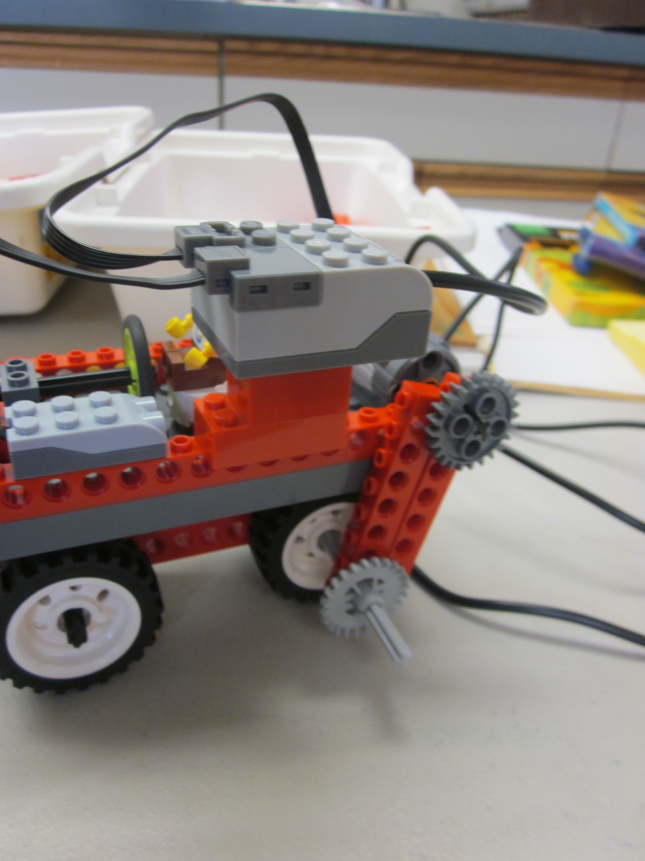

[00:50:34][EVALUATE-VISUAL][Gets idea of using a gear train to transfer energy. ]

[00:50:52] [PLAN] [Seems to be a short planning period here. Hard to tell when evaluation ended and planning began.]

[00:51:01] STUDENT: So if I use a bunch of these [gears] … and then this is spinning. It’s just going to … and this is spinning … it's just gonna … move right along [moves car] [unintelligible] gears … gears. [PROJECT-CORRECT] [PROBLEM-SOLVING][SCIENCE]

[00:51:29] [BUILD-REBUILD] [Works to build his gear idea]

[00:51:57] STUDENT: Longer, need a longer piece …

[00:52:04][EVALUATE-PHYSICAL] [Lifts up car to examine. Also looked from down low before that.]

[00:52:19] STUDENT: It keeps falling off.

[00:52:20] [PLAN] STUDENT: This will work. [PROJECTION-INCORRECT]

[Attaches gears to motor axle.]

[00:52:46] STUDENT: I am just going to keep this frame off for now. [STRATEGY]

[00:52:50] [BUILD-NORMAL] [Goes back to building.]

[00:53:00] STUDENT: They are kind of like tractor wheels.

STUDENT: Spread this apart.

[00:52:55][BUILD-REBUILD][Did get 2 axles to work but one would be better.][PERSIST-BAD][UNANTICIPATED-CONSEQUENCES][PROJECT-INCORRECT][CONNECTION] [STABILITY] [IMPORTANT]

[Tries to solve axle issues. Need one axle to stick out so it can connect to motor via gears. His stuck out, way out, so that it is going to hit the blocks on the side of his ramp.]

[00:53:21] [EVALUATE-VISUAL] [Looks down chassis main beam.]

[00:53:25] [EVALUATE-PHYSICAL] [Moves car manually.]

[00:53:31] [BUILD-REBUILD] [Tweaks his design.]

[00:53:36] [EVALUATE-PHYSICAL] STUDENT: [unintelligible] [SELF-TALK]

[00:53:38] [BUILD-REBUILD] STUDENT: If I turn this around [block]…

[00:53:45] [EVALUATE-PHYSICAL] … move this … [SELF-TALK] [Moves bottom chassis of car up ramp testing axle length.]

Umm. [Looks perplexed or in deep thought.]

[00:53:54] [BUILD-REBUILD] [Goes back to rebuilding chassis and extra axle.]

[00:54:09] RESEARCHER: What are you thinking about?

[00:54:10] [PLAN] STUDENT: I’m thinking … I think … This [axle] won’t get over all the way to it. But if I put this on it will just it that [the side of the ramp]. [PROJECT-CORRECT]

[00:54:34] STUDENT: I’m going to get something smaller than this but bigger than this. [MATH]

[00:54:43] [BUILD-REBUILD] STUDENT: This will work! [AFFECT] [PROBLEM-SOLVING]

[Looking for, getting, then comparing axles by length.]

STUDENT: Yup. That will work.

[00:55:07] [EVALUATE-PHYSICAL] STUDENT: [sighs] [AFFECT]

[Inserts longer axle, then tests car on ramp.] [TEST]

[00:55:09] [WAIT] [Researcher takes photo of car.] [PHOTO]

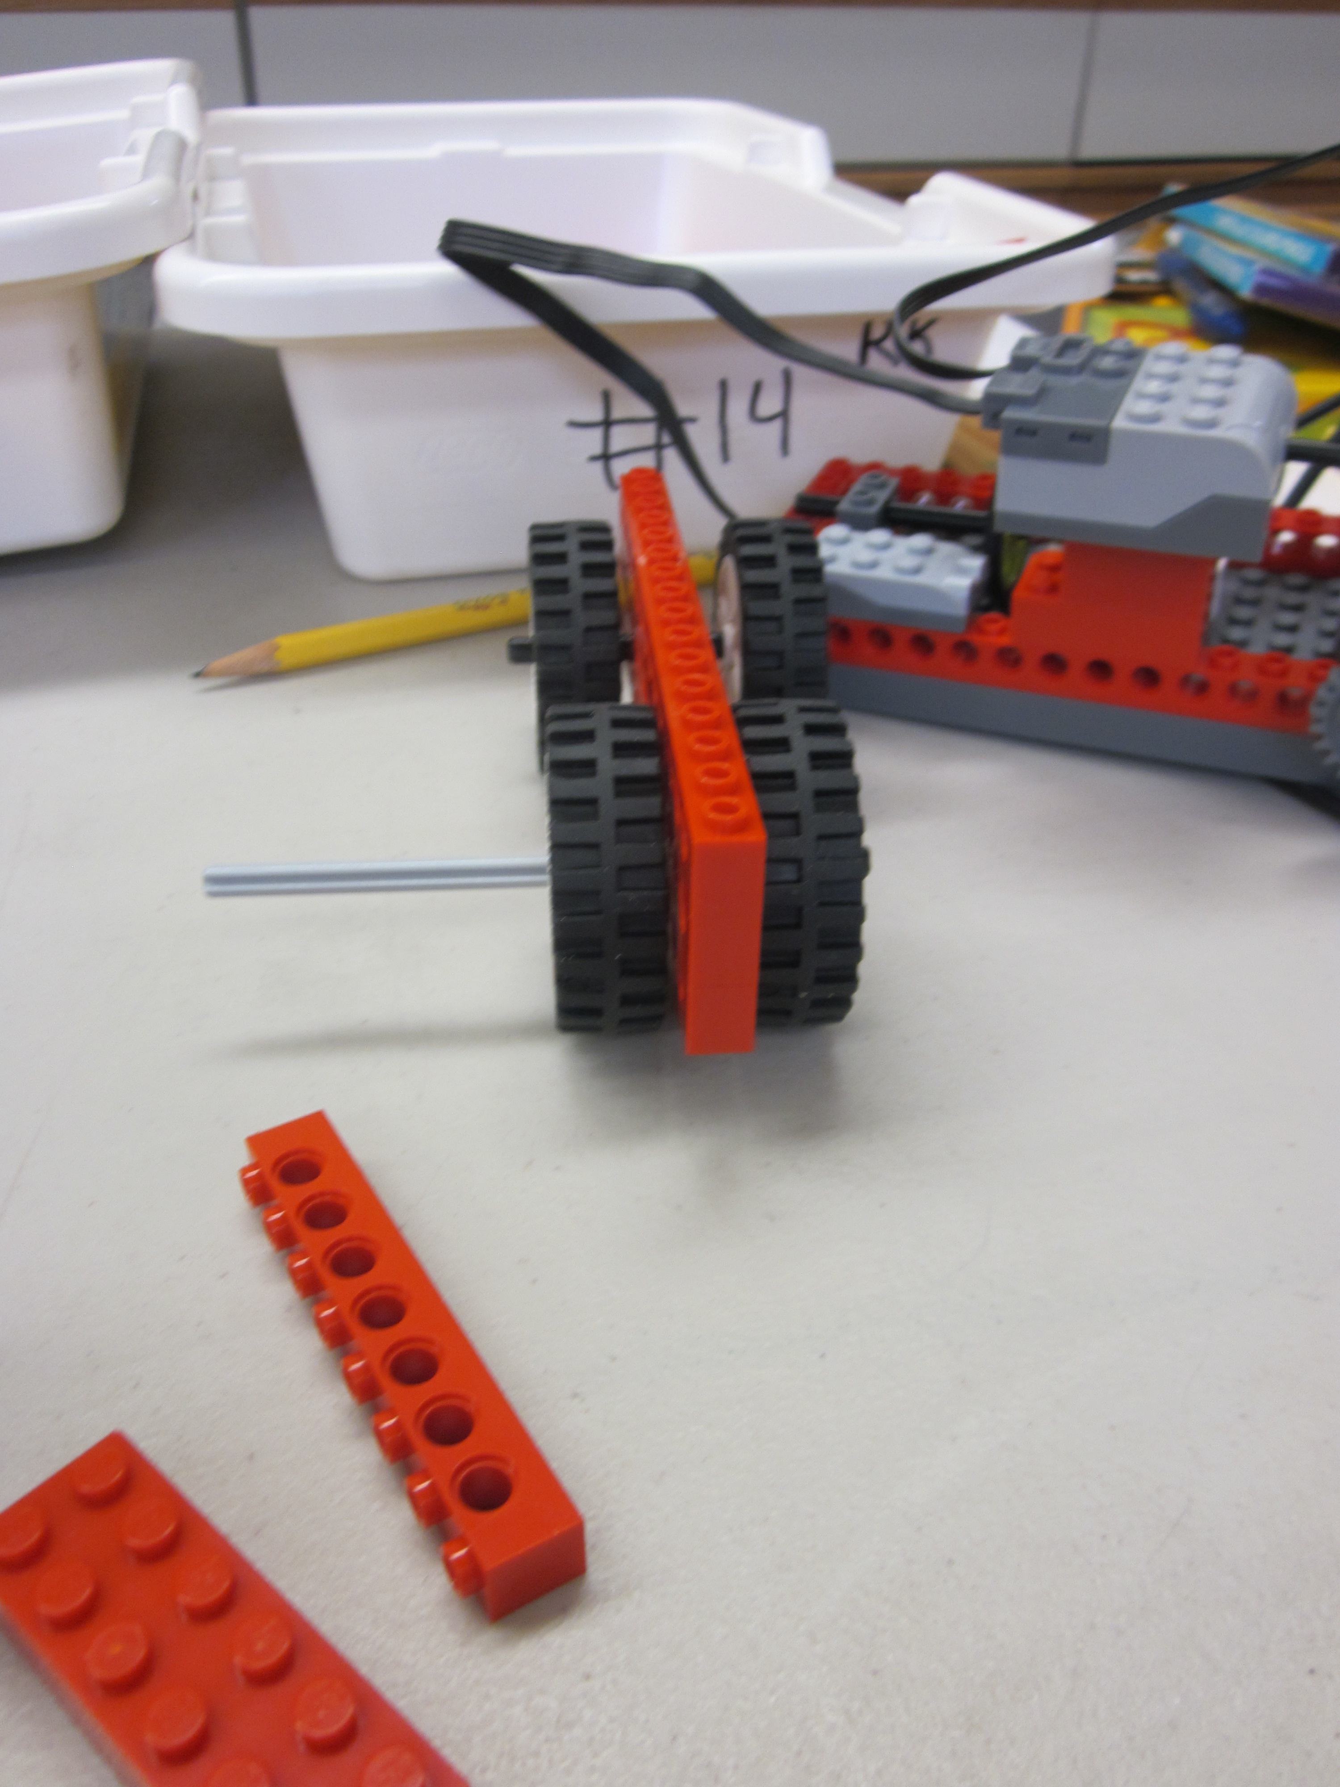

[00:55:24] [BUILD-REBUILD] STUDENT: So now, I’ll put the frame back on.

[00:55:27] [Lifts vehicle up by hub, which falls off. Student lifts eyebrows as if surprised. How many times has it fallen off? 5? [PERSIST-BAD][STABILITY]

[Note: Continuing to see stability issues in grade 2.]

[00:55:54] [Counterbalance falls off.][STABILITY][PERSIST-BAD]

[00:55:55] [EVALUATE-VERBAL] STUDENT: A lot of pieces are falling off.

[00:55:59] [BUILD-REBUILD] STUDENT: There. Get back in there. [TALK-TO-ROBOT] [Puts hub/motor assembly back on.]

[00:56:29] STUDENT: I put it on the wrong way. [sing-songy voice] [SELF-TALK][AFFECT] [Also, note that there is no center of base plate to attach one beam since there is an even number of holes.][ASYMMETRY][UNANTICIPATED-CONSEQUENCE]

[00:57:11][Connects gears to top and bottom but teeth do not touch.] [UNANTICIPATED-CONSEQUENCE]

[00:57:20] STUDENT: There.

[00:57:24] [EVALUATE-PHYSICAL] STUDENT: Now, it’s just going to be like that. [Moves car.]

[00:57:32][BUILD-REBUILD] [Again, he has stability issues.] [Puts hub back on.] [STABILITY][PERSIST-BAD] [CONNECTION][Still trying to plug in 2 axles to separate sides of one wheel, which will not be stable, instead of using one longer axle that goes through wheel.

[00:58:18] STUDENT: [unintelligible] [SELF-TALK]

[00:58:48] [Goes back to rebuilding the 2 axles in one wheel.] [PERSIST-BAD] [CONNECTION]

[00:58:50] STUDENT: [separates car main assemblies. Works on lower chassis and extra long axle. Note: I am amazed that he still motivated to work through all the issues. It’s hard for me as a teacher not to help more. Trying next to make a gear train with the gears touching. So he does slowly figure out working solutions.][IMPORTANT]

[00:59:22] STUDENT: Push that in the hole a little bit. [PERSIST-BAD] [CONNECTION]

[00:59:29] STUDENT: There! Now it's just like that. [He gets axles to connect inside wheel.]

[00:59:33] [EVALUATE-PHYSICAL] [Moves lower chassis of car.]

[00:59:44] [BUILD-REBUILD] STUDENT: Put that back on. [Sticks out tongue as if concentrating.] [AFFECT] [Reassembles chassis and base plate assembly.]

[01:00:15] RESEARCHER: STUDENT, I am going to move this camera so I can see what you are doing with your hands a little better. Can you hold on one second? OK. Thanks. Let me take a picture of that, OK? OK, Let me just take a picture of the different progress that you are making. OK, good.

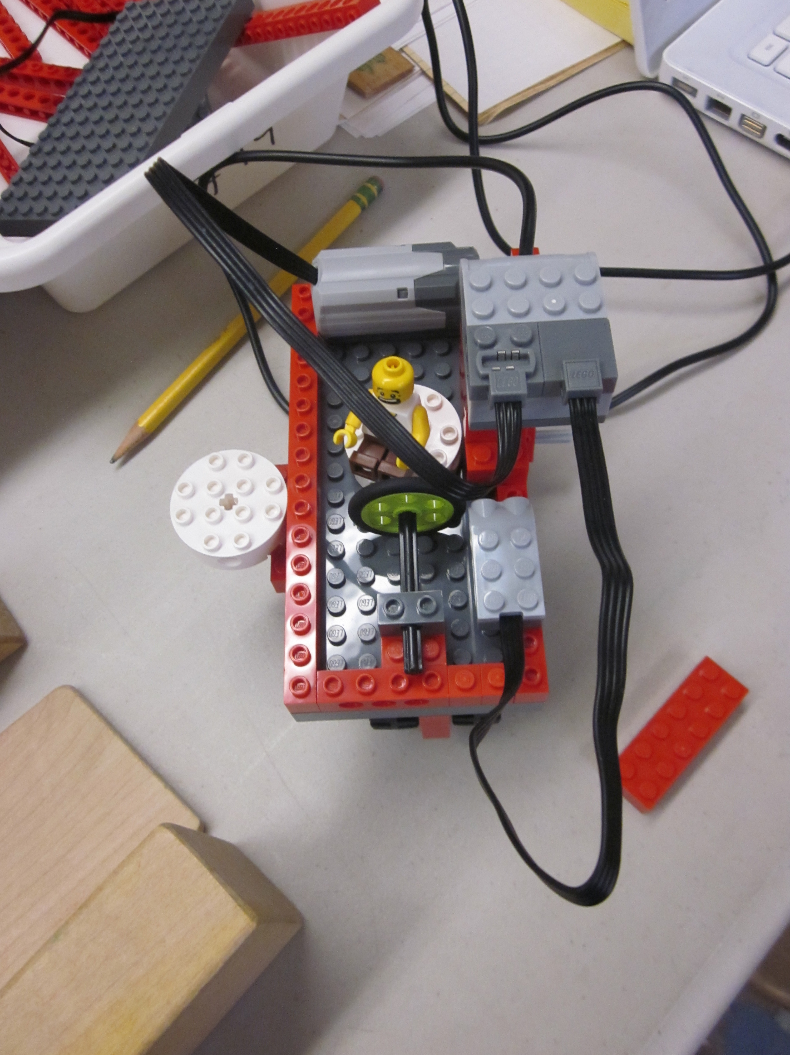

[Note: video camera out of focus initially after moving.]
[01:00:47] [WAIT]

[01:01:06] [BUILD-REBUILD] [Gets part]

[01:01:57] RESEARCHER: Why are you adding another gear? What's the idea there?

[01:01:59] STUDENT: Because umm if … if this falls off … if the motor is up here and the wheel is down here, it… motor is down here, the (no gear), the motor is just running. And if the motor is just running, that means … it doesn’t do anything to the wheel. So that's why … so if I put some a wheel on … if I put an axle … some gears in, … and then it will just start going until it will hits this [end block]. So… Now I put the frame back on. [PROJECT-CORRECT][IMPORTANT] [SCIENCE][He shows a good understanding of gears here, which he seems to have had to get experience with to understand.]

[Note: important and accurate articulation of the problem. Seemed to be searching for the right words at times]

[01:03:57] RESEARCHER: Boy, it's tricky, huh? [Still trying to reassemble car.]

[01:04:00][STUDENT: Uh, huh. [sing-songy voice] [SELF-TALK]

[Note: check camera once in a while. Seem to go out of focus from certain angles.]

[01:04:25] [Tries to reassemble car.] [PERSIST-BAD] [He persists in his gear idea, which is difficult to implement. A belt and pulley design is much easier.]

[01:04:51] RESEARCHER: Do you need to go get a snack or anything?

STUDENT: No.

RESEARCHER: No?

STUDENT: Nope.

[01:05:18] [He tried to get the 2 axles in one wheel again.] [PERSIST-BAD][CONNECTION]

[01:05:26] STUDENT: Almost there. [SELF-TALK] [Trying to create a gear assembly. Car comes apart again and he struggles with many problems even though he had worked through and figured out many solutions, I can see that it would be a very long time for him to get a working car by himself.]

[01:07:02] STUDENT: [Hums] [SELF-TALK]

[01:07:25] [WAIT] [I helped him to build a successful car. It was clear that it would be very difficult to get his design to work. ][HELP]

[01:07:23] RESEARCHER: STUDENT, you have been working for about an hour and we don't have much time left. I am wondering if I should give you some help so you can get this car going. What do you think?

[01:07:33] [EVALUATE-VERBAL] STUDENT: I just need help with getting the motor on here and getting all the gears on here.

[01:07:45] [WAIT] RESEARCHER: Right, so, you had a really good idea to make all the gears together… but there is an easier way. I think it’s going to be a lot easier. Can I show you? So first thing I would … why don't you take… Use one axle. That will make it more stable.

[01:08:19] RESEARCHER: You know how it was hard to connect on both sides, right? Put it through there first.

RESEARCHER: Gear is sticking out. So have the extra gear stick out this side, right. Push it through.

[01:08:55] RESEARCHER: Maybe a bit little more. Something you can too if it’s hard is … [to push the axle through. You can use the table to push it down. OK. And this was [unintelligible].

[01:09:07] RESEARCHER: So that can work with gears but there’s an easier way. You remember the dancing birds we had?

STUDENT: Yup.

RESEARCHER: So how did that connect the motor to the birds? Do you remember?

STUDENT: So there were gears, two of the green, then we put a rubber band. [Note: calls pulleys gears.]

RESEARCHER: So that's a good way to do it too. That way … It’s not as fussy. These … These don’t have to touch each other.

So try using the gears and pulleys to connect everything. Connect the motors to the wheels.

STUDENT: All right.

RESEARCHER: All right.

[01:10:23] STUDENT: It's supposed to be in the third.

RESEARCHER: What's that?

STUDENT: I put it in the wrong way.

RESEARCHER: Oh. The third hole.

[Hub falls off]

[01:10:48][Sing songy utterance/hum] [SELF-TALK]

[Puts car back together.]

[01:11:29] RESEARCHER: Is that in really good?

[01:11:49] STUDENT: There. Oh yeah, that does work.

[01:11:51] RESEARCHER: Now, can I make one more suggestion for your program? If you do this, it will go forever. Why don’t we test it with this [shorter program]? Just do, uh, “MOTOR ON FOR”. Just do a little program. Take up this … and then this one, MOTOR ON FOR. And ten means one second. So before we do that fancy program, let’s just see if it works. And I would suggest even not doing it on the ramp first. Let’s just see if it works. And I’ll go on the other side to catch it if it does fall. [unintelligible]. [IMPORTANT] [Had to demonstrate some common troubleshooting techniques.]

[01:12:47] STUDENT: I worked really, really hard on this. [AFFECT]

RESEARCHER: What did you say?

STUDENT: I worked really, really hard.

RESEARCHER: Yes, you did.

[Car goes opposite way than expected.]

[01:12:58] RESEARCHER: [laughs] It went the other way! You caught it though. Let’s try it over here so it goes backwards.

STUDENT: OK.

[01:13:16] STUDENT: Wait. I know what the problem is. [IMPORTANT][STRATEGY][PROBLEM-SOLVING] [He shows some important understanding here in changing the direction in software and also lifting the wheel to test.]

RESEARCHER: Oh. … Change the direction? Oh, turn it around?

[01:13:17] STUDENT: I am just going to test the wheel. [STRATEGY]

RESEARCHER: Oh, lifting it up? That’s a great idea.

[Lifted wheel (great troubleshooting).]

[01:13:33] RESEARCHER: What are you trying to figure out?

STUDENT: I am trying to figure out which way …

RESEARCHER: Which way it goes?

[01:13:50] STUDENT: Whoa! It actually works! [AFFECT]

RESEARCHER: All right.

RESEARCHER: Can I see?

[01:14:01] STUDENT: I am glad I have a head [unintelligible] here.

STUDENT: So now I am just going to try the other one.

RESEARCHER: OK. On the ramp, you mean?

[01:14:18] [He wants to try the car on the ramp. Note how important and integral the ramp was as part of his process. It defined his design path in many ways.] [IMPORTANT]

STUDENT: Yeah.
RESEARCHER: Yeah.

STUDENT: I’m doing it backwards.

STUDENT: Now it’s going forward.

RESEARCHER: Remember that this one goes forever. This one goes for just a little bit of time.

STUDENT: I am going to do the forever one.

RESEARCHER: OK.

STUDENT: Then I’m just going to stop it manually.

RESEARCHER: Stop it manually?

[01:14:48] STUDENT: Because the FOR SECOND one. The FOR … the FOR one …

RESEARCHER: MOTOR ON FOR?

[01:14:57] STUDENT: Yeah, the MOTOR ON FOR will probably just go to here. [PROJECT-CORRECT]

RESEARCHER: OK.

[01:15:18] STUDENT: Whoa! Wow! [AFFECT]

STUDENT: Something’s stuck.

[01:15:19] STUDENT: That’s so cool. Great! [AFFECT]

RESEARCHER: Are you all done?

RESEARCHER: Great, so congratulations, how do you feel about it now?

RESEARCHER: How to you feel about it?

STUDENT: Awesome.

RESEARCHER: What was hard about making your car? And what was easy?

[01:15:57] STUDENT: The frustrating part was the frame. The fres, the fres.

RESEARCHER: The what? Sorry?

[01:16:11] STUDENT: The frustrating part was getting the frame to be on here. Because it kept on falling down. But the easy part was just building … building … the wheels and the frame. I actually just used my imagination, my imagination … [IMPORTANT] [Note how he stressed using his imagination himself.]

RESEARCHER: Yeah, for what?

STUDENT: … for building the car and the ramp.

RESEARCHER: Uh, huh.

[01:17:01] STUDENT: Great! [AFFECT]

RESEARCHER: Any other thoughts on this? What it was like building it or programming?

STUDENT: Umm. I liked building it and I liked programming it. I didn’t think it would work before but now I don’t think it would work but now it does. Awesome.

RESEARCHER: All right, just writing this down. Anything else?

STUDENT: Nope.

RESEARCHER: Let me take a picture of it. I have to take it apart. So I will print out a picture of it. A picture of you with your car. Is that good? Thanks, buddy, You really helped me do my homework. I appreciate it. I will walk you back up.

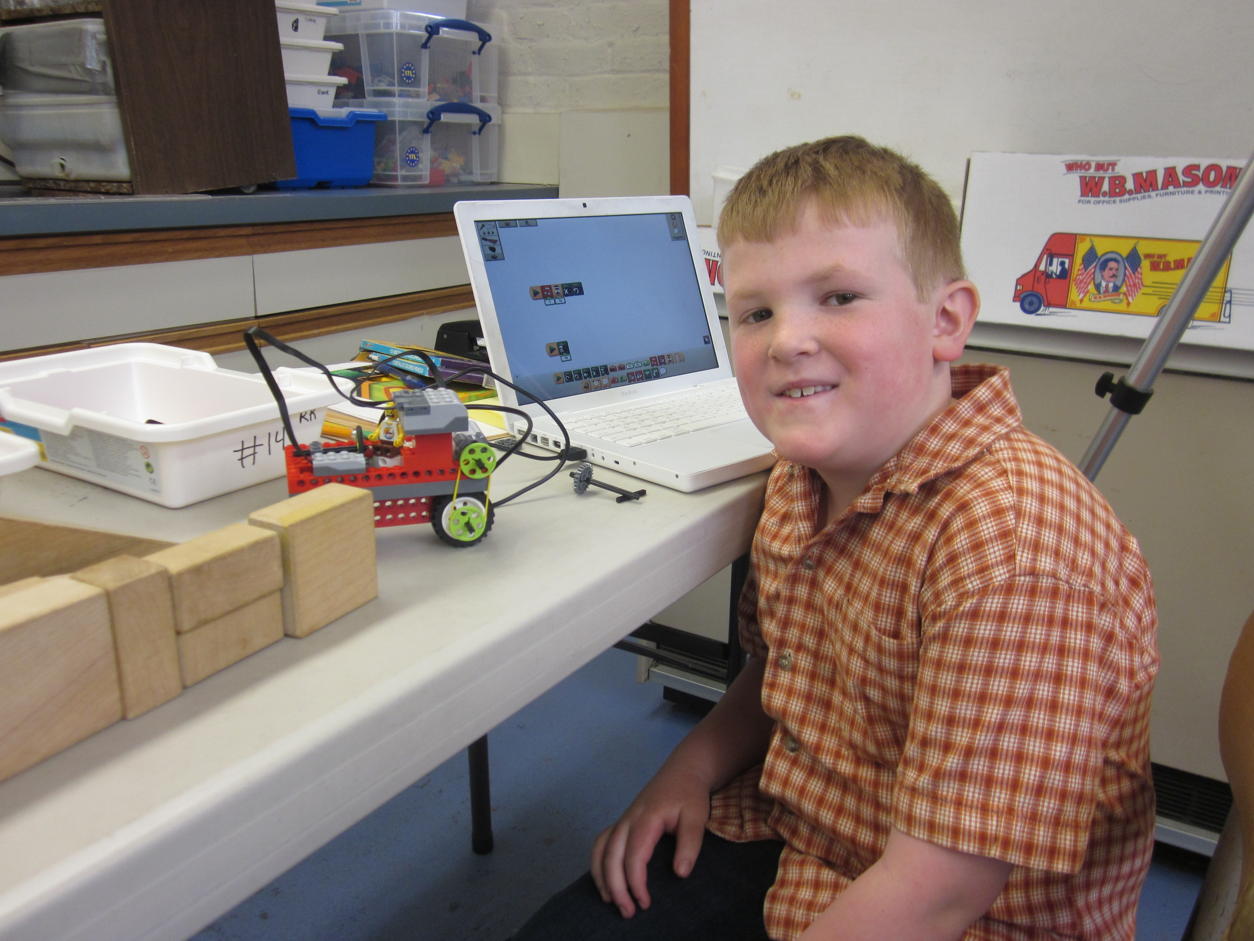

[END OF VIDEO]

Appendix E - Sixth Grade Transcript

Boy 11 - Comps Pilot Study - 5/21/14 10:30 AM

RESEARCHER: So, STUDENT, I asked you to join me to help me with some of my homework for my own schoolwork. Did you know I was going to school to be a Doctor of Education? My homework is to better understand how kids design and build robots at different ages. You may remember working in second grade on an amusement park ride.

RESEARCHER: To better understand what you are thinking as you do this task, I am going to ask you to talk out loud as you work so I understand what you are doing and thinking. I may also ask you other questions if I am not sure what you are doing or thinking.

RESEARCHER: Have you ever been to a fair or amusement park?

BOY 11: Yeah.

RESEARCHER: What kind of rides do you like?

BOY 11: Roller Coasters.

RESEARCHER: Six Flags? Bizarro?

BOY 11: Well, I just went there was the first time this summer so I didn’t go on that ride.

BOY 11: My son wants me to go on that on. I’m not too sure about that one. [Laughs]

RESEARCHER: You will now build a model amusement park ride. It can be like a ride you have been on before or it can be one you make up using your own imagination. You may want to use paper to draw pictures, write words, whatever you need to plan what you are going to build. You can also tell me in your own words what you are planning to build, if you know that ahead of time.

RESEARCHER: You can use any of the materials you see. [Show and explain student LEGOs, craft materials, wooden blocks.] It doesn’t just have to be LEGOs. You may also use a computer laptop to program your ride with motors, sounds, or sensors. I’ll bring that over in a minute.

RESEARCHER: You will have about 1 hour to build your model amusement park ride.

RESEARCHER: Are there any questions before you start?

BOY 11: No.

[00:02:09] [PLAN] BOY 11: OK. [Laughs nervously.] [AFFECT]

RESEARCHER: All right. I may take some notes.

[00:02:20] BOY 11: OK. So I think I want to build some kind of track or … let’s see.

[00:02:25] [RESEARCH] [Starts looking through parts.]

RESEARCHER: A track?

[00:02:32] BOY 11: If the wheels were like gears almost.[PROJECT-CORRECT]

RESEARCHER: [unintelligible] laptop over here.

RESEARCHER: You said you were going to build a track with gears, something about gears, say that again.

[00:03:01] BOY 11: Well, I’m not sure.

RESEARCHER: OK.

[00:03:18] BOY 11: I think if there was like a track, some track, and it seems like gears would get better traction or something but I’m not really seeing anything. [SCIENCE] [PROJECT-CORRECT] [MULTIPLE-PHASES]

RESEARCHER: Yeah.

BOY 11: That it would really fit into…

[00:03:42] [PLAN] [Looks away from parts. Looking at parts bins into as if thinking, then started looking through NXT and WEDO bins.]

[00:03:46][RESEARCH][Looking through parts again.]

[00:04:14] [EVALUATE-VERBAL] BOY 11: Yeah, I don’t think I can do that. [There appears to be a mix of planning and researching here. This is another case where it is hard to clearly differentiate between 2 EDP phases. I am going to infer that he is planning when not touching parts and looking away and researching when looking for parts or looking at the parts in the bins.] [IMPORTANT][MULTIPLE-PHASES]

[00:04:17] [PLAN] [Got out, then put back WeDo motors and/or sensors.]

RESEARCHER: What are you doing now?

[00:04:38] [RESEARCH] BOY 11: I’m just thinking of something that turns.

[00:04:45] BOY 11: It’s hard because like a lot of the pieces aren’t really rounded. [PROJECT-CORRECT] [MULTIPLE-PHASES] [Mix of evaluate, plan, and research.] [SCIENCE]

[00:05:07] [PLAN] [Looks away from parts.]

[00:05:17] [Looking alternatively “into space” and at parts as if thinking about what can be made.] [Seems to be a formal operation.]

RESEARCHER: I’m just going to move this [box] so I can see what you are doing better.

BOY 11: Well, I guess in younger kids’ rides they’re like … There could be something that’s attached to the track that’s goes around in circles.

[00:05:44] [RESEARCH] [Gets out, then quickly put back some angled beams.]

RESEARCHER: What is an example of that ride? Do you have a ride in mind?

[00:05:52] [PLAN] BOY 11: Well, I am thinking of those rides where you get in a little cart or motorcycle like thing and you just go around the track. [TALK-ALOUD-ARTIFACT]

[00:06:08][RESEARCH][Looking at parts.]

[00:06:22][BUILD-NORMAL] [Touches motor and looks through parts.]

[00:06:36] BOY 11: I am going to try and make … wait … ugh. [Makes noise and motion as if expressing difficulty of implementing idea.] [AFFECT]

[00:06:37][EVALUATE-VERBAL][Very quickly evaluate and rejects his current idea.]

[00:06:38][PLAN] [Looking “into space” and at parts.]

[Note: looking for parts, is it building or planning? Also, in talk aloud with kids, it is not 100% possible to get the stage right.]

RESEARCHER: You are going to try and to make what?

[00:06:54] BOY 11: Well, I am not sure. I am just thinking. I’m not sure I want some kind of go-cart thing because that would basically just be putting what we already made into a track. [PROJECT-CORRECT]

[00:07:10] [RESEARCH] BOY 11: So I was trying to think if a way to attach it to the track and I can make it move around but … There’s not really anything spiky that the gears can latch into and move along with. [PROJECT-CORRECT] [SCIENCE]

[00:07:57] [PLAN] BOY 11: I’m just thinking about all the different rides.

[Looks “into space” as if thinking.]

RESEARCHER: Hold on. Sorry.

RESEARCHER: Say that again, STUDENT. Thinking of the rides…

[00:08:22] [RESEARCH] BOY 11: Yeah, I don’t really see what would be the easiest to do.

[00:08:24] [EVALUATE-VERBAL] [This is for the above utterance as he was looking through parts.] [MULTIPLE-PHASES]

[00:08:27] [PLAN] [Thinking, looking into space.]

[00:08:37] [RESEARCH] [Gets out sensor.]

[00:08:40] BOY 11: I am thinking about self-sufficient like bumper car things but I only have one of these sensors. [PROJECT-CORRECT]

BOY 11: Wait. Are there supposed to be two of these?

RESEARCHER: Yeah.

[00:09:07] [PLAN] BOY 11: There is only one motor.

RESEARCHER: Oh, there should be three motors.

[00:09:13] [RESEARCH] [BOY 11: I mean there is only one brain.

RESEARCHER: There is only one brain.

RESEARCHER: There should be three motors.

[00:09:46] [PLAN] [Thinking, looking at parts. Continues to alternate looking “into space” and at parts. Picks up and looks at motor.]

[Note: I decided to make all the above planning because it is hard to separate looking for parts, sometimes he looks physically, sometimes he just looks, sometimes he seems to look mentally. Note that clearly planning for, BOY 11, involves looking for parts. Do older children spent more time with the initial planning phase?]

[00:10:17][RESEARCH] [Goes back to researching, looking at parts.]

RESEARCHER: Now, you know, right, that this is not about evaluating you in any way?

BOY 11: Yeah, I know.

RESEARCHER: It’s just for me to understand…

BOY 11: I’m just trying to think …

RESEARCHER: Just didn’t want you to be nervous …

BOY 11: Yeah, I know…

[00:10:38] [BUILD-NORMAL] BOY 11: So I am thinking of some sort of Ferris Wheel thing or something and about making like a base for it so I can put a motor up here. [IMPORTANT][PROJECT-CORRECT] [Boy 11 had a long period of considering different ideas and researching parts before deciding on a buildable idea and starting in earnest. Boy 10 seems to start building his initial idea much earlier without being able to really know if it was buildable. He actually built the test track first and seemed to commit to that.][PROBLEM-SOLVING]

[Gets out frame and axle.]

[Puts axle in frame.]

[00:12:32][EVALUATE-PHYSICAL] [Does brief test of folding and unfolding base.]

[00:12:36] [BUILD-NORMAL] [Adds second frame to build tower.]

[00:13:00] [EVALUATE-PHYSICAL] [Tries base on table.]

[00:13:12] RESEARCHER: What is that piece you are making now?

[00:13:14] [EVALUATE-VERBAL] BOY 11: I am making the base [tower part of base] but it doesn’t really seem stable enough right now so I am just going to extend it a little bit. [PROJECT-CORRECT]

RESEARCHER: What? Say that again.

BOY 11: I am going to extend it a little but or try to.

[00:13:34] [BUILD-REBUILD] [Starts building again.]

[00:14:31] [EVALUATE-PHYSICAL] [Puts base down and tries it.]

[00:14:35] [EVALUATE-VERBAL] BOY 11: That won’t work. [PROJECT-CORRECT]

[00:14:36] [BUILD-REBUILD] [Takes apart changes he just made.]

[00:14:38] RESEARCHER: What did you say?

[00:14:38] BOY 11: That … I was trying to put these on for … but they were just too small.

RESEARCHER: So did you say, “That wouldn’t work?” Is that what you said?

BOY 11: Yeah.

[00:14:52] [PLAN] [Somewhat inferred from context that he is planning but he looks into space briefly.]

[00:14:56] [BUILD-NORMAL] [Goes back to building the tower.]

[Looking for new parts and building base for tower.]

[00:15:46] [EVALUATE-PHYSICAL] [Examines base in air and then places on table to test.]

[00:15:49] BOY 11: OK, so I have a base now. [PROBLEM-SOLVING]

[00:15:55] [BUILD-NORMAL] [Attempts to put motor on base.]

[Trying different ways to put motor on base.]

[00:16:48] RESEARCHER: Looks like you are trying to attach the motor to the base?

[00:16:50] [EVALUATE-VERBAL] BOY 11: Yeah, but it’s kind of hard because … these … if I I put them in [black connector pegs], then I can’t fit the motor on. [CONNECTION] [PROJECT-CORRECT][TALK-ALOUD-ARTIFACT]

[Note: as subject builds, there are constant mini-evaluations such as seen here. We will code evaluate as testing the whole system or subsystem but also try to detect these mini-evaluations.]

[00:17:02] BOY 11: [BUILD-REBUILD] OK. [Takes out connector pegs.]

[00:17:16] [PLAN] [Stops to think. Looks away from his building.]

[00:17:21] [BUILD-REBUILD] [Goes back to building.]

[00:17:30] BOY 11: I am going to try to use these longer things so I can put it down and then snake it through. [PROBLEM-SOLVING] [PROJECT-CORRECT]

[00:17:32] [Kneels down to work level with design.] [STRATEGY]

[00:18:15] RESEARCHER: I am going to take some pictures too of your creation as you go along. Can I take one now?

[00:18:22] [WAIT]

[00:18:24] [BUILD-REBUILD]

BOY 11: Yeah.
RESEARCHER: Thanks.

[PHOTO 1]

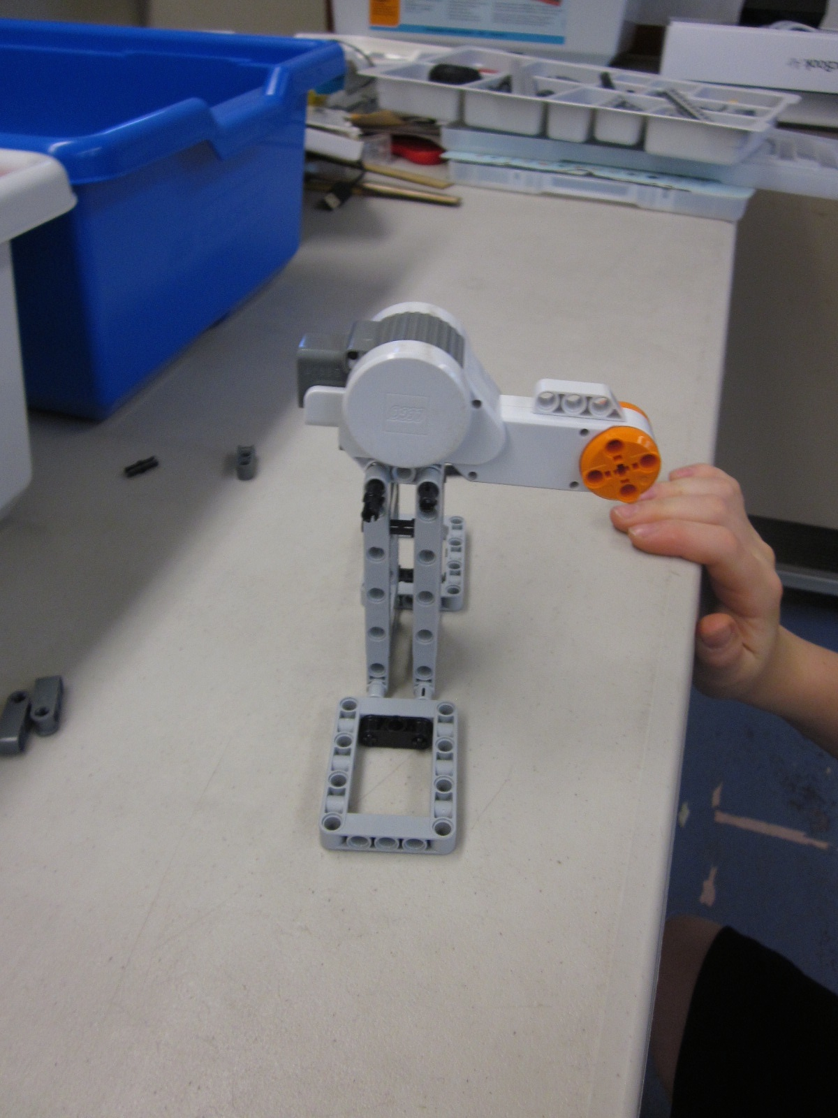

[Attached motor to base/tower.]

[00:18:55] [EVALUATE-PHYSICAL] [Picks up motor.]

[00:18:55] RESEARCHER: So you have motor on?

BOY 11: Yeah, so I have the motor on.

[00:19:01] [Looks intently at creation from a low angle.] [STRATEGY]

[00:19:11] [PLAN] [Unintelligible, self-talk? Made circular motion with hands.]

[00:19:11] RESEARCHER: What are you thinking next? Or what are you thinking now?

[00:19:20] BOY 11: I’m thinking [smiles] … I need to find out how … I know this can turn. I just need to find out how I can actually have something that turns all the way around. [AFFECT] [PROJECT-CORRECT]

[00:19:41] [EVALUATE-PHYSICAL] [Compares some axles.]

[00:19:45] [BUILD-NORMAL] [Tries part but puts back.] [Puts axle in motor. Seems excited to do so. ]

[00:19:48] [PLAN] [Stops to think.]

[00:19:53] [BUILD-NORMAL] [Returns to building.]

[00:20:11] [PLAN] [Looks away from design and thinks.]

[00:20:15] [BUILD-NORMAL] [Returns to building.]

[00:20:29] [PLAN] BOY 11: I was thinking that I could have one that kind of connects on both sides but then all this would get in the way. So then I couldn’t really have it go around. [PROJECT-CORRECT] [SYMMETRY]

RESEARCHER: What are you worried about? [Unintelligible]

BOY 11: Well, if I made it so it was like this, kind of, it couldn’t really go around because of that.

RESEARCHER: Oh, right, under here, hitting this you mean.

BOY 11: [Unintelligible]

[00:21:12] BOY 11: I guess it would be kind of weird if I did a thing on both sides but I could. [SYMMETRY] [PROJECT-CORRECT]

[00:21:19] RESEARCHER: You are certainly welcome to try whatever you want. However you want.

[00:21:32] [BUILD-NORMAL] [Spins beam on axle. Tries to find second beam the same size. He tests by physically comparing to existing one. He seems not sure about beam spinning on axle. Counts hole in beam.][MATH] [STRATEGY][PROJECT-CORRECT]

[00:22:00][EVALUATE-PHYSICAL] [Spins beam on axle.]

[00:22:06][BUILD-NORMAL] [Goes back to building.]

[Tower falls over.]

[Looks into space briefly and then did a test by picking up base.]

[00:22:30] [EVALUATE-PHYSICAL] [After tower falls over, he tests the stability. It was serendipitous that tower fell over and he used it to improve design in the middle of building the next subsystem.] [STABILITY]

[00:22:31] [EVALUATE-VERBAL] BOY 11: I think I might need to develop a more support for this. [IMPORTANT] [STABILITY][PROJECT-CORRECT] [Makes an important evaluation and projection about his current design.]

[00:22:32] [BUILD-NORMAL] [Starts looking for parts. Note: he does not work to develop more secure base at this time. Clearly aware of support and stability concerns and projecting out consequences of his design decisions.][IMPORTANT]

[Building part - double - that goes around.]

[00:22:50] [Builds side arms/beams symmetrically.] [SYMMETRY]

[00:23:07] [EVALUATE-PHYSICAL] [Tests by spinning arms and rocking base. He then picks it up.]

[00:23:17] [PLAN] [Looks away from design and thinks.]

[00:23:25] [BUILD-NORMAL] [Goes back to building. Counts holes in part.] [MATH][STRATEGY]

[00:24:47] [EVALUATE-PHYSICAL] [Falls over again.] [Picks up base and looks at it upside down.]

[00:24:52] RESEARCHER: What are you doing now? What are you picking that up for?

[00:24:55] [EVALUATE-VERBAL] BOY 11: Well, I am trying to attach these and I need to find a way like … Well, let’s see, I just think this needs more support, probably. [STABILITY] [PROJECT-CORRECT]

[Note: he talks above 2 different problems above. Making the beams rigid and making a more secure base so he is aware of and perhaps working on 2 problems at once.]

[00:25:12] [BUILD-REBUILD] [Starts rebuilding base adding more support by providing a larger base.]

[00:25:24] RESEARCHER: How were you able to figure that out? I’m just curious. What are you using to … What are you thinking to help you decide that?

[00:25:30] BOY 11: Well, I have these on the two sides - these little things - to hold it but I think I need more on all sides so … [PROJECT-CORRECT]

[Note: has “circles in circles” currently for actual people carrier. Will that provide enough rigidity to spin? No, he solves that problem later and he was aware of it at this point.]

[Adds more to base.]

[00:26:39] RESEARCHER: Can I take another picture?

BOY 11: Yeah.

RESEARCHER: Let me see one thing.

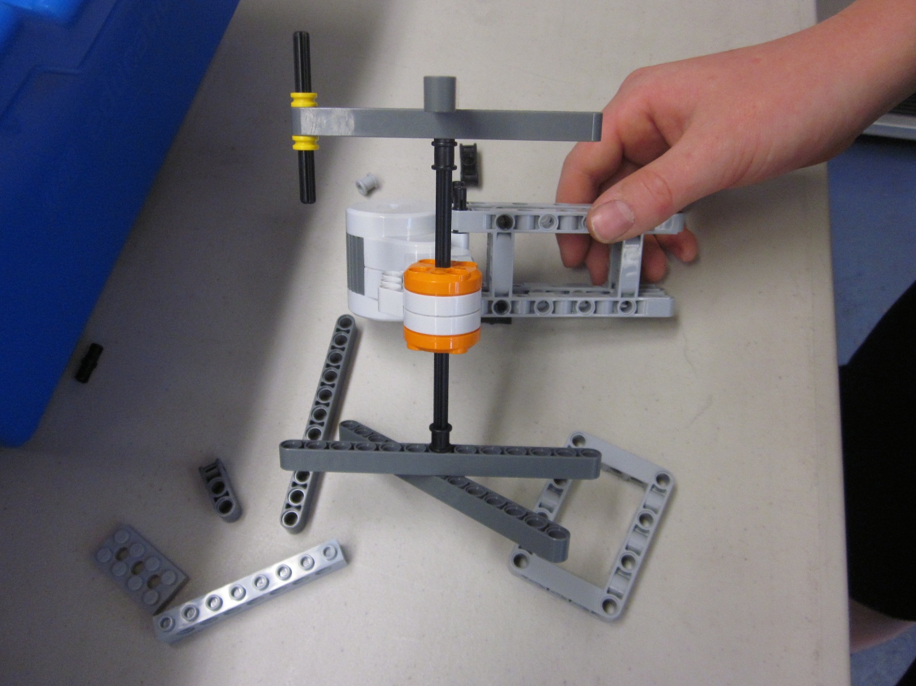

[00:27:14] BOY 11: So I am putting these on before … I put everything on in the right order so that I don’t put it on … like this isn’t … and realize so … [SEQUENCING]

[Note: how will I define REBUILD - fix something that broke or more generally, another modified attempt at the same thing?]

[Phone rings.]

RESEARCHER: Sorry.

[00:27:40] RESEARCHER: Tell me that again that, you were explaining about the base.

[00:27:43] BOY 11: OK, so I have to put these on so this holds its place. Then I have to put this on, and then I have to put this on … actual … [SEQUENCING] [IMPORTANT] [Stability, sequencing, and symmetry emerge as important building principles]

RESEARCHER: So there’s an order?

BOY 11: Yeah.

RESEARCHER: So there’s a correct order, that’s what you’re saying?

BOY 11: Yeah.

[00:28:22] BOY 11: I think I might not need these because it seems like my axles aren’t long enough for them.[PROJECT-CORRECT] [TALK-ALOUD-ARTIFACT] [MULTIPLE-PHASES] [He is verbalizing some planning here but it primarily building.]

BOY 11: So it might just be to fine the way it is without them and hopefully it won’t …

RESEARCHER: The extra support, you mean?

[00:28:38] BOY 11: Well, there are these extra things to hold the extra support where it was but I don’t think I need that because these are just going to be stuck in place. [PROJECT-CORRECT]

RESEARCHER: These little collars you mean on that side.

[00:28:57] BOY 11: I should probably take them off on this side too because they are just in the way now because everything will be so compact that they‘re not going to matter. [SYMMETRY][PROJECT-CORRECT]

[00:29:15] BOY 11: If I have extra room, I can just let it out on the other side of the axle. [PROJECT-CORRECT]

[Removed ones on the other side due to symmetry.]

[00:29:40] [EVALUATE-PHYSICAL] [Stands back and tests the stability by rocking the whole structure.] [STABILITY]

[00:29:40] BOY 11: Ugh. [Sighs] [AFFECT]

[00:29:49] [EVALUATE-VERBAL] BOY 11: OK. Now, I am taking everything off again because these seem too short.

[00:29:50] [BUILD-REBUILD] [Takes off base again.]

[00:29:53] BOY 11: I think maybe if I put longer ones on, that they can support the brain.[PROJECT-CORRECT]

[00:30:30] RESEARCHER: I am going to sit a little closer so I can see better.

[00:30:33] [EVALUATE-PHYSICAL] [Picks up and then tries briefly by moving.]

[00:30:36] [EVALUATE-VERBAL] BOY 11: OK, so now I actually have a support that’s going to work. [STABILITY][PROJECT-CORRECT] [PROBLEM-SOLVING]
RESEARCHER: Oh, all right. Let’s take another picture.

RESEARCHER: [Takes picture.] Thanks.

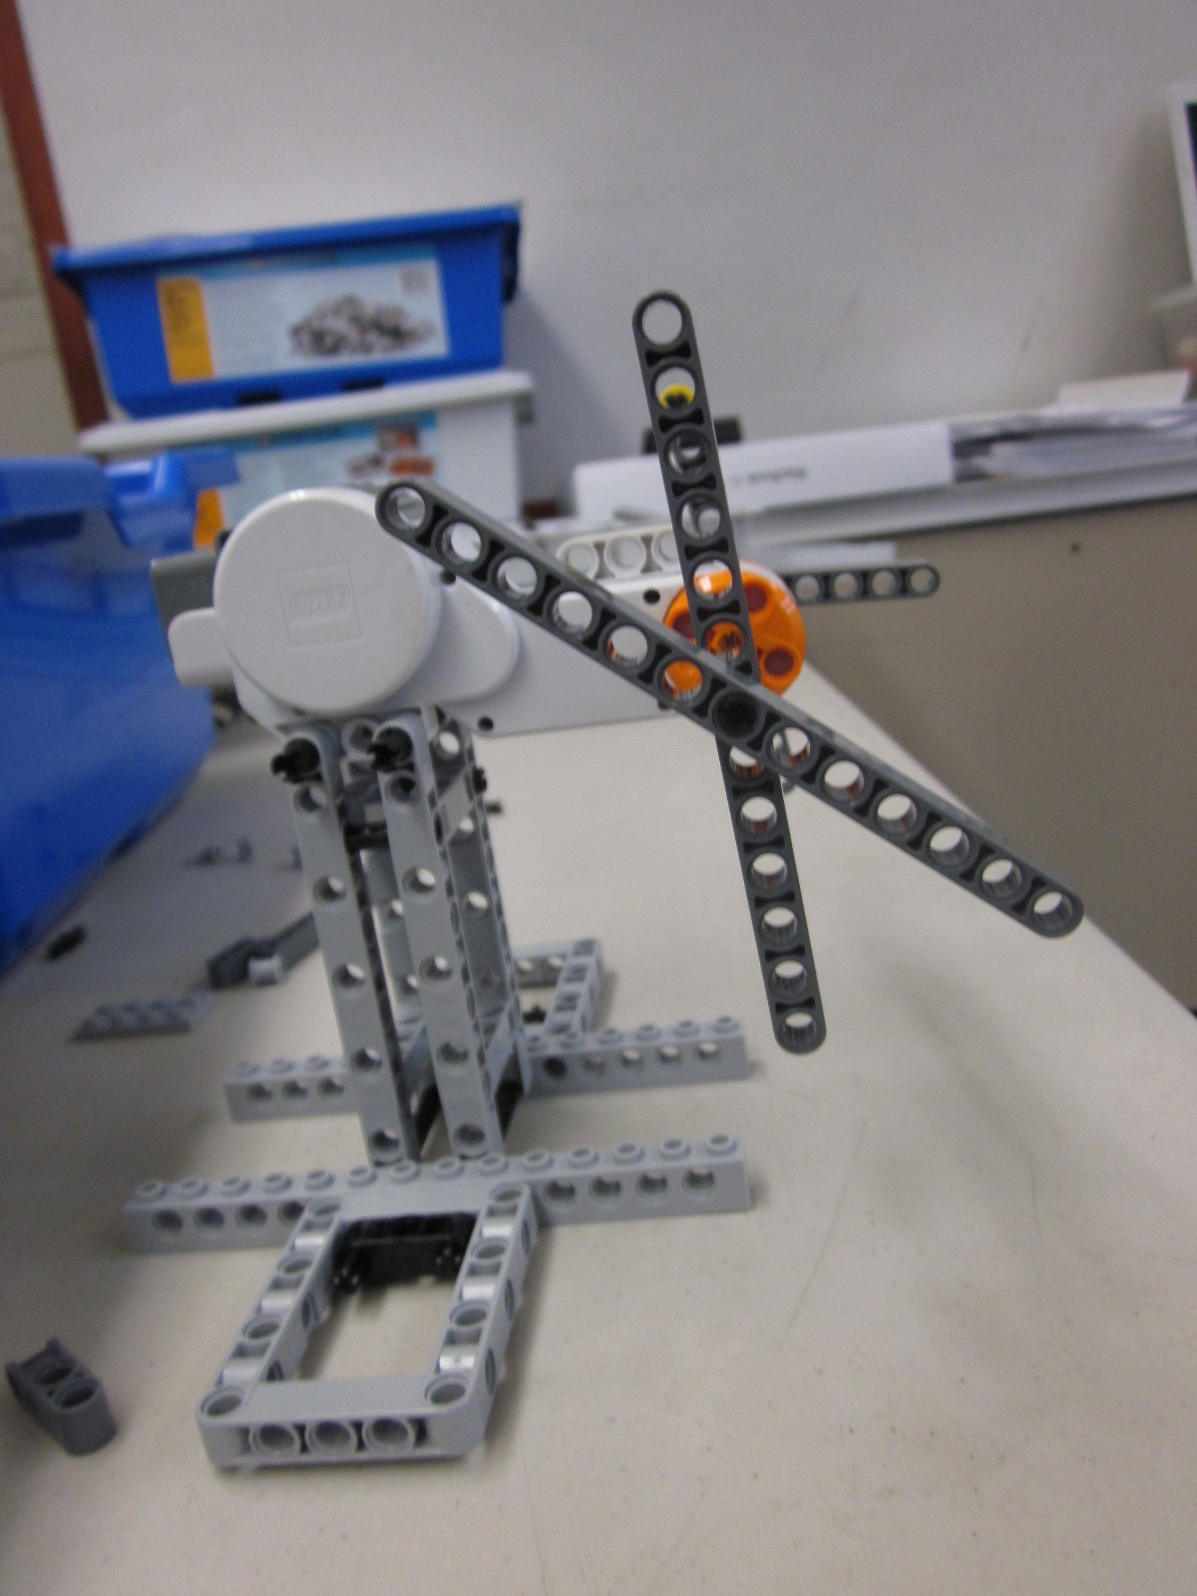

[00:30:41] [EVALUATE-VISUAL] BOY 11: Now it’s in a better state. [Bends over and looks at it level.]

[Note: may be an undetectable PLANNING activity here.]

[00:31:07] [BUILD-REBUILD] BOY 11: I’m taking these off because I want a bigger size.

[00:31:20][Gets out a bunch of beams. Counts holes.] [MATH][STRATEGY]

[00:31:24] RESEARCHER: And why is a bigger size better for that part?

[00:31:27] BOY 11: Because I don’t want the actual [waves hands in a circular motion] ride part to be a lot smaller than like the support and everything. [SCALE]

BOY 11: It shouldn’t be a different scale.

RESEARCHER: What word did you use, to scale?

[00:31:45] BOY 11: Yeah. [Busy counting holes in beam.]

[00:33:20] [Counts the holes the beam is centered on the axle.] [MATH][STRATEGY]

[00:32:22] RESEARCHER: What was that counting that you were doing?

[00:33:25] BOY 11: I was counting the holes so that the sides are equal. [MATH]

[00:32:31] BOY 11: [Sighs.] OK. [AFFECT]

[00:32:32] [EVALUATE-PHYSICAL] [Picks up design. Touches beams simultaneously on both sides to test them.][SYMMETRY]

[00:32:42] [BUILD-NORMAL] [Building symmetrically again. Building the next part of the ride, the places to attach the seats. Building axles to hold seat.] [SYMMETRY]

[00:33:06] [EVALUATE-PHYSICAL] [Moves beams perhaps noticing that they move and are not rigid. He says later that the problem is a different one, the axle is hitting something.]

[00:33:08][PLAN][Looks into space as if thinking. This could be evaluation and not planning.]

[00:33:10] EVALUATE-PHYSICAL][Goes back to testing rigidity of beams.]

[00:33:22][Bends down to look closely at design.] [STRATEGY]

[00:33:26] RESEARCHER: What are you looking at so intently there?

[00:33:30] BOY 11: Well, the axle right here which is supposed to be kind of like where a seat might be. [PROJECT-CORRECT]

[00:33:43] [EVALUATE-VERBAL] BOY 11: … is like slightly rubbing up against another part. [Puts hand on head as if indicating difficulty.] [AFFECT]

[00:33:45] BOY 11: [PLAN] I might have to use a bigger axle. I don’t think I have one. I don’t see one. [unintelligible]

[00:33:49] [BUILD-REBUILD] [Takes axles off.]

[00:34:14][Lots of trial and error/searching for optimal part sizes. Compares axle to one he already had.][STRATEGY][MATH]

[00:34:29] [PLAN] BOY 11: OK, well, I kind of have of use that size. [Compares axles again.][STRATEGY][MATH]

[00:34:32] BOY 11: It’s the biggest size I have available. I guess I could do two but I don’t think that would be very well supported or anything. [PROJECT-CORRECT] [STABILITY]

[00:34:43][BUILD-REBUILD] [Puts axles in wheel beams.]

[00:34:47] [Goes back to building. Puts original axles back.]

[00:35:12][EVALUATE-VISUAL] [Steps back and looks at design.]

[00:35:14][BUILD-REBUILD] [Goes back to rebuild. Tweaking parts a bit. A bit of a mix of testing and building going on as he builds and tests.]

[00:35:21][EVALUATE-PHYSICAL] [Moves arms on both sides of motor.]

[00:35:26][BUILD-REBUILD] [Goes back to building.]

[00:35:48][EVALUATE-PHYSICAL] [Moves arms on both sides of motor.]

[00:36:10] RESEARCHER: What are you testing there?

BOY 11: I am trying to make… I am just testing out if it will really matter if these axles are touching this part sticking out so… but it seems like it will matter so… [PROJECT-CORRECT]

[00:36:33] [PLAN] [Steps back and looks away.]

[00:36:42] [BUILD-REBUILD] [Pushes axle out.]

[00:36:47] [EVALUATE-PHYSICAL] [Moves arms on both sides of motor.]

[00:36:49] BOY 11: I am going to make it so they stick out instead of in so I think that will work. [PROJECT-CORRECT][PROBLEM-SOLVING]

[00:37:09] [BUILD-REBUILD] [Gets part. Goes back building the rest of the axles. Building symmetrically] [SYMMETRY]

[00:38:03] [EVALUATE-PHYSICAL] [Tests arms symmetrically.] [SYMMETRY]

[00:38:06] [BUILD-REBUILD] [Goes back to building.]

[00:38:17] RESEARCHER: What is your plan for those beams that are sticking out there?

[00:38:19] BOY 11: Well, I am hoping I can turn them into like a seat thing. [TALK-ALOUD-ARTIFACT][MULTIPLE-PHASES]

[00:38:43] [EVALUATE-VERBAL] BOY 11: I don’t have enough of the right size axle in that kit.

[00:38:47][BUILD-NORMAL][Looking for parts - more axles of the same length. Checks size of part by comparing to existing part on ride.[MATH][STRATEGY]

[00:39:28] RESEARCHER: So you probably are about half way, OK, just to let you know.

BOY 11: OK.

[Looking for parts.]

RESEARCHER: Are you looking for more axles of the same length?

[00:40:09] BOY 11: No, I need more of these [yellow collars].

[00:40:11] BOY 11: I found the axles and I need more of these. I just need two … one more. [PROJECT-CORRECT] [Note: anticipates number of parts needed.] [IMPORTANT][STRATEGY]

[00:40:29] [Makes eight symmetrical parts.] [SYMMETRY]

[00:40:40] [PLAN] [Looks into space as if thinking/planning.]

[00:40:44][BUILD-NORMAL] [Goes back to building.]

[00:41:08] [EVALUATE-VISUAL] [Bends over to look closely at ride. Looks from a different angle.] [STRATEGY] [IMPORTANT] [Interesting finding some of these micro strategies. ALSO, IT SEEMS LIKE HIS EVALUATION ABOVE WAS ALSO PLANNING THE NEXT STEP.]

[00:41:14] [PLAN] BOY 11: I have this [design] and now I just want to make it so that these are like, what’s the word? They’re adjacent? Or something like that. And I probably want to use something for that … [What does he mean? Rigid?] [CONNECTION] [IMPORTANT][MULTIPLE-PHASES] [Evaluating physically while he is talking about his plan.]

[00:42:04] [BUILD-NORMAL] [Looks for parts. Holds part up to design get correct length.][SEMICONCRETE][STRATEGY] [PROJECT-CORRECT]

[00:42:24] RESEARCHER: When you held that part next to the other one? What did you do with that part when you held it up? What was that about?

BOY 11: Well, I was trying to find out what I could do to make it so these [2 beams] are connected, kind of. [Beams on not rigid relative to each other.]

[00:42:46] [EVALUATE-VISUAL] [Tries various part(s) but they don’t work. Steps back, bends over, and looks at design.] [STRATEGY]

[00:42:48] [PLAN] BOY 11: Because there is already something right in the middle so I can’t use that. [He sees, by looking perhaps, that one idea would not work. By a movement of his eyes, one can seem to see the light bulb go off at one point. ] [PROJECT-CORRECT] [I am really noticing his movements to get a better angle of design.]

[00:43:03] [BUILD-NORMAL] Attaches a small beam to make the 2 long beams more rigid relative to each other.]

[00:44:37] [EVALUATE-PHYSICAL] [Tests out by turning arms.]

[00:44:40] [EVALUATE-VISUAL] [PROJECT-INCORRECT][Bends down and looks closely. Note that, in this case, he could not project out ahead of time that this mini-design would not work perhaps because it is hard to see directly.]

[00:44:46] RESEARCHER: I just want to see that little detail there.

BOY 11: Here.

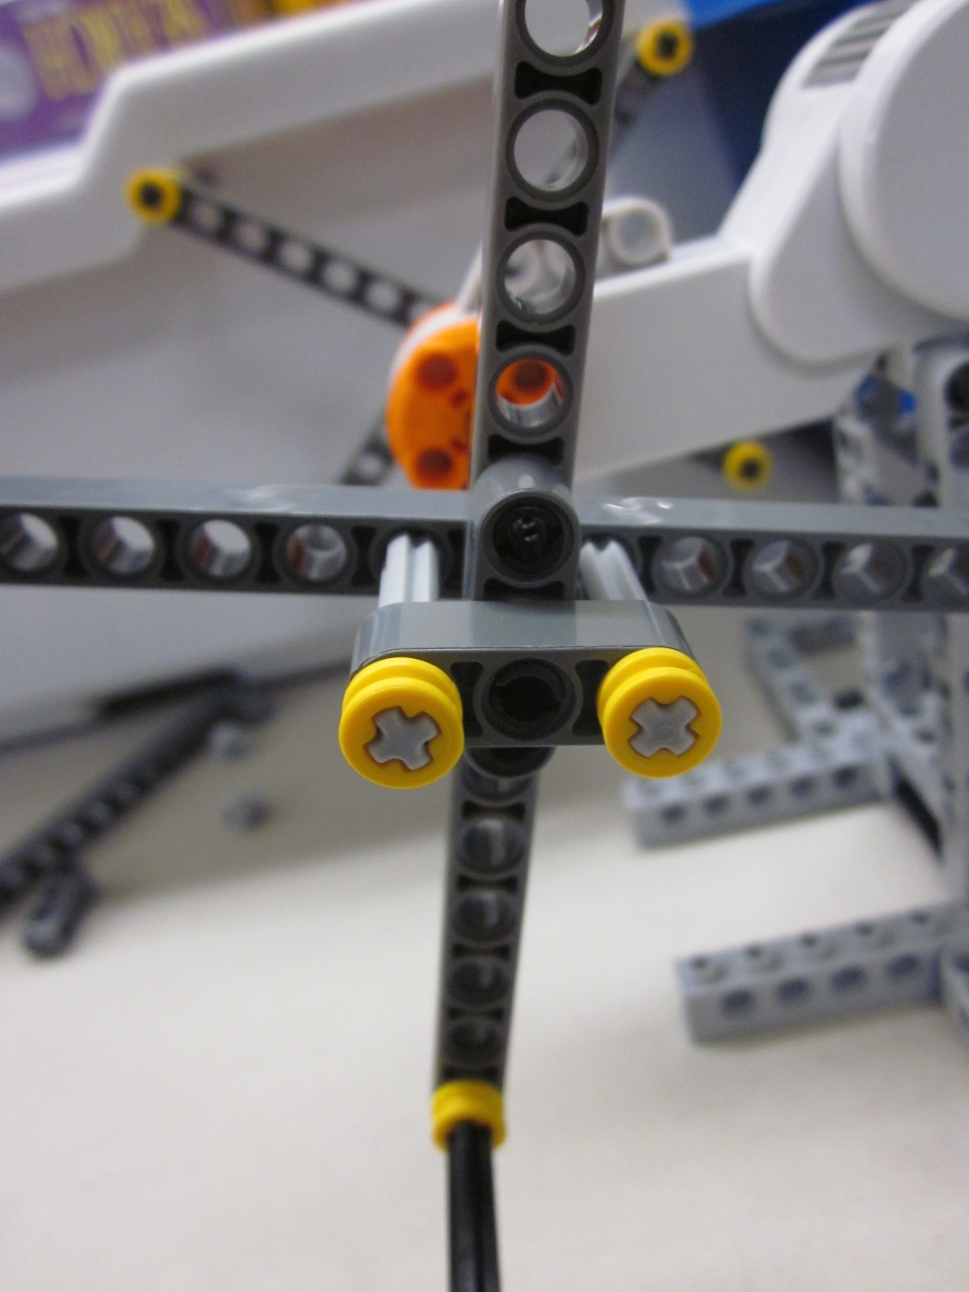

RESEARCHER: Did that work?

[00:44:51] BOY 11: No. [Laughs.] [AFFECT]

[00:44:52] BOY 11: The problem is that … this part, this like turns. That can’t happen. [Laughs.] [AFFECT] [Needs to use crosses!] [PROJECT-CORRECT][CONNECTION]

[00:45:12] [PLAN] [Looking at parts for another solution.]

[00:45:17] [BUILD-REBUILD] [Tries adding a different part to make it rigid.]

[00:45:28] [EVALUATE-PHYSICAL] BOY 11: Argh. [Sighs] [AFFECT] It still turns.

[00:45:40] [BUILD-REBUILD] [Goes back to looking for a different part.] [Note: is this planning, rebuilding? Some of these classifications seem to co-exist.]
[00:45:45] BOY 11: Do you know? Are these any different than these? [Triple connector pegs.]

[00:45:50] RESEARCHER: Nope, they’re the same, just a different color. [HELP]

[00:46:50] BOY 11: [sighs] [Looking for parts, rejects some parts] [AFFECT]

[It’s interesting that even with all the sighs how satisfying the activity is for him, perhaps because he overcame difficult problems with his own creative solutions.]

[00:46:45] [PLAN] BOY 11: I think I need a different solution for that because … different pieces that are going to hold it that way. But what would really help is a … [PROJECT-CORRECT][MULTIPLE-PHASES][He is planning and taking something apart at the same time.]

[00:47:09] BOY 11: Oh, this would really help. [T-beam] [Note that he could tell just by looking that this piece could solve his problem. Moves part to design to see if it fits/works.] [CONNECTION][PROBLEM-SOLVING]

[00:47:14] [BUILD-REBUILD] [Finds piece that he was thinking of and tries it.]

RESEARCHER: Did that help? That piece?

[00:48:16] BOY 11: Yeah, because this is already basically a T. [SCIENCE]

[Builds new mini-design.]

[00:48:12] [EVALUATE-PHYSICAL] [Tests by lifting up and moving and examining. I see increased role for examination from grade 2. ]

[00:48:13] BOY 11: OK.

RESEARCHER: Oh, did that fix it?

BOY 11: Yeah.

[00:48:26] [PLAN] BOY 11: So now … [Tests in the air.] I just have to do it on the other side. [SYMMETRY]

[00:48:28] [BUILD-NORMAL] [Gets more yellow collars out of WeDo kit.]

[00:49:32] RESEARCHER: Do you get all your parts out ahead of time? Or some of them?

[00:49:38] BOY 11: Yeah, well, I always need like a bunch of these and stuff. And I was just getting them out for what I’m about to do. I’m about to do this and then 4 of the yellow pieces …[PROJECT-CORRECT][STRATEGY][IMPORTANT] [TALK-ALOUD-ARTIFACT][MULTIPLE-PHASES]

[Note the planning with the words “I’m about to do”. I wonder if older/more expert students have more of a plan in general. This planning happened due to a question but was going on undetectable the whole time.]

[Talked about getting yellow pieces out.] [He projects out that he needs multiple pieces.]

[00:49:54] [Goes back to building.]

[00:50:29] BOY 11: It’s kind of turning into like a double Ferris Wheel, which I think is kind of cool. [MULTIPLE-PHASES][Evaluates verbally while building.]

[00:50:51] [EVALUATE-VISUAL] [Steps way back and looks.][STRATEGY]

[00:50:57] BOY 11: OK. [Sighs.] [AFFECT]

[00:50:59] [PLAN] BOY 11: So basically before I do programming, I need to put the brain down and I need to make the seats. [PROJECT-CORRECT]

RESEARCHER: You are running a little short on time. We can go a little longer.

[00:51:15] [BUILD-NORMAL] [Pulled out “brain” but never really started building.]

BOY 11: OK. Well.

RESEARCHER: So you said you need to get the brain and seats. Right?

[00:51:24] [PLAN] BOY 11: Well, I don’t think the brain will be hard but I just… I’ll just put it on here but … [Tried brain in position. [SEMICONCRETE][PROJECT-CORRECT] Looks into space, clearly thinking and planning. ]

[00:51:45] [BUILD-NORMAL] [Goes back to building. Put on one beam as potential seat then tests it and explains the issue.]

[00:51:56] [EVALUATE-PHYSICAL] BOY 11: The problem with the seats is that they have to be balanced all the way around and I don’t want them to go upside down.

[00:51:57] [EVALUATE-VERBAL]

[00:51:58] BOY 11: And this is pretty nice but it’s not completely secure. [STABILITY]

[00:52:04] [PLAN] [Thinks looking away from robot. ]

[00:52:21] [Sighs.] [AFFECT]

[Bends over and closely examines robot.]

[00:52:26] BOY 11: That is a setback. [Note: interesting choice of words.] [AFFECT]

RESEARCHER: What’s the setback?

BOY 11: The seats.

[00:52:33] [BUILD-NORMAL] [Puts beam on axle. Moves brain to try and find a position for it. He is building here but it seems to be tightly coupled with planning and evaluating.] [MULTIPLE-PHASES]

[Note: there may be some unique affordances here to LEGO robotics in that very quick cycles of plan, build, test are easily done and may encourage a tinkering style.]

[00:52:50] [PLAN] [Looks into space and then back at robot.]

[00:52:56] [BUILD-NORMAL] [Starts building seat by trying a piece in position.] [STRATEGY] [PROJECT-CORRECT] [Maybe some planning involved here too?]

[00:53:07] BOY 11: I really want to but I’m afraid the best I can do is just to put them and to … I mean … If I put them on it the middle they should stay balanced it’s not really a very good idea. [SYMMETRY][MULTIPLE-PHASES][PROJECT-CORRECT][SCIENCE][Makes verbal evaluation as he builds.]

RESEARCHER: How do you know that?

[00:53:33] BOY 11: Well, since … I mean. It’ pretty balanced but it can definitely … You don’t really want to go on a Ferris Wheel that’s depending on a seat like completely balancing. [SYMMETRY][PROJECT-CORRECT]

BOY 11: I don’t think it’s that much of a problem but it’s going upside down which I don’t really want to happen.

[00:53:54] [EVALUATE-PHYSICAL] [He has built a seat and now tests it out by moving the Ferris Wheel as if the motor was turning it.]

[00:54:01] [EVALUATE-VERBAL] BOY 11: I guess it’s actually not that bad but it’s flipping over upside down.

RESEARCHER: So you want them to stay level so they don’t tip people out. Is that what you are worried about?

[00:54:11] [BUILD-NORMAL] BOY 11: Yeah, I don’t think it’s that much of a problem but it’s going like upside down which I don’t really want to happen. [MULTIPLE-PHASES][Evaluates verbally while building.]

[00:54:29] [Looking for parts.]

[Changes seat, puts it on, and spins it.]

[00:55:28] [Sighs] [AFFECT] [Maybe he did not find the part he needed?]

[00:55:33] [EVALUATE-PHYSICAL] [Tries it again. Testing how it moves. The seat spins around freely.]

[00:55:43] RESEARCHER: Did you make that or was that made already?

[00:55:46] BOY 11: This? I just made it. And it’s good but I DO NOT have enough pieces for 8 of these. [Emphatically] [AFFECT] [SYMMETRY][PROJECT-CORRECT]

[00:55:58][PLAN] BOY 11: Like do you think …

RESEARCHER: So you don’t have to make all of them, I think I can get the idea just from one side or a couple.

[00:56:09] BOY 11: I can do a couple. [PROJECT-CORRECT]

BOY 11: Probably [unintelligible] this one.

[00:56:12] [BUILD-NORMAL] [Looking for parts in WeDo kit, probably yellow collars.]

[00:56:18] RESEARCHER: You know, we don’t have enough time today so …

BOY 11: Yeah. How much time is there? [Looks at watch.]

RESEARCHER: Well, it is almost an hour but I’ll let you go a little longer until you get something working. OK?

BOY 11: Yeah.

RESEARCHER: Try to wrap up the building if you can.

BOY 11: OK.

[00:56:41] [PLAN] BOY 11: Maybe. I’m just going to do this one and I’ll probably, hopefully, probably won’t have time to do another but hopefully you can get the idea from the one. [PROJECT-CORRECT]

[00:56:47] [BUILD-NORMAL] [Goes back to building while still talking/planning. Note that these phases can overlap.] [MULTIPLE-PHASES] [Some of his planning and evaluation seems to be an artifact of the self-talk protocol.]

RESEARCHER: Yeah, I’ll definitely get the idea.

[Makes example seat.]

[00:57:52] [EVALUATE-PHYSICAL] [Tests seat.]

[00:57:54] [PLAN] BOY 11: OK, so now I think I have to do, really, is attach the brain. Argh. [AFFECT]

[00:57:54] [EVALUATE-PHYSICAL][MULTIPLE-PHASES] [He is planning with his words but testing equally at the same time! How do I handle this in the data analysis? Just have 2 at once on timeline. Count each for frequency.]

[00:58:02] [EVALUATE-PHYSICAL]

[Above there is a brief verbal planning explanation during a physical test. As he sees a problem, he aborts his planning discourse.]

[00:58:07] BOY 11: My seat is flipping over. [Smiles.] [AFFECT]

[Worried about seat flipping over.]

RESEARCHER: I think I wouldn’t worry about it now, STUDENT. Don’t worry about it.

[00:58:21] [BUILD-NORMAL] [Goes back to building.]

BOY 11: OK.

RESEARCHER: We know it’s not going to be perfect with the amount of time we have.

BOY 11: Yeah.

[00:58:08] [Puts on some mini-figures. Interesting that this is important for even a sixth grader. [CREATIVE-PLAY]

[00:58:45] [EVALUATE-VERBAL] BOY 11: OK. [Bends over to look. Satisfied with seat for now.]

[00:58:51] [BUILD-NORMAL] [Working on attaching brain. Gets out a wire.]

[00:59:28] BOY 11: OK. Well, do you think should this - [NXT brain] should this be attached?

RESEARCHER: No, I would not worry about it.

BOY 11: [PLAN] Then I guess I’ll start programming.

RESEARCHER: [unintelligible] USB cable. [Notices there is no USB cable so I had to find one for student.]

[00:59:51] [EVALUATE-VERBAL] BOY 11: [It’s not perfect. [Smiles.] [AFFECT]

[Researcher had to search for USB cable; student starts programing.]

RESEARCHER: No problem [unintelligible].

RESEARCHER: Sorry you had to do it in one hour.

BOY 11: Yeah.

[00:59:59] [WAIT] [Don’t include in data analysis.]

[Waiting for researcher to find USB cable.]

RESEARCHER: [Unintelligible] could not find one in this kit either.

BOY 11: It’s so weird.

RESEARCHER: You can start programming and I’ll bring that over.

[01:00:24] BOY 11: [PROGRAM-NORMAL] OK. [Really just logging in, I think.]

[Student goes to laptop and starts using laptop.]

[01:00:53] [PLAN] BOY 11: I am going to use Mindstorms because it was Mindstorms like technology that I was using. [SYSTEMS-THINKING]

[01:01:01] [PROGRAM-NORMAL] [Goes back to programming.]

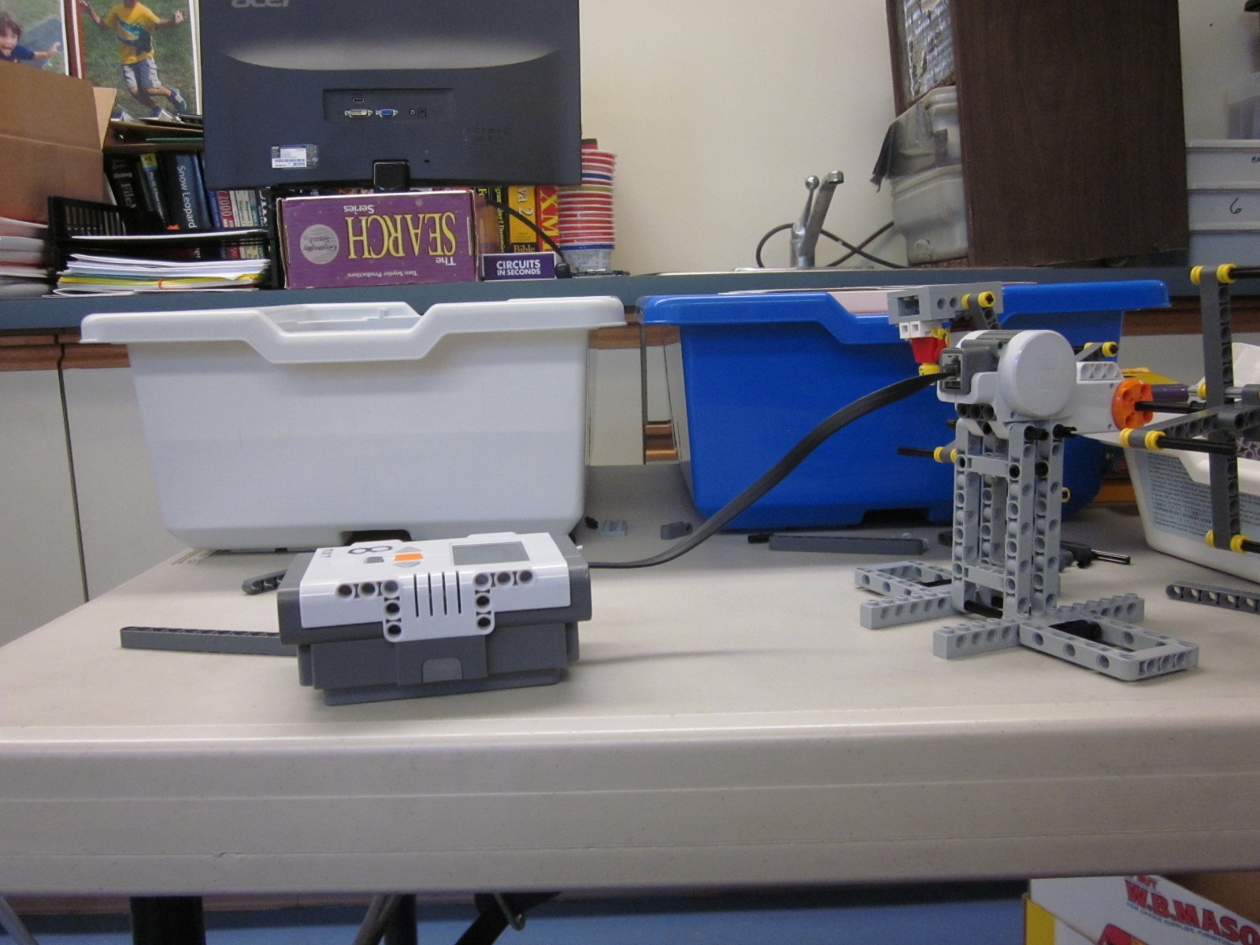

[Names program STUDENT Double Ferris Wheel.]

[01:01:50] BOY 11: It just crashed.

[01:01:55] RESEARCHER: Yeah, I have seen that happen. Start it again. [HELP]

[01:02:37] RESEARCHER: You named it STUDENT’S Ferris Wheel. Good. Thank you for saving that. [STRATEGY]

BOY 11: OK.

[01:02:48] [PLAN] BOY 11: So I am going to program it so it doesn’t go … it goes probably 50% speed - not too fast. It’s going to go … let’s see. One rotation of that should be one rotation of the Ferris Wheel. [Looks from screen to Ferris Wheel to make connection.] [PROJECT-CORRECT] [SCIENCE]

[01:03:05] [PROGRAM-NORMAL] [Programs again.]

I will make it go for 5 [rotations].

RESEARCHER: 50% power, 5 rotations. [Looking at screen.]

[01:03:44] [EVALUATE-SYSTEM] [Tests whole system with program.]

[Brick not on, figured it out because program would not download.]

[01:04:37] BOY 11: [intelligible] turn it on. [Forgot?] [STRATEGY]

RESEARCHER: What’s that?

BOY 11: It was off. [Note: Don’t have a code to reflect this kind of troubleshooting. Just coded as a strategy while keeping the EDP phase as a EVALUATE-SYSTEM.]

[01:05:17] BOY 11: OK. [Smiles but sighs too as if he is feeling a big moment of testing coming up.] [AFFECT]

RESEARCHER: [Laughs.]

[01:05:28][Runs program, guy hits head. Smiles.] [AFFECT]

RESEARCHER: [Laughs.]

[01:05:32] [EVALUATE-VERBAL] BOY 11: Well, it kind of did what it was supposed to do.

[01:05:39] [PLAN] BOY 11: I think I am going to slow it down a little bit to like 15%. [MATH]

[01:05:41] [PROGRAM-REPROGRAM]

BOY 11: And this was bumping its head so that would kind of be a safety hazard. [MULTIPLE-PHASES] [Evaluates while reprogramming.]

RESEARCHER: [Laughs]

[01:06:07] [EVALUATE-SYSTEM] [Bring robot over to download and try again.]

[01:06:15] BOY 11: I’m hoping that since it’s going slower it will not hit its head. It’s going to stay. [PROJECT-INCORRECT]

[Tests again.]

[01:06:42] BOY 11: OK. [Laughs.] [AFFECT]

RESEARCHER: Kind of a tricky problem.

BOY 11: It kind of seems like…

[01:06:54] [PLAN] BOY 11: I think if I actually used these, if I didn’t use these [different kinds of connectors] and I just used one of the …[CONNECTION][PROJECT-INCORRECT]

[What’s needed, I believe, is a bottom heavy seat, that can turn freely.

RESEARCHER: If you want to make a quick fix, we have time.

[01:07:11] [BUILD-REBUILD] BOY 11: Yeah.

RESEARCHER: Sure.

RESEARCHER: Sounds like you had an idea of how to fix it.

[Changed axles to connector pegs.]

[Quickly realized that connector pegs would hold seat upright.]

[01:07:57] RESEARCHER: Did you change the kind of connector pegs? Oh, they were axles and now you’ve made them connector pegs? Yup. Got it.

BOY 11: Yup.

[01:08:06] BOY 11: I know connector pegs can spin but not really as well so I don’t think that will really be a problem. Yeah. [CONNECTION][PROJECT-INCORRECT]

[01:08:18] [EVALUATE-VERBAL] Oh!

[01:08:19] [EVALUATE-PHYSICAL] But there is a problem though … because they can’t spin so they will be going upside down. [PROJECT-CORRECT] [IMPORTANT]

[Tests by hand.]

[01:08:40] [EVALUATE-SYSTEM] [Tests with program.]

BOY 11: [Smiles.] It could certainly be fun if they had seat belts. [AFFECT]

RESEARCHER: [Laughs] Well, some people might like that but I know what you are trying to do.

[01:08:51] [PLAN] BOY 11: Yeah, I mean I’m not sure really how I would really get them to balance the whole way.

RESEARCHER: Yeah, right. That’s an interesting problem.

[01:09:02] [EVALUATE-VERBAL] BOY 11: [Bends down to look closely] I mean a real person would fall straight off but without a safety belt or something. [PROJECT-CORRECT]

RESEARCHER: Well, are you fairly satisfied?

[01:09:16] [EVALUATE-VISUAL]

[01:09:18] [EVALUATE-VERBAL] BOY 11: Yeah, I am. It seems pretty good for an hour, I guess.

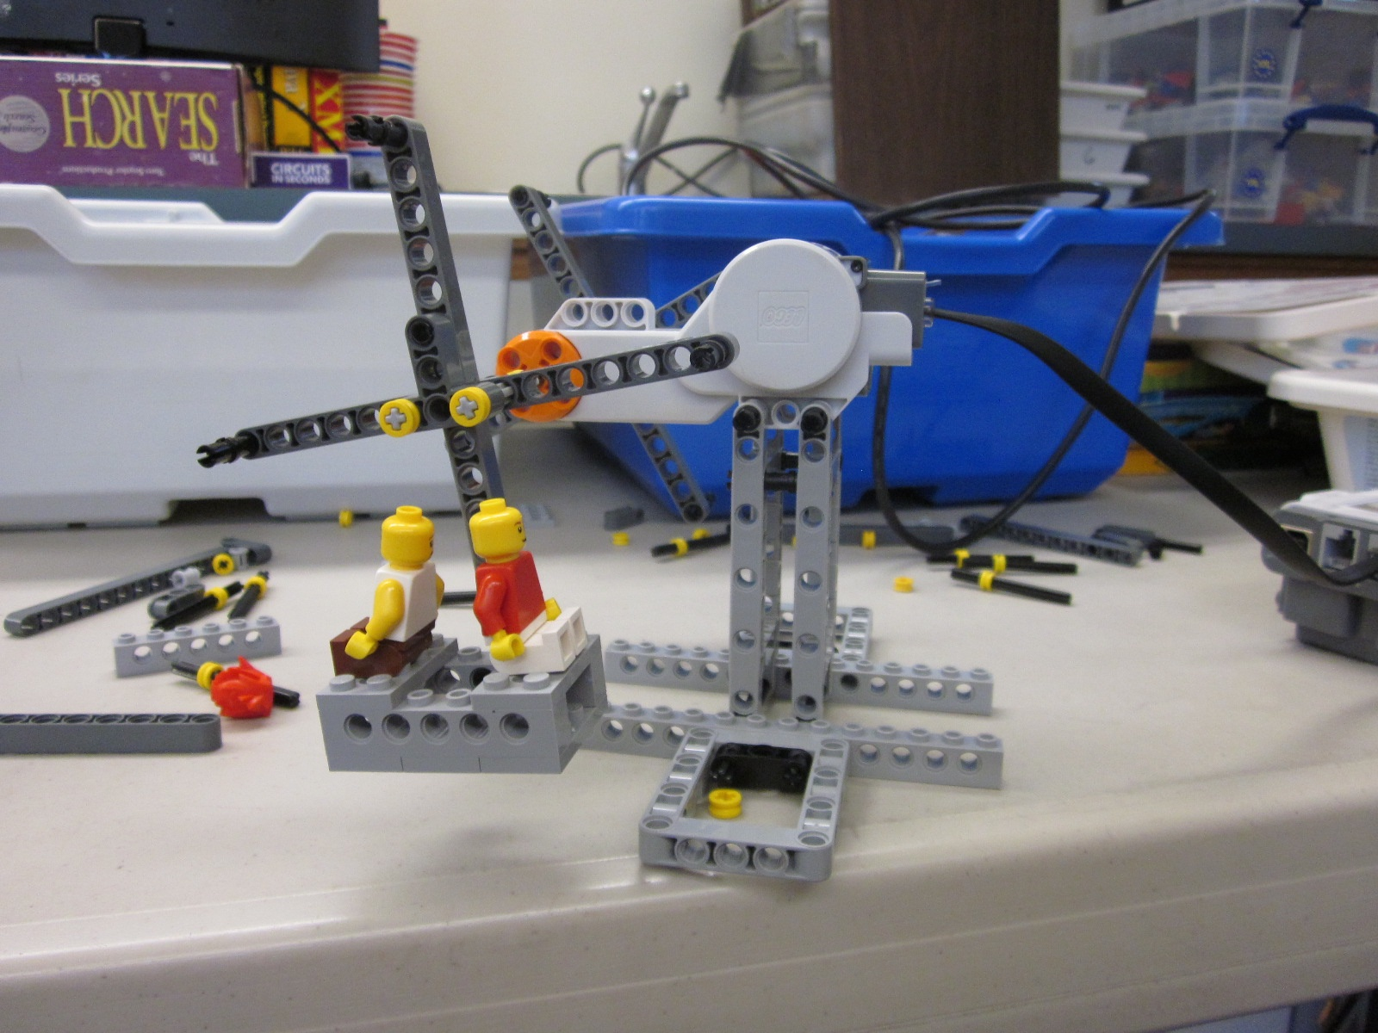

[01:09:24] [WAIT] RESEARCHER: Yeah. Well, have a seat and let’s talk for a little bit. I am just writing down what you said, “It was pretty good for an hour.”

[01:09:47] RESEARCHER: So, what was this experience like?

[01:09:50] BOY 11: Well, it was kind of challenging because I was like … at a lot of points I was like … like I wanted to have it finished but I was afraid something was going to go wrong. And I mean, smaller things went wrong but it went around which was pretty good. [AFFECT]

RESEARCHER: What would you say was hard and easy about this?

[01:10:16] BOY 11: Well, what helped, I’d say, was that I had all the access to all these kits so I wasn’t worrying about … I probably couldn’t have done this without the other kits. I couldn’t have because I used a lot of the smaller like connecting parts.

[01:10:43] RESEARCHER: Right, so that was easy or helpful?

[01:10:43] BOY 11: Yeah. That was helpful and that made it a lot easier. And it was hard because I had to keep switching things around and stuff was falling off and there weren’t always easy solutions like how it was balancing. Because it was my invention and not something already set up basically. [IMPORTANT]

[He differentiates here between open-ended challenges and more structured activities.]

RESEARCHER: How do you feel about your ride?

[01:11:15] BOY 11: I think it’s kind of cool. [Smiles.] It’s not perfect because the guys are upside down. It’s kind of bulky and … yeah. It’s like the motor and all the other stuff is two times bigger than the ride part but if it was like real ride, I’d go on it. [SCALE]

RESEARCHER: Good. If you had to do this again, would you do it any differently in any way?

BOY 11: Well if I had more time.

RESEARCHER: In terms of the process and not just the actual ride.

[01:12:04] BOY 11: Yeah, well, probably if I had time, I’d probably think it over more before I did it and I would maybe sketch it out.
RESEARCHER: Yeah, right, why do you say that?

BOY 11: Because at certain points, I was just going and it wasn’t necessarily going to work or I was afraid that it wouldn’t work. [AFFECT]

RESEARCHER: All right, I think you’ve been doing robots since you know kindergarten or first grade. How has that affected this task?

[01:12:46] BOY 11: Well, I knew how to program it and I knew how to do this and I … I had experience kind of using all the parts. We designed like the drag racers and I knew what different parts did. Like if I was making one and I saw like one of these little connector things, I’d have an idea of what to do with it and stuff.

RESEARCHER: And by the same token, were there things that you thought, “If I was taught that, that might have helped me?”

BOY 11: Well. I’m not sure. Not really. [Laughs.]

RESEARCHER: Well, that’s kind of a hard question. Any other comments on it?

BOY 11: I don’t think so.

RESEARCHER: Well, thank you. I think you did an awesome job. I really learned a lot. So in my study I am doing I studied a second grader too so I can compare your process to his process and eventually I want to do from K to 2 to 4 to 6 - 3 kids from each grade level. But this pilot study was really helpful to me.

